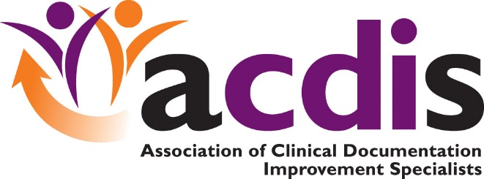

ACDIS Symposium:

CDI Outpatient Conference

Lake Buena Vista, FL

November 8 - 9, 2018

**206**

**106**

**F&B**

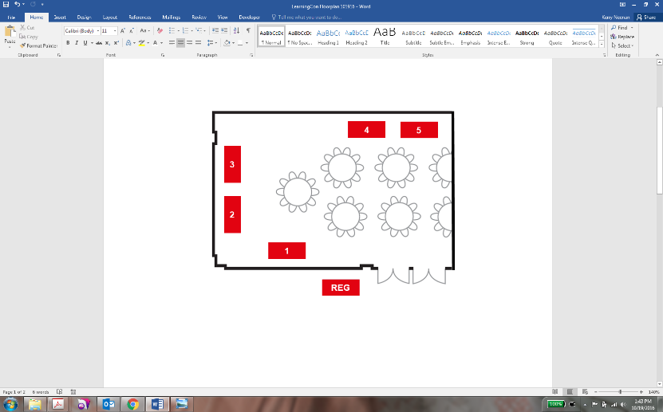

**105**

**205**



**204**

**104**

**203**



**103**

**Session Room**

**Session Room**



**202**

**102**

**F&B**

**F&B**

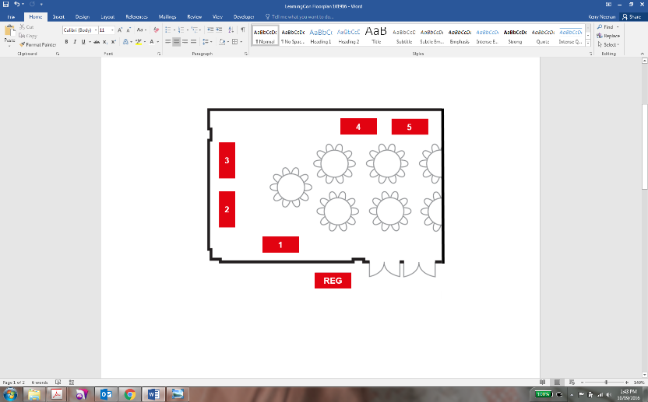

**201**

**101**

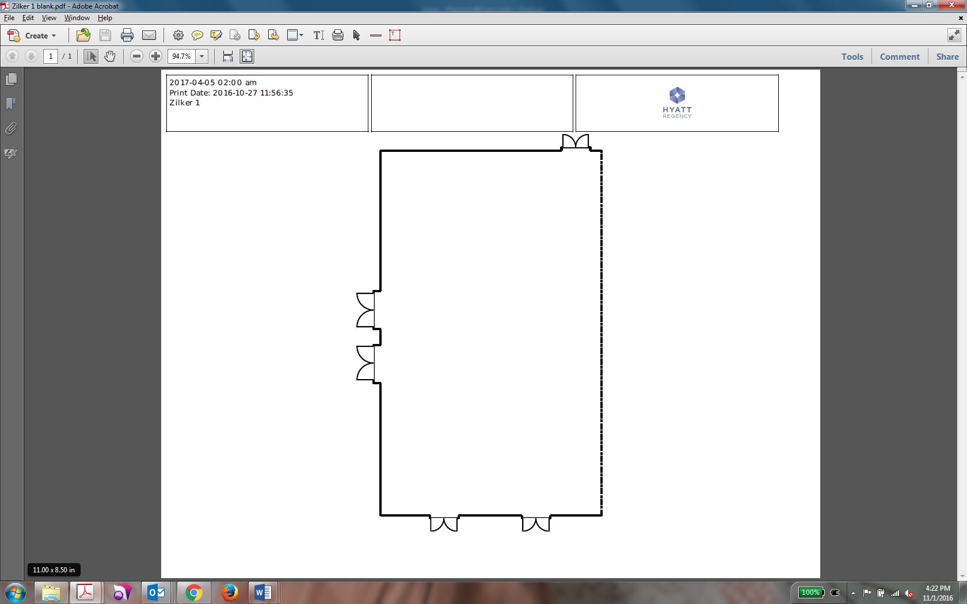

|  |  |  |
| --- | --- | --- |
| **Exhibit Hall Booth Legend** |  |  |
| **Booth 100: 3M** | **Booth 200: MedPartners** | **Table 1:** |
| **Booth 101: M*Modal** | **Booth 201: Saince** | **Table 2:** |
| **Booth 102: UASI** | **Booth 202: Optum** | **Table 3:** |
| **Booth 103: ChartWise Medical Systems, Inc.** | **Booth 203: HCTec** | **Table 4:** |
| **Booth 104:Nuance** | **Booth 204: AHIMA** | **Table 5:** |
| **Booth 105: Bolder Healthcare Solutions** | **Booth 205: RecordsOne** | **Table 6: ACDIS/HCPro** |
| **Booth 106: Peak Health Solutions** | **Booth 206: Enjoin** | **Table 7: Elsevier** |
|  |  | **Table 8: Mayo Clinic** |

**5**

**4**

**1**

**2**

**3**

**To hotel**

**200**

**100**

**8**

**7**

**6**