2018 ACDIS Symposium: Outpatient CDI
Conference Committee

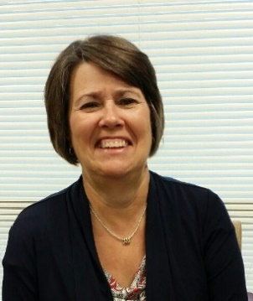
Rita Fields, BSN, RN, CCDS
A nursing professional for 46 years, Fields recently retired from her role as regional CDI manager at Baptist Health in Louisville, Kentucky. Her experience includes medical-surgical, labor and delivery/postpartum, emergency department, and case management. She has worked in CDI since 2010, beginning as a CDI specialist and advancing through auditor/educator, and regional manager.
Fields served on the ACDIS Local Chapter Advisory Board, as president of the Kentucky/Southern Indiana ACDIS Chapter for four years, and co-chair for one year. At her facility, Fields was an advocate for CDI education and collaboration, starting a physician advisor program, facilitating meetings between CDI and coding departments, and moving the program toward a quality-focus as opposed to a financial one. ACDIS recognized her as the CDI Professional of the Year in 2017.

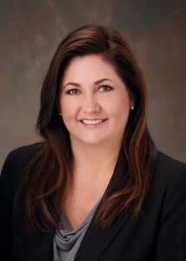
Wendy Clesi, RN, CCDS, CDIP

As executive director of CDI services for Enjoin, Clesi oversees the inpatient, ambulatory, and advanced CDI programs working with clients to tailor each program. She also works collaboratively with the Enjoin physician team to ensure an effective and consistent process for clinical documentation and physician education for clients.

Wendy has more than 23 years of acute care nursing experience with 13 years of CDI experience. She began her career as a critical care nurse, eventually providing administrative oversight for nursing services and patient care for a multi-site national dialysis provider. She was the recipient of the 2009 ACDIS Award for Recognition for Professional Achievement, is an active member of ACDIS and AHIMA, and previously served on the ACDIS Advisory Board for the 2014-2017 term. Clesi also serves as an adjunct instructor for the AHIMA CDI Academy.

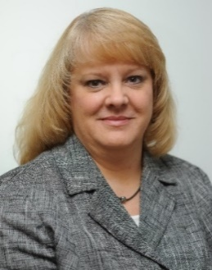
Tamara A. Hicks, RN, BSN, MHA, CCS, CCDS, ACM-RN

As director of clinical documentation excellence at Wake Forest Baptist Health (WFBH) in Winston-Salem, North Carolina, Hicks is responsible for the enterprise-wide Clinical Documentation Excellence (CDE) department at WFBH’s five campuses. She was one of the original staff when WFBH rolled out its CDI program in 1999, and since then she has participated in expanding the program by adding all payer, severity of illness, risk of mortality, hospital-acquired conditions, and patient safety indicator reviews to the team’s workflow. Most recently Hicks led the team though restructuring and the creation of a new outpatient CDE team.

Tamara holds a diploma in nursing from Watts School of Nursing, graduated summa cum laude from Gardner-Webb University with a bachelor of science degree in nursing, and a master’s degree in health administration from Pfeiffer University. She has worked for WFBH for nearly 34 years, with 15 years of service as a staff nurse in the hospital's intermediate care unit and nine years as manager of care coordination.

An AHIMA certified ICD-10-CM trainer, Six Sigma Green Belt, Hicks is also a member of American Case Management Association (ACMA), AHIMA, and ACDIS. She served as a founding member of the advisory board and the CCDS Certification Committee. She was re-elected to serve on the ACDIS advisory board in 2016.

Married with has two grown children (she met her husband, is a mental health nurse, in nursing school), Hicks enjoys supporting her favorite NFL team, the Carolina Panthers; she and her husband are season ticket holders. She also enjoys spending time with her five dogs and volunteering on the board of a local non-profit, Project Pearl, that provides care for animals in need of medical and foster care, therefore not able to be placed in the adoption program at the local shelter. So her pack is often joined by a foster pup in need of care.

Ellen Jantzer, RN, MSN, CCDS, CCS

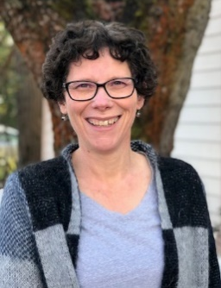
As the clinical documentation integrity (CDI) manager for Asante Health System located in Medford, Oregon, Jantzer led the Asante CDI team for six years. She has a master’s degree in nursing and is both a Certified Clinical Documentation Specialist (CCDS) through ACDIS and a Certified Coding Specialist (CCS) through AHIMA. Prior to her work in CDI, Ellen worked on the cardiology step-down unit and in ICU/CCU. She also has experience in discharge planning, resource management, and denials.

A year ago, Asante made the decision to expand the inpatient CDI program to include the outpatient setting. Currently, this team consists of four nurses working in the ambulatory primary care clinics. The focus is to assist providers to improve the accuracy and specificity of their documentation related to Hierarchical Condition Categories (HCCs) and ICD-10 code assignments in general.

When not digging through medical records or buried in coding rules, Jantzer enjoys spending time with her husband of 32 years, Jason, their four adult children and their spouses, plus her 1 ½ year old granddaughter. Jantzer and her family enjoy the many outdoor activities that Southern Oregon has to offer such as hiking, camping, and rafting.

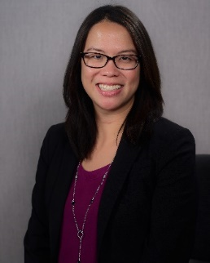
Anny Pang Yuen, RHIA, CCS, CCDS, CDIP

As the principal of AP Consulting Associates, Yuen brings her strong background in CDI, HIM, coding, and revenue cycle to assist clients in developing and re-invigorating their CDI programs. She is the author of First Steps in Outpatient CDI: Tips and Tools for Building a Program and the co-author of The Complete Guide to CDI Management published by ACDIS/HCPro.

She currently serves on the ACDIS Advisory Board and is a nationally recognized HIM and CDI subject matter expert. Yuen is also a member of the AHIMA Outpatient Query Toolkit Committee, AHIMA Outpatient CDI Toolkit Committee, AHIMA Clinical Documentation Improvement Practice Council, CCS Exam Development Committee, and the CDIP Credential Item-Writing team. She holds a bachelor of science degree in HIM from Temple University where she minored in business.

Lisa J. Garrett, BSN, RN, CPC, CPC-I, CPC-P, CRC

As a team coordinator in the population health management department at Sentara Medical Group in Norfolk, Virginia, Garrett manages a team of coders focused on ambulatory CDI.

She creates, produces, and analyzes quality reports for the operational team within the medical group to assist with quality measure gap closure for targeted populations. Garrett has experience in clinical operations, hospital chargemaster, healthcare charge capture and revenue integrity concepts, as well as ICD-10-CM, and CPT/HCPCS coding concepts. She also has extensive experience in analyzing various Medicare payment systems and in assessing the impact of these systems on reimbursement in the outpatient and inpatient settings. She has been an AAPC certified CPC instructor since 2005.

An adult critical care nurse for more than 10 years, Garrett worked in areas such as open-heart surgery ICU, surgical-trauma ICU, neurology ICU, and CCU. She transitioned from bedside nursing to work for an insurance company as a medical management nurse, and then served as a physician coding and auditing specialist conducting evaluation and management, and operative report audits for a multispecialty surgical group.

She then transitioned to the hospital arena where she gained expertise in acute hospital chargemaster and working with hospital clinical leadership on operational improvements related to charge capture. She successfully created and managed a centralized observation charge capture unit.

She is currently pursuing her masters of science in healthcare administration degree from Virginia Commonwealth University in Richmond. She received her bachelor’s degree from Molloy College.

She enjoys practicing yoga, boxing, and spending time with her life-partner of 22 years, Bryant, and her mother Rosetta.

Cheryl St. Onge, MHA, BSN, RN

As CDI director at Dayton (Ohio) Children’s Hospital, St. Onge helped implement both an inpatient and outpatient CDI program concurrently.

She has a clinical nursing background in a variety of areas including NICU, PICU, pediatric house float, ED, perioperative services, hematology oncology, general pediatrics, and pediatric transport. Her nonclinical experience includes time as a nurse auditor and implementing a surgical quality improvement program.

St. Onge earned a bachelor of science in nursing from Wright State University and a masters of healthcare administration from University of Cincinnati.

She runs half marathons for fun and is working on a 50 half marathons in 50 states challenge.

Other committee members:
- Jennifer Grubb

