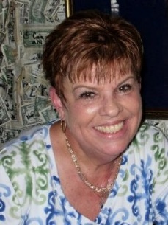
Debra Dallos, CDIP, RN
Supervisor of CDI program
Sarasota (Florida) Memorial Hospital
Deb-Dallos@smh.com

When did you join CDI and how did you get here?
I am a registered nurse with 28 years in the profession. My career for the first 22 years was in the critical care arena—ICU, open heart recovery, PACU, and ER. I have served as chair on unit-based practice councils and was selected to be chair of the hospitalwide practice council. I was the EXCEL Award winner at Sarasota Memorial Hospital after being nominated by my peers.
The last six years of my nursing career have been spent in CDI with two years as a CDI specialist and four as supervisor of CDI team at Sarasota Memorial Hospital. I have hosted two Florida ACDIS meetings at my facility (with a little help from my friends) and have been board president of Florida ACDIS for the past two years.

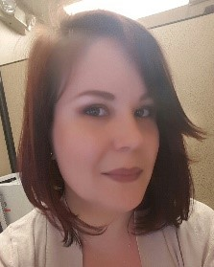
Lillian M. Dickey, BSN, RN, BSBA
Clinical Documentation Specialist
Providence Regional Medical Center, Everett, Washington
lillian.dickey@providence.org, lillian.dickey@gmail.com

When did you join CDI and how did you get here?
I became a CDI specialist on December 28, 2015. Prior to that, I’d been a bedside nurse for eight years, mostly in ED/trauma, but also pediatric ICU and various specialties. I spent much of my life moving around. I’ve lived primarily in Hawaii, Nevada, Georgia, and now Washington with shorter stints as a travel nurse in Texas and Massachusetts. My travel nurse experiences pushed me further and further away from the bedside. At nine patients to one nurse in a busy Level I trauma center, I was finally tapped out and ready to try something new.
I discovered CDI by accident after having applied for a utilization management position. When calling about my application, my director suggested I interview for a CDI position first. I did some research and thought she might be right. (Serendipity, anyone?)
What made you volunteer for the local chapter?
About six months into my position, my team went to a chapter meeting. Our event hostess shared information with us about becoming an “official” ACDIS chapter and asked for volunteers to both sign the agreement form and, ideally, be more involved. I’d grown increasingly interested in learning more about my new specialty, but I wasn’t sure how useful I’d be, as a new CDI staff person. After having participated in many groups throughout college, though, I knew I’d have something to offer. My team lead encouraged me to chase my interest, so I did!
Prior to joining our chapter leadership team, I wasn’t involved much at all in local chapter activities. Now that I am, however, it has opened plenty of new opportunities for me to be involved.
What excites you most about local chapter events?
I’ve been involved with all the Washington events since joining the chapter leadership team a little more than a year ago. The most exciting part for me is the planning: coordinating with the other members of our leadership team, communicating with members, and preparing materials.
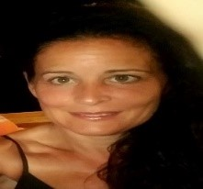
Lori J. Ganote, MSN, RN, CCDS
System Clinical Documentation Integrity Auditor/Educator
Baptist Health System, Louisville, Kentucky
lori.ganote@bhsi.com

When did you join CDI and how did you get here?
I joined the ranks of CDI in October of 2013. Prior to this transition I’d been a bedside nurse for eight years, in different venues. I did most of my direct care in outpatient settings, including home and long-term care. My favorite specialties are pediatrics and geriatrics.
My husband and I are blessed with five children, and as they aged we recognized their needs changed. It was during this time I began to expand my horizons. I transitioned away from direct care to a position that would accommodate busy schedules for our teenagers and young adults. It was with great excitement and a whole lot of anticipation when I began my CDI career. I honestly could not be happier with the change in course. I still feel a strong sense of advocacy to our patients, providers, and staff and strive to serve our community through education. The mutual benefit, of course, is being able to be there for my family and their needs. (Editor’s note: Ganote just welcomed a new grandbaby into the world, Emma June, born December 6, 2017.)
What made you volunteer for the local chapter?
The sense of community and sharing is very strong at our local chapter. Teamwork, encouragement, and support is offered to one and all. This atmosphere is very conducive to learning and sharing of challenges, success, and strengths. This environment made it easy to volunteer to help with planning the upcoming annual meeting, presenting educational topics, and outreach, and I have been very grateful for the opportunity to participate in our local chapter.
What excites you most about local chapter events?
I am excited about outreaching to other programs that are not participating with the local chapter. I feel a strong sense of community and shared learning within our group, and the opportunity to extend this to others is amazing. I am eagerly anticipating planning for the events, coordinating with the other members of our leadership team, communicating with new members, and preparing education materials.

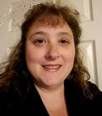
Lori LaFaver, BSN, RN, CCDS
Clinical Documentation Specialist Manager
Reading (Pennsylvania) Hospital, Tower Health System
Lori.LaFaver@towerhealth.org

When did you join CDI and how did you get here?
I started my CDI career in December of 2005 at Reading Hospital and obtained my CCDS in June 2012. My background prior to becoming a CDI was as a bedside nurse for 10 years in the areas of telemetry, ICU, and hemodialysis. In 2005, Reading Hospital started a CDI program through the HIM department. I was intrigued by the job description and what the vision was for the program. It was exciting to be part of a new program at the hospital. The growth in the area of CDI that I have experienced since 2005 has been a tremendous journey, and I look forward to continuing the journey to advance in new areas of healthcare.
How did you first get involved in local chapter activities?
I have watched CDI progress many ways since I first started in 2005. One of the ways is the networking possibilities and different venues of growth within our profession. Years ago, I was part of a group of CDI specialists who tried to get together to network and learn from each other. It was a great concept that just could not be sustained at the time. I attended a meeting at a local hospital and started discussing the role and the profession with the CDI manager, and we discussed what we could do to help create a local chapter and become more organized as a group. We progressed into being co-leaders and have been working together to educate and promote the progress of the CDI profession with the help of our peers.
What excites you most about local chapter events?
I enjoy seeing the more seasoned CDI members encouraging and helping the newer CDI members. There are different levels of experience that attend the local chapter events, and the ability to support our peers and profession has been wonderful to experience.

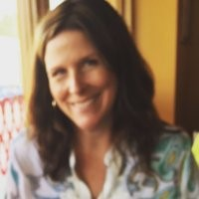
Kerry Seekircher, RN, BSN, CCDS, CDIP
Director, Clinical Documentation Improvement
Northern Westchester Hospital/Northwell Health, Mount Kisco, New York
kseekircher@northwellhealth.com

When did you join CDI and how did you get here?
I was hired in March 2010 to help start up the CDI program. Being brand new to CDI, I relied heavily on all the resources made available by ACDIS, including webinars, the ACDIS Forum, forms, policies, education tools, and the conferences. Over the years, I have been fortunate to see the progression of the program shift from a CC/MCC-driven focus to a focus on quality documentation and collaboration with a multidisciplinary team.
What made you volunteer for the local chapter?
As an active member of ACDIS, I was looking for another opportunity to network with other CDI professionals. Starting up a local chapter just seemed like the logical next step, and with guidance from ACDIS and help from a group of amazing volunteers, our chapter has grown to approximately 30 members from several counties in Hudson Valley, New York.
What excites you most about local chapter events?
Being a part of ACDIS at the local level has been rewarding in that it helps me connect with my peers, learn about best practice, and hear about what others are doing to bring their programs to the next level. Knowing that we are filling a gap by offering networking and educational opportunities is a bonus, and I look forward to watching the chapter and all its members grow in the years to come.

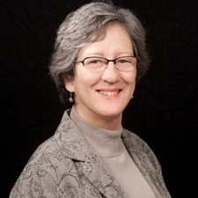
Molly M. Siebert, RHIA, CCDS
Clinical Documentation Specialist
Legacy Health, Portland, Oregon
msiebert@lhs.org; molly@thrivenet.com

When did you join CDI and how did you get here?
I was hired by Legacy Health as a CDI specialist October 15, 2013. I became a CCDS on June 8, 2016. Prior to that, I have been in HIM since 1975 working for a QIO Medicare reviewer for seven years and three hospitals performing quality, trauma registry, cancer registry, systemwide EMR development, and assistance in HIM operations management.
I have always known, based on my QIO and quality experience, there was an opportunity to work with physicians on documentation improvement. After a temporary EMR development position was completed, I discovered a job opening at Legacy Health. The CDI director and I talked for more than an hour about documentation issues and some AHIMA best-practice publications, notably the Best Practice for the Problem List (since updated).
What made you volunteer for the local chapter?
I have always been active in associations and civic organizations. I was on the OrHIMA board, off and on, for a grand total of five years. I was involved in two different AHIMA workgroups in 2007–2009. Civic duties included Soroptimist International, several arts councils in Alabama, the Junior Women’s League, and currently the Al Siebert Resiliency Center.
How did you first get involved in local chapter activities?
I was raised to be civic minded. With my experience, I saw an opportunity to perhaps enhance ACDIS NW of Oregon to a higher level of functionality. Plus, my mentor encouraged me to volunteer to be on the board.
What excites you most about local chapter events?
Connecting with other members is my favorite part of local chapter events. Also, I see opportunities to enrich and assist members through these events so that members can make a difference in the delivery of healthcare.

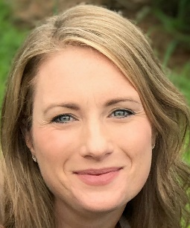
Aimee Van Balen, RN, BSN, CCDS
Certified Senior Clinical Documentation Specialist
Lifespan Corporation in Providence, Rhode Island
avanbalen@lifespan.org

When did you join CDI and how did you get here?
I currently work at Lifespan Corporation in Providence, Rhode Island, as a senior CDI specialist. I am coming up to almost nine years in the role and truly could not have imagined how much the CDI industry would change within that time frame.
Since entering the CDI field, I joined the Massachusetts ACDIS leadership team, served on the ACDIS Chapter Advisory Board, spoke at the 2017 ACDIS national conference, and have been lucky enough to join the ACDIS staff on ACDIS Radio twice. I received my CCDS certification in 2011.
In my current role, I not only review charts and educate providers but also serve as a resource to my peers and often train new staff on the day-to-day aspects of our job. I also review charts concurrently for HACs/PSIs, mortality and length of stay risk adjustment, and pre-bill retrospective mortality charts for risk adjustment optimization.
What made you volunteer for the local chapter?
I was looking for a new way to get more involved within the CDI profession and felt that I had much to offer our local chapter. My co-leads and I have been busy since the initiation of our tenure creating bylaws, building our membership, and incorporating a strong emphasis on education for our events. We have also collaborated with the MA AHIMA for an all-day Northeast CDI and Coding Symposium, which had its third successful event this past summer.
Chapter leadership involvement has reignited my energy for the CDI profession. It is so rewarding to plan and execute a successful event that is meaningful to our members. I have been so fortunate to get to know many of my CDI peers on a more personal basis as a result, and it has enhanced my leadership, communication, and networking skills.

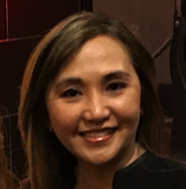
Alma Yap, RN, BSN, CCDS, CDIP
Clinical Documentation Improvement Specialist
St. Joseph Hospital and Medical Center, Phoenix, AZ
Alma.Yap@Dignity.Health.org, Rnalmay@gmail.com

When you joined CDI and how did you get here?
I was a bedside RN in a cardiac-neuro progressive care specialty for more than five years prior to my transition to CDI. When I was in my RN to BSN degree program, I became interested in exploring other nursing areas such as Informatics, case management, quality, and CDI. As I was considering the different non-bedside specialties, a CDI position opened at another affiliated hospital where I was working. I did my own research about the CDI specialist’s responsibilities before I finally applied for a transfer! I transitioned to the position in June 2013; and I felt blessed to be starting in the inpatient setting at a teaching hospital as I gained more skills and experience through collaboration with providers and interdisciplinary healthcare teams in maintaining clinical documentation integrity.
I’ve been an active ACDIS member since 2015 and I received my CCDS certification in the same year. I took my CDIP certification in 2016.
What made you volunteer for the local chapter?
Volunteering has opened several new opportunities for me to be involved and make a positive impact in both professional and local communities. Prior to joining our AZACDIS leadership team, I joined the Arizona Nurses Association leaders as one of the delegates at the ANA Lobby Day held at Washington, DC (July 2015). Additionally, at the hospital where I first worked as a CDI specialist, I also love helping in the facility’s events at my own time.
Back in 2015, it was my first time attending a chapter meeting at Mayo Hospital in Scottsdale, Arizona. Our AZACDIS chapter president at that time was encouraging members to step up and volunteer for local activities. I took the opportunity!
How did you first get involved in local chapter activities?
I first joined the local leadership as a chapter officer/educator in early 2016. Currently, I am happy to be co-leading the AZACDIS chapter with my truly supportive co-officers (Lee Anne, Debra, and Melissa) from three other organizations.
What excites you most about local chapter events?
I’m always looking forward to meeting new members, connecting with CDI colleagues and guest speakers, and learning from others’ best practices or compliance strategies. The most exciting part for me is coordinating with my co-leaders on planning chapter meetings, preparing event agenda, creating the meeting invite flyer, and bouncing off ideas that would benefit the whole AZACDIS memberships.

