***2018 Incoming Conference Committee Members***

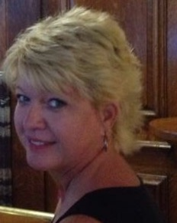**Barbara Brant, MPA, BSN-RN, CCDS, CDIP, CCS  
CDI specialist  
Cooper Health  
Friendsville, Tennessee**[**Barbarajane.brant@gmail.com**](mailto:Barbarajane.brant@gmail.com)

Barbara Brant is a CDI professional with 25 years of clinical nursing experience and more than 13 years’ experience in documentation improvement efforts as a CDI, coder, and auditor. She has worked within health systems as well as outside consulting for documentation and coding improvements. Brant also has a proven ability to lead in the development, training, and implementation of CDI program incentives. With experience working as a Recovery Auditor Contractor (RAC), her passion is the importance of denial prevention and clinical validation for CDI professionals. She currently resides in TN with her husband.

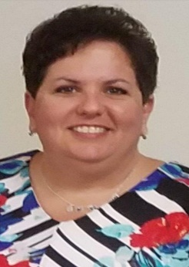**Rhonda Chism, RN, CCDS  
CDI specialist  
Medical Center at Bowling Green  
Bowling Green, Kentucky**[**RGChism@MCHealth.net**](mailto:RGChism@MCHealth.net)

Rhoda Chism is a CDI specialist at the Medical Center at Bowling Green Kentucky where she helped launch the program in 2001. She obtained her associate degree in 1989 at the age of 19 and got married the same year, embarking on a career which spanned intensive care unit (ICU)/coronary care unit (CCU), medical-surgical, orthopedics, and the ED. She completed her bachelor’s degree in nursing in 2015.

Chism and her husband have two 20-something children and enjoy “junking” at yard sales and antique shops. As Kentuckians, they also cheer for the University of Kentucky Wildcats. An avid reader of all genres (she’s on a historical fiction kick right now), Chism says her guilty pleasures are eating pancakes and playing bingo, but not at the same time.

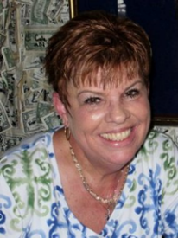**Debra Dallos, RN  
CDI program supervisor   
Sarasota Memorial Hospital (SMH)  
Sarasota, Florida**[**Deb-Dallos@smh.com**](mailto:Deb-Dallos@smh.com)

Debra Dallos has nearly 30 years nursing experience with 22 years in critical care and six in CDI. Dallos is a past chair of the Florida ACDIS Local Chapter and a member of the ACDIS national Chapter Advisory Board.

She is an EXCEL award winner at SMH (house-wide employee recognition program), and the former chair of both the house-wide and unit-based Global Unit Practice Council at SMH.

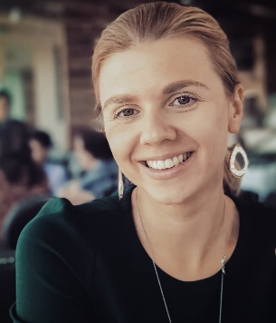**Olga Kormuskina, RN, BSN, CCDS**

**Lead CDI specialist**

**Palomar Medical Center**

**Escondido, California**

[**olga.kormuskina@palomarhealth.org**](mailto:olga.kormuskina@palomarhealth.org)

Kormuskina has more 10 years of nursing experience at Palomar Health, having spent the first five as a bedside nurse in various settings from medical/surgical to the progressive care unit, with focus on pulmonary and trauma patients. She enjoys teaching and preparing educational sessions and e-mail tips for providers and on-boarding new CDI professionals and providers by providing one-on-one CDI orientations.

Kormuskina has been involved in multiple projects and initiatives with a specific focus on quality and revenue. Coding/CDI auditing, denial appeals, and mortality reviews are some of the additional areas of her expertise. Her experience has primarily been in the inpatient arena, but recently she began developing an outpatient CDI program from scratch. It has been an interesting journey.

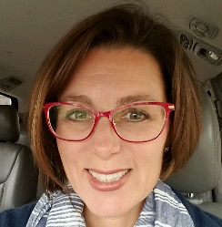**Sarah Matacale, RN, BSN, CCS  
CDI specialist   
Vidant Health  
Middlesex, North Carolina**[**sarah.matacale@gmail.com**](mailto:sarah.matacale@gmail.com)

Sarah Matacale is a CDI specialist with more than 20 years’ experience in nursing specializing in cardiac critical care and hospice. She has nursing experience in a wide variety of inpatient and outpatient areas.

After suffering a large extent of hearing loss, Matacale regrouped, and refocused her career goals on CDI efforts and has been diving head first into charts ever since. Longing for a way to reach people, writing became an outlet and she has written about CDI on nursing websites and for magazines.

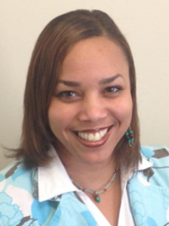**Lakeyshia Moore, MBA, RHIA, CHCO  
Senior director of coding and reimbursement  
Texas Health Resources  
Arlington, Texas**[**LakeyshiaMoore@texashealth.org**](mailto:LakeyshiaMoore@texashealth.org)

Lakeyshia Moore is currently responsible for coding operations for 18 hospital entities. She has more than 17 years of HIM and healthcare experience, including in leadership, compliance, HIPAA, Recovery Audit Contractor, CDI, hospital coding, informatics, and project management.

Some of her proudest accomplishments include decreasing the discharge not final billed (DNFB), successfully implementing an enterprise document imaging solution, and leading a successful ICD-10 implementation. She is currently serving as president elect for Dallas Fort Worth American Health Information Management Association and she is on the nomination committee for TXHIMA. In her free time, Moore loves spending time with family and friends, mentoring others, traveling, and shopping.

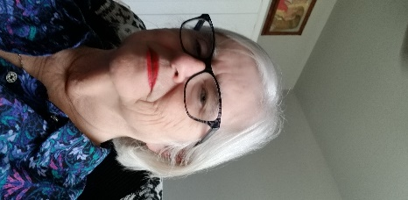**Lorraine A. Neil, PhD, RN  
CDI specialist   
CHRISTUS Health   
Corpus Christi, Texas**[**lorraineneil@yahoo.com**](mailto:lorraineneil@yahoo.com)

Lorraine A. Neil started her career more than 30 years ago as an emergency medical technician prior to making the leap into CDI.

Through the years, she has held various positions including critical care bedside nurse, and director, home health director, and hospital director of nursing. Along the way, she received her PhD in health care administration and she is educated in medical death investigation and medical legal consulting.

**Priscilla Stuart, MS, RHIA, CCS  
CDI specialist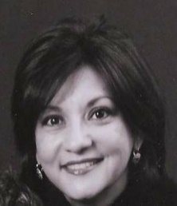Baylor Scott & White McLane Children’s Hospital  
Temple, Texas**[**Priscilla.Stuart1@BSWHealth.org**](mailto:Priscilla.Stuart1@BSWHealth.org)

Priscilla Stuart has experience as coder, coding auditor, and a division coding manager where she led a team of inpatient coders responsible for seven hospitals in central Texas.

After attending an ACDIS CDI Boot Camp, Stuart saw an opportunity to take her skill set to the next level where she now enjoys sharing education with providers and serving as a resource to her peers.

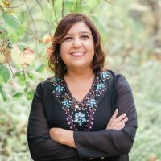**Madhu Subherwal, MHA, MBBS, CCDS, CDIP  
CDI manager  
Torrance Memorial Medical Center  
Torrance, California**[**Madhulika.Subherwal@tmmc.com**](mailto:Madhulika.Subherwal@tmmc.com)

Madhu Subherwal is a physician, completing her medical education from Dayanand Medical College in India. She has been now held her current position for the past three years.

She began her journey in CDI in 2010, while completing her master’s degree in health administration from the University of La Verne, capping her education with her thesis “The Importance of Clinical Documentation Improvement Programs and Physician Documentation Practices in the Hospital Setting.” Her personal interests include walking on the beach with her dog, listening to music and attending concerts, and watching movies. ***2018******Returning Conference Committee Members***

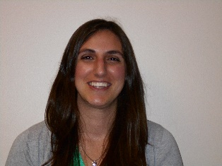**Jennifer Cooper, MHIIM, RHIA, CDIP, CCS  
HIM director and privacy officer  
Hunt Regional Healthcare  
Greenville, Texas**[**jcooper@huntregional.org**](mailto:jcooper@huntregional.org)

Jennifer L. Cooper completed her bachelor’s degree from Indiana University and her masters from the University of Tennessee.

Cooper has more than 14 years of experience in healthcare, having assisted in the development of the inpatient CDI program in 2012. She has had direct oversight of the program since 2013. Cooper currently serves as secretary for the DFW HIMA board as well as a co-leader for the Texas ACDIS Local Chapter. She is happy to be on this committee again and is looking forward to another great conference in 2019!

A person wearing a suit and tie looking at the camera

Description generated with very high confidence**Faisal Hussain, MD, CCDS, CDIP, CCS  
Corporate CDI director in clinical services  
CHSPSC, LLC  
Thompson, Tennessee**[**smfaisalhussain@hotmail.com**](mailto:smfaisalhussain@hotmail.com)

Faisal Hussain is corporate CDI director in clinical services at CHSPSC, LLC, which consists of over 110 hospitals in 20 states. Prior to his current role, Hussain managed the CDI program at Robert Wood Johnson University Hospital Somerset and was involved in numerous initiatives, including changing the workflow for patient safety indicators/hospital-acquired conditions, updating query forms for ICD-10 compliance, and creating action plans to collaborate with case management to reduce symptom DRGs.

He has served on the ACDIS Conference Committee in 2017 and 2018, and was a speaker at the 11th annual ACDIS Conference in San Antonio. He has also spoken on the ACDIS Radio show, and he is currently serving on the 2018 ACDIS CDI Week Committee.

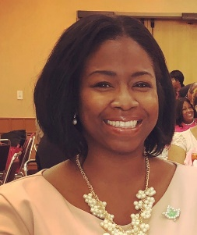**Chaka T. Prior, MPA, BSN, RN, CDIP  
CDI manager  
Piedmont Healthcare  
Atlanta, Georgia**[**Chaka.Prior@piedmont.org**](mailto:Chaka.Prior@piedmont.org)

Chaka T. Prior has 15 years of experience in healthcare. Originally from South Carolina, she insists that Carolina peaches are sweeter. She transitioned to CDI, from critical care nursing in 2012, and quickly determined the move as one of the best professional decisions of her life.

In October of 2015, she joined Piedmont’s leadership team for CDI which is expanding in terms of acquisitions and integration, the comprehensive review, optimizing on software, and capitalizing on new trends in the industry. She served on the 2018 ACDIS Conference Committee and is a past Georgia ACDIS Local Chapter leader.

Though she calls work a “sometimes hobby,” Prior also enjoys watching movies, dining on good food, a good glass of wine, and ANY genre of good music. And anytime there’s an opportunity to be by a beautiful beach, she’s there.

***2018 ACDIS Ad Hoc Contributors***

Carrie Mayfield, MSN, RN, CCDS, CDI supervisor, Children’s Minnesota, [Carrie.Mayfield@childrensmn.org](mailto:Carrie.Mayfield@childrensmn.org).

Alma Yap, RN, BSN, CCDS, CDIP, CCS, CDI specialist, St. Joseph Hospital and Medical Center, Phoenix, Arizona, Alma.Yap@Dignity.Health.org, [Rnalmay@gmail.com](mailto:Rnalmay@gmail.com).

***2018 ACDIS Advisory Board Liaisons***

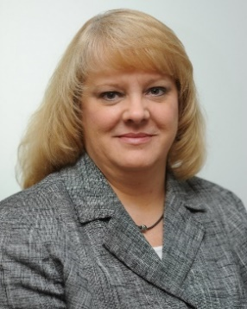**Tamara A. Hicks, RN, BSN, MHA, CCS, CCDS, ACM  
CDI director   
Wake Forest Baptist Health  
Winston-Salem, North Carolina**[**thicks@wakehealth.edu**](mailto:thicks@wakehealth.edu)

Tamara A. Hicks has more than 30 years of experience, 15 years in critical care, and more than 17 years in CDI and management. She is responsible for all CDI activity at Wake Forest Baptist Health system, an 885-bed academic medical center. She was a founding member of the CDI team at Wake Forest in 1999, and continues to lead the team expanding its efforts into all-payer reviews, reviews related to hospital-acquired conditions/patient safety indicators and severity of illness/risk of mortality, and the implementation of ICD-10. The team has also expanded into the outpatient arena .

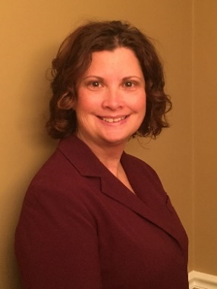**Robin Jones, RN, BSN, MHA/Ed, CCDS  
Regional CDI director, West Florida Division  
Adventist Health Care  
Tampa, Florida**[**Robin.Jones@ahss.org**](mailto:Robin.Jones@ahss.org)

Robin Jones began her CDI career in 2004 with Mercy Health in Cincinnati, Ohio, and worked her way up to eventually having direct oversight of 24 facilities. Her most important work was increasing physician awareness regarding CDI as well as collaborative work processes within the health care team including coding, case management, quality, revenue cycle, and ancillary departments to ensure the documentation is accurate for the care provided.

**Irina Zusman, RHIA, CCS, CCDS  
Director of HIM and CDI initiatives  
New York University Langone Health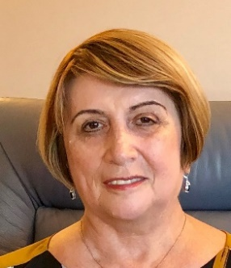New York, New York**[**izusman@gmail.com**](mailto:izusman@gmail.com)

Irina Zusman has more than 25 years of HIM experience where she used her blend of clinical and CDI skills to advance data analytics and validate the importance of documentation and coding. Zusman has contributed as a subject matter expert on a variety of focus groups regarding coding concepts, Agency for Healthcare Research and Quality patient safety indicators and hospital acquired conditions, among other topics.

Zusman currently serves on the CCDS certification committee. She has presented at AHIMA and ACDIS national and local conferences and several Vizient (formerly University HealthSystem Consortium) annual CDI pre-conference meetings.