ACDIS Symposium: Outpatient CDI Conference

November 14 – 15, 2019

Hyatt Regency

Austin, TX

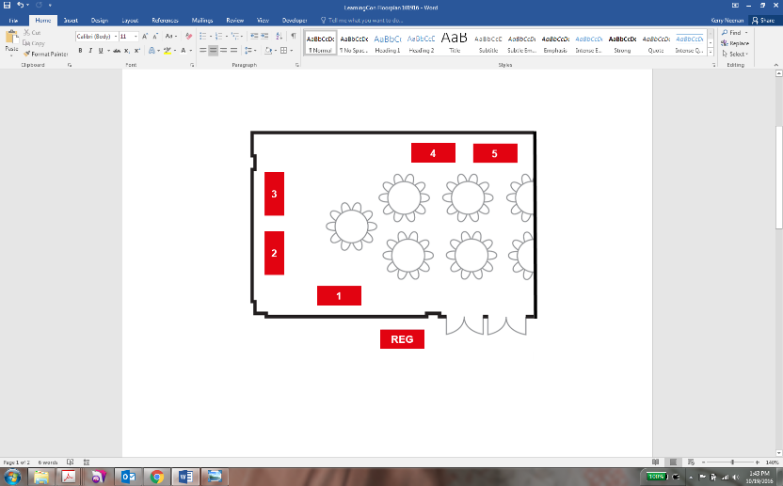

**117**

**ACDIS**

**116**

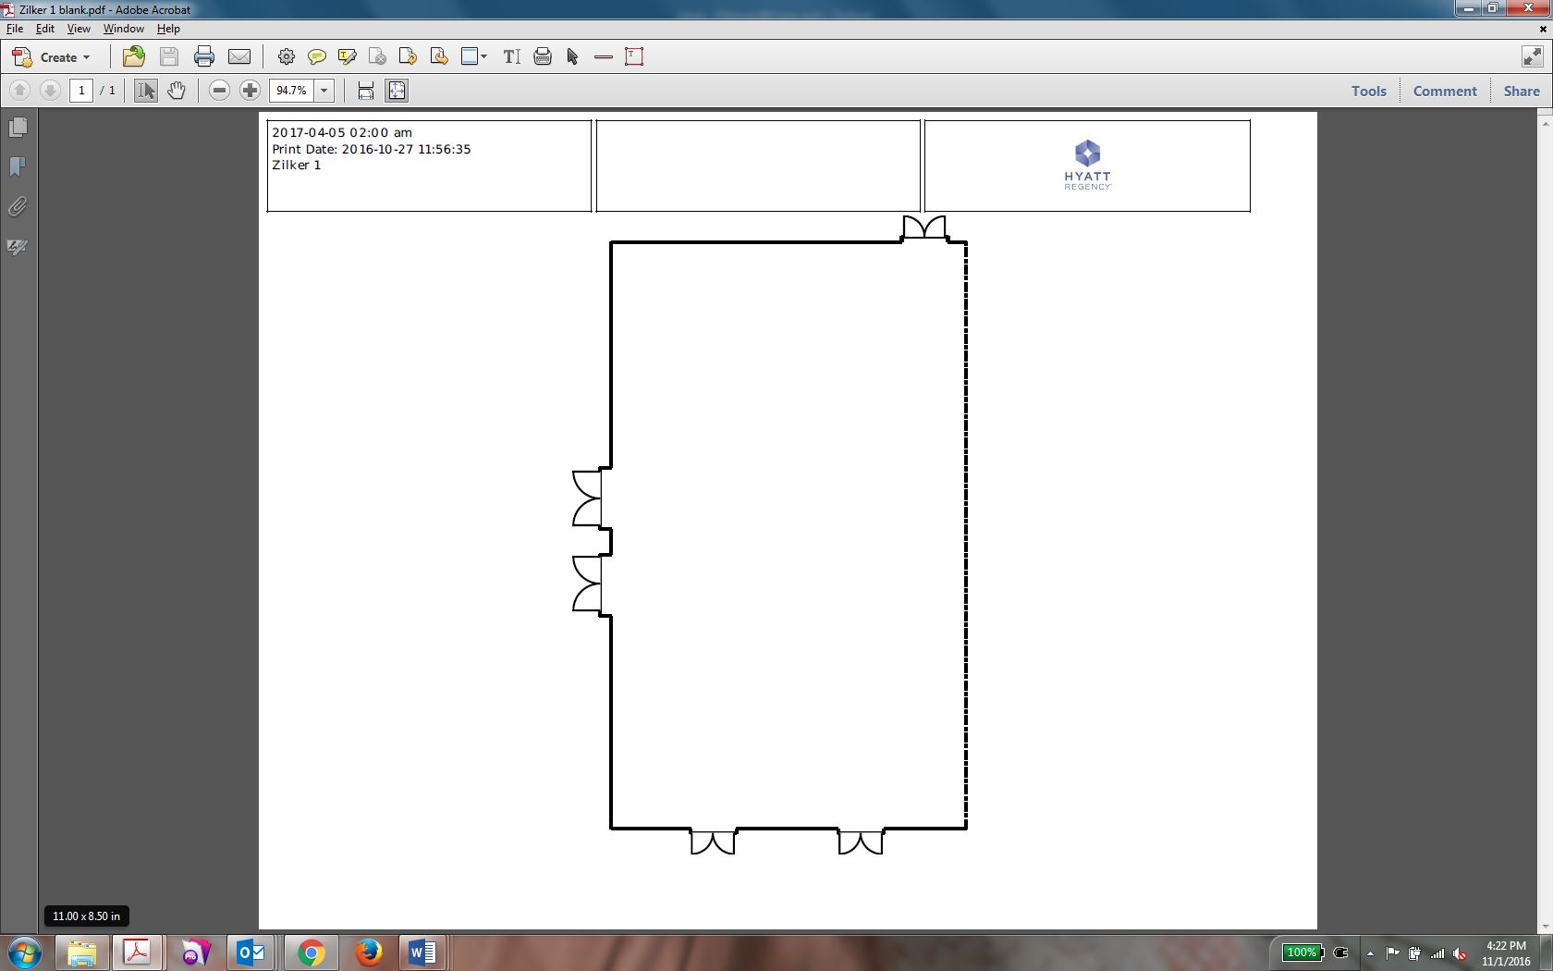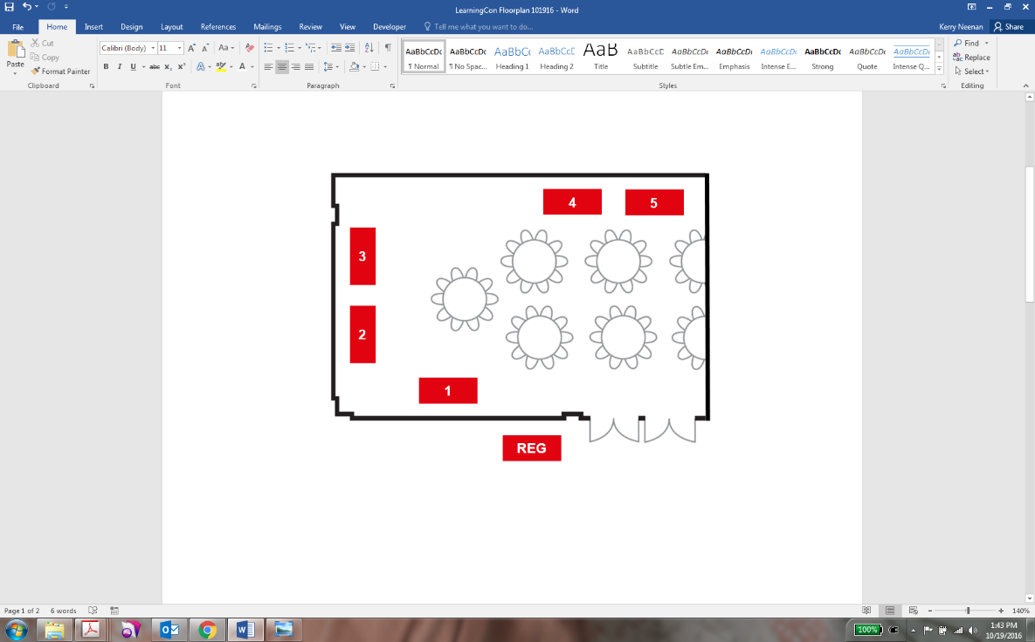

**111**

MAIN ENTRANCES

**115**

**113**

**114**

|  |
| --- |
| **Exhibit Hall Booth Legend** |
| **Booth 100:** |
| **Booth 101:** |
| **Booth 102:** |
| **Booth 103:** |
| **Booth 104:** |
| **Booth 105: Peak Health Solutions/MedPartners** |
| **Booth 106:** |
| **Booth 107: Dolbey** |
| **Booth 108: UASI** |
| **Booth 109: TrustHCS** |
| **Booth 110:** |
| **Booth 111: 3M** |
| **Booth 113: Optum360** |
| **Booth 114: Artifact Health** |
| **Booth 115:** |
| **Booth 116: Enjoin** |
| **Booth 117: ACDIS** |
| **Booth 119: Pinson & Tang** |
| **Booth 120:** |
| **Booth 121:** |
| **Booth 122:** |
| **Booth 123:** |

**F&B**

**F&B**

**F&B**

**123**

**122**

**121**

**120**

**119**

**107**

**110**

**106**

**109**

**108**

**103**

**102**

**100**

**101**

**104**

**105**