2020 Conference Committee
Incoming members:
- Deb Jones: CDI Director at Brigham & Women’s Boston
- Karen Elmore: Missouri chapter leader, member of CAB, joined the Leadership Council
- Sheri Sanford: Newbee attended her first conference in 2019 and is jazzed
- Becca Millar (Barwick): Boss says she can use work hours to do this task because ACDIS is so important to the industry and it will be a great boon to the department 😊
- Caryn Nowak cnowak@rchsd.org: Worked with Linnea on CDI Week and has both HIM and pediatric backgrounds
- Cindy Hestir

Returning Committee:
- Madhu
- Barbara Brandt
- Deb Dallos
- Tamara Hicks
Advisory Board Liaisons:
- Irina

Administrative:
- Melissa Varnavas (ACDIS)
- Shelia Bullock (nurse planner)

Potential additions:
Michelle Brooks: From Reg Cmmttee
Heidi Thomson: Has unique compliance and legal perspective
Sommer Slavin: Spoke at 2019 event

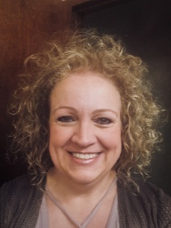
Karen Elmore, BSN, RN, CCDS
Documentation Quality Coordinator
BJC HealthCare
St. Louis, Missouri
karen.elmore@bjc.org
missouristateacdis@gmail.com
Karen Elmore began the CDI program at Boone Hospital in Columbia, Missouri, (part of BJC HealthCare) in 2008. Her previous experience includes 18 years as a neurological intensive care unit nurse and the clinical education lead. Elmore earned her CCDS in 2014, and in 2016 became a documentation quality coordinator for BJC HealthCare where she supports 14 CDI specialists and four CDI leaders within four hospitals in the Columbia/St. Louis area. Her current areas of focus include account management, second level reviews, quality measures (patient safety indicators/hospital-acquired conditions), coding and CDI mismatches, physician/provider education, mortality reviews, insurance denial reviews, and orientation of new CDI staff and providers.
Elmore started the Heart of Missouri ACDIS local chapter in 2009 and in 2015 brought together other Missouri chapters to hold a state-wide, full-day event. They’ve since held three state conferences gathering more than 100 participants. She also currently serves on the ACDIS Chapter Advisory Board.

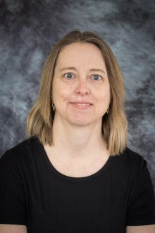
Cindy Hestir, RN, MSN, CCDS
CDI specialist
Facility
City, State
hestirc@health.missouri.edu
Cindy Hestir serves as a CDI specialist at XXXXX. She’s been a nurse in the University of Missouri healthcare system for more than 25 years working in a variety of positions including general medicine, cardiology, cardiac and pulmonary rehabilitation, staff health, care coordination and utilization review. She is an active member of the Heart of Missouri ACDIS chapter serving as the treasurer, and a member of the state conference planning committee. She enjoys traveling, hiking, and spending time visiting her children.

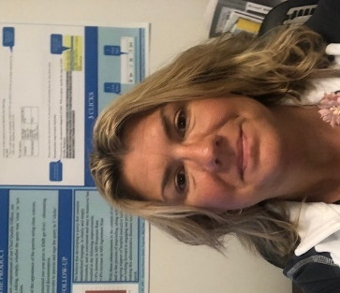
Deb Jones, RN, MSN
Director of Clinical Documentation
Brigham and Women’s Hospital & Brigham Faulkner Hospital
Boston, Massachusetts
djones32@bwh.harvard.edu

Deb Jones serves as the CDI director at Brigham and Women’s Hospital, a large academic medical center affiliated with Harvard Medical School in Boston, Massachusetts. Reporting to the quality and safety department, the CDI team collaborates with quality professionals, clinical teams, HIM, and coding to ensure the accuracy and integrity of the medical record. Since taking on the director role in October of 2017, Jones expanded the program to include commercial payor reviews and risk adjustment queries, and consequently doubled the number of CDI staff at the facility. She attributes her success to “recruiting and retaining the best and brightest CDI professionals in the industry.”
Jones is an inaugural member of the ACDIS Leadership Council and a frequent poster presenter at the national conference.

Rebecca Barwick Millar, RN
CDI specialist
Asante
Grants Pass, Oregon
barwick.becca@gmail.com

Rebecca Barwick Millar is a CDI specialist at Asante graduated with honors from University of Memphis Loewenberg and is currently working on her master’s degree in in business administration Her nursing experience includes ICU, ER, and oncology. She serves on committee’s regarding patient safety, medication safety, improving staff morale, others at her facility.

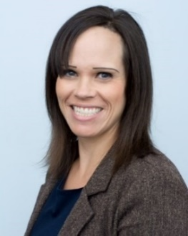
Caryn Nowak, RHIA, CDIP
CDI specialist
Rady Children’s Hospital of San Diego
San Diego, California
cnowak@rchsd.org
Caryn Nowak has more than five years of experience within healthcare and has been a CDI specialist at Rady Children’s Hospital of San Diego for the last two years. Her previous experience includes inpatient and outpatient coding record reviews and education, CDI education and ICD-10 transition projects. Nowak served on the CDI Week Committee last year and has served on the other boards and committees in the past.

Returning Committee Members

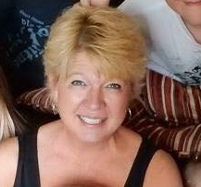
Barbara Brant, MPA, BSN-RN, CCDS, CDIP, CCS
CDI specialist
Cooper Health
Friendsville, Tennessee
Barbarajane.brant@gmail.com
Barbara Brant is a CDI professional with 25 years of clinical nursing experience and more than 13 years’ experience in documentation improvement efforts as a CDI, coder, and auditor. She has worked within health systems as well as outside consulting for documentation and coding improvements. Brant also has a proven ability to lead in the development, training, and implementation of CDI program incentives. With experience working as a Recovery Auditor Contractor (RAC), her passion is the importance of denial prevention and clinical validation for CDI professionals. She currently resides in TN with her husband.

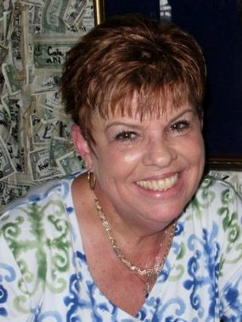
Debra Dallos, CDIP, RN
CDI supervisor
Sarasota Memorial Hospital
Sarasota, Florida
Deb-Dallos@smh.com

Dallos has served the past eight years in a CDI role coming from more than 28 years of experience as a nurse with 22 years in the critical care arena, including the intensive care unit, open heart recovery, post-anesthesia care unit, and ED. She is the current supervisor of a robust CDI program at Sarasota Memorial Hospital, and she is active in the wound care steering committee, provides CDI education to all new incoming medical staff members. Dallos also works hand-in-hand with the CDI physician advisors. She served as chair on unit-based, as well as hospital-wide, practice councils and earned the EXCEL Award at her organization after being nominated by her peers.

Dallos was the president of the Florida ACDIS local chapter for two years, where she coordinated quarterly meetings for one of the largest ACDIS state chapters. Deb completed her role as president of FLACDIS in 2018 and joined the CAB, where she has appreciated learning all the different aspects of chapter management across the country.

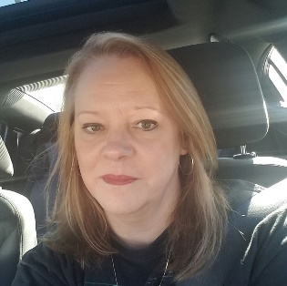
Tamara A. Hicks, RN, BSN, MHA, CCS, CCDS, CCDS-O, ACM
Manager, Care Coordination
Wake Forest Baptist Health
Winston-Salem, NC
thicks@wakehealth.edu

Tamara Hicks is a registered nurse with more than 30 years of experience, 15 years in critical care and more than 16 years in CDI and management. She currently manages the CDI team at Wake Forest Baptist Health, an 885-bed academic medical center and previously served as manager over the case management, social work, and utilization departments.
Hicks is a founding ACDIS advisory board member, a 2019 Conference Committee advisory board liaison, and currently serves on the CCDS and CCDS-O boards advisory board. She has spoken at several local and national ACDIS meetings and was named 2019 CDI Professional of the Year by ACDIS. A member of AHIMA and ACMA, Hicks earned her bachelor’s degree in nursing her master’s degree in health administration with a concentration in leadership and organizational change.

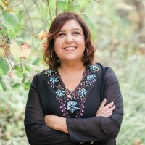
Madhu Subherwal, MHA, MBBS, CCDS, CDIP
CDI manager
Torrance Memorial Medical Center
Torrance, California
Madhulika.Subherwal@tmmc.com
Madhu Subherwal is a physician, completing her medical education from Dayanand Medical College in India. She has been now held her current position for the past three years. She began her journey in CDI in 2010, while completing her master’s degree in health administration from the University of La Verne, capping her education with her thesis “The Importance of Clinical Documentation Improvement Programs and Physician Documentation Practices in the Hospital Setting.”

She is a member of the California ACDIS Chapter leadership team and served on the 2019 Conference Committee. Her personal interests include walking on the beach with her dog, listening to music and attending concerts, and watching movies.

Nurse Planner
Shelia A. Bullock, DHA, BSN, MBA, CCDS, CCS, CAHIMS
Assistant professor/ANCC nurse planner
University of Mississippi Medical Center (UMMC)/ACDIS
Jackson, Mississippi
sabullock@umc.edu
Bullock helped start the CDI program at UMMC in 2007. She previously
served as an ACDIS Advisory Board member from 2009 to 2011, has been a speaker at the
national conference in 2012 and 2015, served as a resource for ACDIS publications such as the
CDI Journal, and currently serves as ACDIS’ nurse planner helping the association ensure its
programs meet the educational standards of the American Nurses Credentialing Center.

