|  |
| --- |
|  |
| **Journal of ACDIS, Maryland Chapter**  **August 2018** |  |

Maryland ACDIS

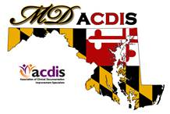

# Upcoming Events

|  |
| --- |
|  |
| **3rd Annual Maryland ACDIS**  **Conference will be Friday,**  **September 14, 2018**  **Next Maryland ACDIS meeting**:  (No August meeting)  October 19  December 7  *All meetings are from*  *12noon - 2p at the Maryland*  *Hospital Association*  **Maryland ACDIS Leadership:**    Deb McClain, President  [dmclain2@fmh.org](mailto:dmclain2@fmh.org)    [Vacant], Vice President    Kyle Gafney, Secretary  [jossik@holycrosshealth.org](mailto:jossik@holycrosshealth.org)  Jill Kirchoffner, Membership  Liaison  [jkirchoffner@umm.edu](mailto:jkirchoffner@umm.edu)  Candace Blankenship,  Education Coordinator  [cblanke4@jhmi.edu](mailto:cblanke4@jhmi.edu) |
|  |

|  |
| --- |
|  |
|  |
|  |

**2018 Annual Maryland ACDIS Conference – registration is closed. No more space available.**

If you registered you should have received email confirmation. If you haven't, please email Mary Plevyak mplevyak@umm.edu

**Preview of the Maryland ACDIS Conference**

Our theme is "Ride the Maryland Waiver!!!" and much of the content will focus on the new Maryland Waiver.

Speakers and topics include:

Justin Ziombra – Director, Maryland Hospital Association

*Medicare Performance Adjustment and Total Cost of Care Programs in the New MD Waiver*

Trish Dasch – Manager of Clinical Documentation Excellence at Johns Hopkins Medical Institute

*New Maryland Waiver Quality Programs*

Carmel Murphy Director of Clinical Documentation Excellence, University of Maryland

*Opportunities in Physician Alignment Initiatives and Tertiary Health care Facilities Using the Population Health Programs in the New MD Waiver*

Trish Kaehne, Certified Yoga Instructor, RN and CDI

*Staying Healthy at Your Desk (Chair Yoga, Ergonomics and Mindfulness)*

 **   **

**Call for Posters!**

The conference committee would like to invite our members to create and display a poster at our 3rd Annual Maryland ACDIS Conference on September 14th.  The poster can be used to highlight a CDI project and its outcomes, good or bad.  The poster can be used to tell the story of the evolution of your CDI team and how you negotiated the “bumps in the road” when dealing with other departments.  The poster can be used to illustrate a CDI concept that has helped you grow in your profession.  These are just some poster ideas.  Use your imagination and have fun!  We are excited to see what everyone is doing around Maryland to elevate the CDI profile and make our profession a valuable resource for health care providers.  If you are interested in submitting a poster, please email Candace at [cblanke4@jhmi.edu](mailto:cblanke4@jhmi.edu).

We will also have a continuous slide presentation scrolling during the breaks.  If you would like to submit a slide for this project, please contact Candace Blankenship at [cblanke4@jhmi.edu](mailto:cblanke4@jhmi.edu).  The slide can be a picture of your team, your team’s mission statement, a synopsis of a CDI team project or your favorite query. Our maybe you would like to thank someone on your team.  Use your imagination and have fun!

A prize will be awarded to the winning poster team and Maryland ACDIS will sponsor your application to display the poster at the national conference.  Good luck!

**Questions from our Members**

1. **Coding Z515 Palliative Care**

One of our members posed the following question:

Do you code Z515 palliative care when the patient is being discharged to hospice, even if palliative care was not initiated per se while in the hospital?  Do you know what any of the other hospitals are doing?  I’ve heard some places only code if initiated during the hospital admission and some code based on a discharge to hospice.

We thought this was probably a question many of you have asked which is why we're including the responses here. It's an important topic because the code Z515 is a huge risk adjustor for mortality.

Three quarters of the responding hospitals said that they code the Z515 if a patient is discharged to hospice.

Teresa Krepps responded, "I sent the “discharged to hospice” scenario to 3M nosology and they recommended assigning the Palliative Care code." Teresa added the caveat that 3M nosology advice is not considered official coding guidance. Only advice from the four cooperating parties is considered “official” (AHA, AHIMA, CMS, AMA).

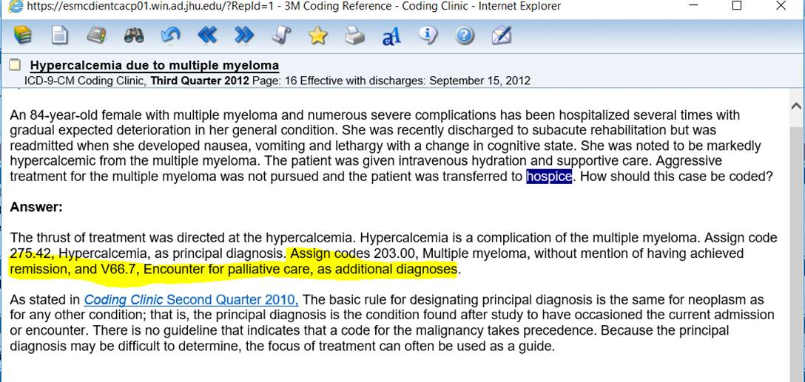

Another question came up about whether Z515 is a global exclusion if it's N POA. Thank you Trish Dasch for responding, "Yes this is still an exclusion this year due to not having the POA for these codes for a full year in the base year data" However, Andrea Norris stated, "My guess is that it will not be a PPC exclusion next year unless it is POA Y. ☹

# Encephalopathy guidelines

From Maria Moore, Western Maryland Health System

I need to establish some guidelines for encephalopathy. We have just had a rash of encephalopathy PPCs and we need to do something about it.

Would you ask the group if anyone has guidelines they have and are willing to share, or any insights as to what they do with this diagnosis as a PPC?

Please respond to mmoore@wmhs.com



|  |
| --- |
|  |

**Current Leadership positions**

# As mentioned before, the leadership team has decided to table the voting on leadership positions until the fall as we work out a process that is inclusive of all members of our group. In the meantime we ask that you begin to think about ways that you can become a more active member of our group either by assisting in the voting process or consideration of joining our leadership team. All new board members will be mentored into their role by current and past leadership team members.

# Link to the new Maryland Waiver

# <http://www.hscrc.state.md.us/Documents/Modernization/TCOC-State-Agreement-CMMI-FINAL-Signed-07092018.pdf>

# Change in results reporting for CCDS exam

It was recently brought to our attention that if you are taking the CCDS exam, you will not receive your exam results immediately as in the past. You may have to wait up to 6 weeks for your results.

Update: Fortunately the delay in reporting exam results was a temporary one and this is no longer an issue.

The Maryland ACDIS Leadership team is drafting a letter to ACDIS expressing our concerns regarding the lack of communication from ACDIS. Every member of ACDIS receives an abundance of emails and post mail regarding upcoming events, courses, and other commercial content.  It would seem that communications regarding something as critical as changes in the CCDS test reporting would be a priority. Certification and CEUs are one of the important benefits of membership and for many of us, one of the most important reasons to justify the cost of membership. Any response we receive to our letter of concern will be shared with you.

# National ACDIS contacts:

Current HCPro Representative: Caison Morisey, Senior Account Executive/Maryland Chapter Rep

1-800-650-6787 ext. 8108, [cmorisey@hcpro.com](mailto:cmorisey@hcpro.com)

Mike Bryant, Retention Account Representative, 1- 800-650-6787 ext. 8127, [mbryant@hcpro.com](mailto:mbryant@hcpro.com)

***2017 Renewal Rate for MD ACDIS Members-$107***