|  |
| --- |
|  |
| Journal of ACDIS, Maryland Chapter  July 2018 |  |

Maryland ACDIS

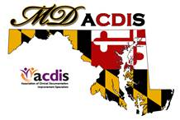

# Upcoming Events

|  |
| --- |
|  |
| **3rd Annual Maryland ACDIS**  **Conference will be Friday,**  **September 14, 2018**  **Next Maryland ACDIS meeting**:    No August meeting  October 19  December 7  *All meetings are from*  *12p - 2p at the Maryland*  *Hospital Association*  **Maryland ACDIS Leadership:**    Deb McClain, President  [dmclain2@fmh.org](mailto:dmclain2@fmh.org)    [Vacant], Vice President    Kyle Gafney, Secretary  [jossik@holycrosshealth.org](mailto:jossik@holycrosshealth.org)  Jill Kirchoffner, Membership  Liaison  [jkirchoffner@umm.edu](mailto:jkirchoffner@umm.edu)  Candace Blankenship,  Education Coordinator  [cblanke4@jhmi.edu](mailto:cblanke4@jhmi.edu) |
|  |

|  |
| --- |
|  |
|  |
|  |

**2018 Annual Maryland ACDIS Conference**

Where: St. Joseph's Medical Center in Baltimore

Breakfast and lunch will be provided

The venue will accommodate 120 people.

Registration forms were sent out in June; registration is first come, first served.

Contact Candace Blankenship [cblanke4@jhmi.edu](mailto:cblanke4@jhmi.edu) if you need a registration form.

Cost: $35. Attendees will receive 4 CEUs.

**Highlights from the June CCDS Exam Prep**

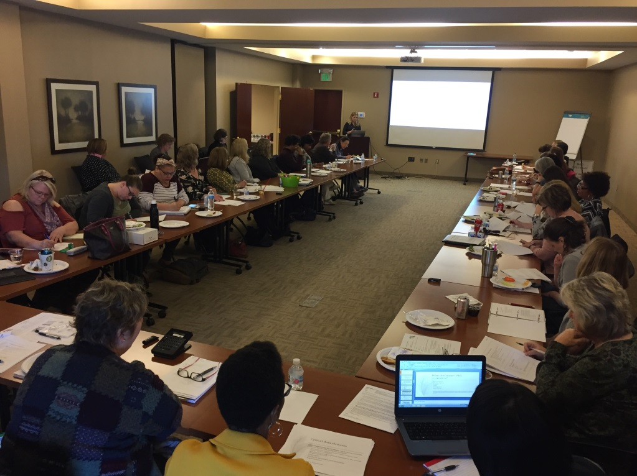

Photos above and below from the April CCDS exam review.

A HUGE shout out to Candace Blankenship for coordinating another amazing event and presentation of the CCDS Exam Prep for Maryland test candidates. Thank you to Teresa Krepps and Teri Gruenberg for your presentations and assistance in such a successful event.

Words of wisdom and encouragement from Heather Breidigam:

Please pass along to all the folks to study that book for the CCDS exam and go OVER and OVER that practice exam they give you for the CCDS exam. I found when I took the exam last year that there were a ton of question from the practice exam. I can't tell you how many times I took that. I did it on my phone about 2 -3 times/day and in the exam I saw the same exact questions on the exam!!!! Also my other tip is DON'T SLOW DOWN...you really have to motor to get through it all.

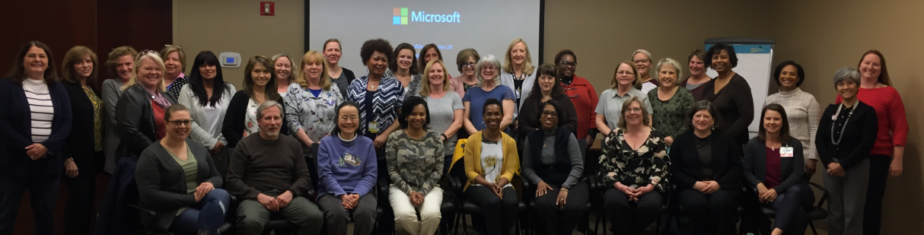

**It’s that time of the year again….**

We currently have over 220 people on our distribution list, with 5 Board Members. Finding members willing to commit to leadership positions is a never ending challenge, and we are facing a challenging year ahead. In order to maintain the level of energy and involvement that our group is known for, it takes many people. The more volunteers we have, the lighter the work load is on all.

Currently vacant is the Vice-President position which has remained unfilled from last year. This year, we will need to fill the Membership Liaison and the Secretarial positions. The Membership Liaison reaches out to new members with information regarding Maryland ACDIS via email and helps to maintain a membership contact list. In the past, membership is an area where we have struggled to define and quantify. If you have ideas on how to improve this area of our group, we are very interested in hearing from you. The Secretarial position sounds scarier than it is. If you think you might be interested but are worried about the time commitment or duties, please contact Deb. Kyle promises to be available as a resource to the new Secretary.

If you are interested in any of these positions, please contact Deb McClain at [dmcclain2@fmh.org](mailto:dmcclain2@fmh.org).

The annual voting process is behind the timeline set forth in our by-laws. The leadership team has decided to table the voting until the Fall as we work out a process that is inclusive of all members of our group.

**Membership meeting change**

Because of summer vacations and our upcoming Maryland ACDIS Conference, the August membership meeting has been cancelled. The next membership meeting will take place October 19th. I hope that you enjoy the rest of your summer with family and friends celebrating the little things in life. I look forward to seeing you in October, but hopefully sooner at our conference on September 14. Please contact Kyle Gafney [jossik@holycrosshealth.org](mailto:jossik@holycrosshealth.org) with any agenda items for the October meeting.

**Feedback from our members**

We have received feedback from several members who attend our meetings via conference call that it is hard to hear and there is a large amount of background room noise. Please continue to send any suggestions or barriers during the calls so we can continue to work to improve our phone in process.

**Thank you to our members from Deb!**

I want to thank all who responded to my email regarding the release of your name and email contact to ACDIS. This is an expectation of the local ACDIS chapters and I am glad that our group is willing to support both our Maryland ACDIS chapter and the national organization. ACDIS has been supportive of the Maryland ACDIS chapter for many years with a significant discount in membership, free giveaways, CEU offerings and most recently an additional 2018 conference discount.

**National ACDIS Conference**

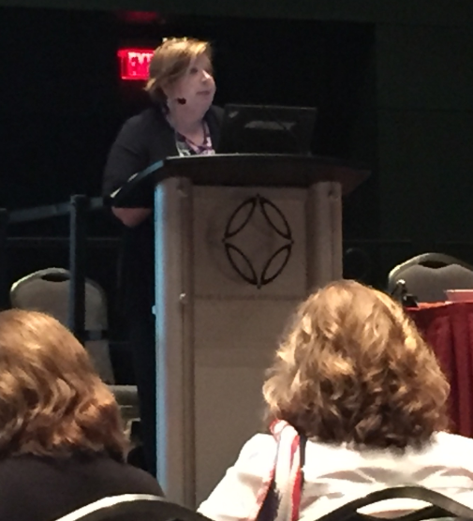

Over 40 Maryland ACDIS members and our DC colleagues attended the 2018 ACDIS conference in San Antonio, Texas at the end of May. This is the third ACDIS conference that I have attended and just when I think ACIDS can’t do any better they raise the bar again. The speakers were phenomenal! Maryland ACDIS was well represented with presentations by Candace Blankenship (pictured right) and Mark Dominessy! Their presentations were stellar and well received.

The beauty of Clinical Documentation Improvement is that there are so many options and areas to use our skills and this conference is a great way to become familiar with some of them. The networking opportunity alone was worth the time away from the desk.

Below: Maryland ACDIS members enjoy a Riverboat tour of the canals.





|  |
| --- |
|  |

# 

# National ACDIS contacts:

Current HCPro Representative: Caison Morisey, Senior Account Executive/Maryland Chapter Rep

1-800-650-6787 ext. 8108, [cmorisey@hcpro.com](mailto:cmorisey@hcpro.com)

Mike Bryant, Retention Account Representative, 1- 800-650-6787 ext. 8127, [mbryant@hcpro.com](mailto:mbryant@hcpro.com)

***2017 Renewal Rate for MD ACDIS Members-$107***