|  |
| --- |
|  |
| **Journal of ACDIS, Maryland Chapter**  **October 2018** |  |

Maryland ACDIS

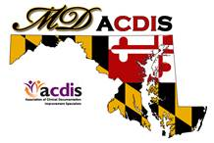

# Upcoming Events

|  |
| --- |
|  |
| **Next Maryland ACDIS**  **meeting**:    **October 19**  The new IPPS rules, APR-DRG  Impact and the new  definitions of MI.  **CEUs will be available**      **December 7**  Annual Pot Luck  Good and Welfare    *All meetings are from*  *12p - 2p at the Maryland*  *Hospital Association*  **Maryland ACDIS Leadership:**    Deb McClain, President  [dmclain2@fmh.org](mailto:dmclain2@fmh.org)    [Vacant], Vice President    Kyle Gafney, Secretary  [jossik@holycrosshealth.org](mailto:jossik@holycrosshealth.org)  Jill Kirchoffner, Membership  Liaison  [jkirchoffner@umm.edu](mailto:jkirchoffner@umm.edu)  Candace Blankenship,  Education Coordinator  [cblanke4@jhmi.edu](mailto:cblanke4@jhmi.edu) |
|  |

|  |
| --- |
|  |
|  |
|  |

**Highlights from the 2018 Annual**

**Maryland ACDIS Conference**

**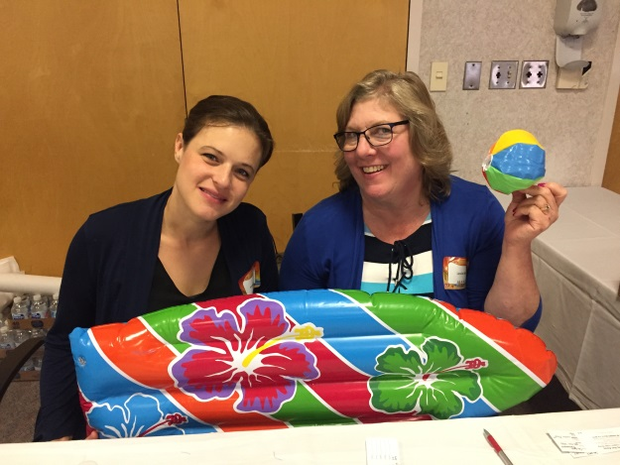**

Angela Roeder and Leslie Barry were busy at the registration table.

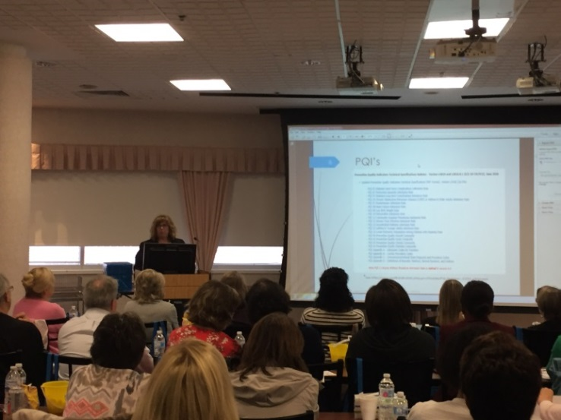

Trish Dasch explains Maryland Waiver Quality Programs

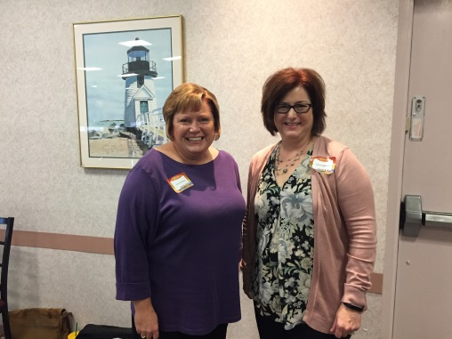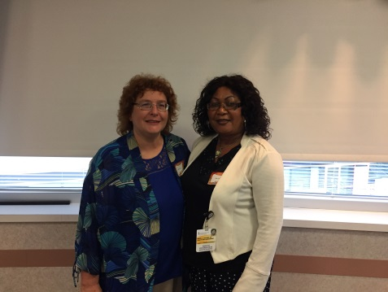

Kathi Ciello from Trust HCS with Denise Applefeld and Lisa Lynn

Ola Chijioke, Winner of the Trust HCS Gray won the CDI Search Visa card

$100 Visa gift card. donated by CDISearch! CDI Search

Trust HCS also sponsored our also paid for everyone's parking!

afternoon break.

# Image

Hand made all occasion cards created and donated by Chelsea Romine and Angie Stone from Johns Hopkins Hospital were won by Alvean Caple

# C:\Users\jossik\AppData\Local\Microsoft\Windows\Temporary Internet Files\Content.Outlook\HN9ZGRP6\IMG_6190.JPG

Jill Kirchoffner with Jacob Lieman from Artifact Health. Jill won the raffle for the Artifact Heath $100 Visa gift card. Artifact Health also sponsored our morning break.

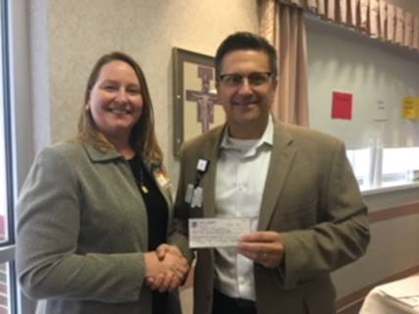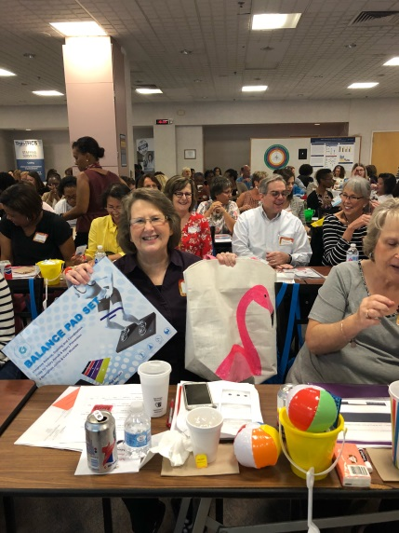 Cristy Bates won the Stay Healthy Maryland ACDIS President presents a $250

At Work gift bag donated by check to Paul Nicholson, Sr. VP and CFO at

Maryland ACDIS St. Joes. It will be used for the Employee

Assistance fund.

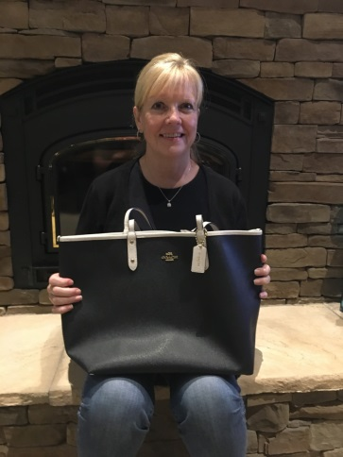

Kathy Baldwin was the very happy winner of

a new Coach bag donated by Matt Turner at Dolby.

Matt will be presenting a free webinar to MD ACDIS

during our February meeting!



Justin Ziombra explains the

Maryland Total Cost of

Care model.

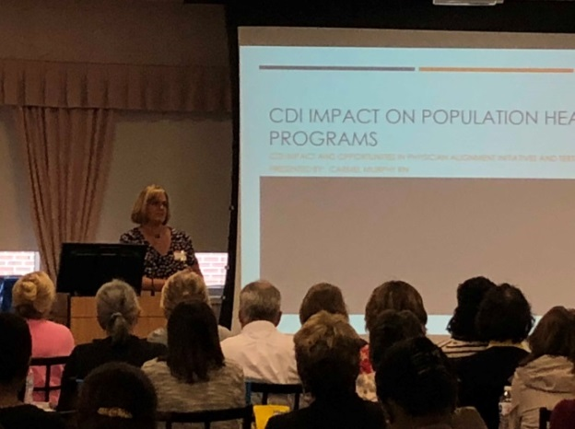 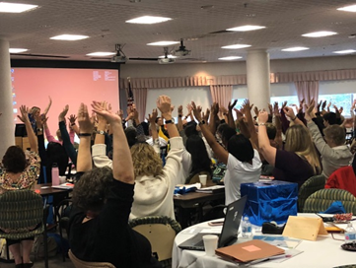

Carmel Murphy enlightens the group Trish Kaehne leads the group in

on CDI Impact on Population Health chair yoga

Programs

# Thank you from the President:

Sometimes “Thank you” just isn’t a big enough word to contain all the gratitude one feels.

Our conference this year was the best one yet! A huge Thank you to Candace Blankenship, Mary Plevyak and Olga Firstbrook for their yearlong effort in planning such a wonderful event. Thank you to Angela Rhoder and Leslie Berry for their diligent work at the check-in table making sure everyone received what they needed while keeping the line moving smoothly. My sincerest gratitude and thanks to Mr. Nicholson and St. Joes for offering to host our conference, their wonderful catering department, and to Mary Plevyak for arranging all of it. Another sincere thank you to our sponsors: Trust HCS, CDI Search Group, Chelsea Romine and Angie Stone, and Artifiact Health for their generosity that allowed for such an amazing day! Without our sponsors, conference fees would be significantly higher with a different atmosphere. Lastly, a special Thank you to our speakers Trish Kaehne, Justin Ziombra, Trish Dasch and Carmel Murphy who donated their time and expertise to talk about Maryland’s Total Cost of Care Model, Maryland Quality Waiver Programs, CDI Impact on Population Health, and to remind us that we too must take care of ourselves while navigating the world of healthcare. Lastly, I would like to thank all who attended our 3rd Annual Maryland ACDIS conference, without your support and participation the conference would not have the positive impact that was felt in that room on September 14th. Networking, mingling, sharing contact information, discussions and problem solving were in the air that day because you came to the conference with an open mind, eagerness to learn and willingness to participate. I hope that each of you can use that energy in the year ahead with our new reimbursement model and continue to create synergy in your success.

# Maryland ACDIS Leadership Elections

This fall will prove to be a busy time for Maryland ACDIS. Most importantly we will soon be facing another round of elections. There hasn’t been much interest in the past by way of volunteers. I am hoping that is not a prediction for the longevity of our group.

We are in immediate need of a few short term volunteers who can serve on the Nominating Committee and we are in search of volunteers who are willing to be mentored into the Membership Liaison, Secretary and Vice-President positions.

More information will be shared at our October meeting. In the meantime, if you have any interests or concerns about our group or volunteering to take an active role, I invite you to share with a member of the Leadership team. Your input is valuable to us and will help determine the direction of our journey moving forward.

# Wow! Wow! Wish!

Candace has wowed us with her skills to create amazing education offerings during our membership meetings. Candace has wowed us with her vision and foresight to produce a conference agenda to coordinate with Maryland’s new CMS waiver.

Now it’s your turn – yes you – the member, the recipient of free CEUs and valuable education. Candace’s wish is for you to forward suggestions for education topics for both membership meetings and the Maryland ACDIS conference in 2019. What do you want to know? What do you want to learn more about? What area of CDI is most important to you? Please forward any and all ideas to Candace at cblanke4@jhmi.edu

# Maryland ACDIS member concerns

I recently had a wonderful conversation with Melissa Varnavass at ACDIS and shared the multiple concerns that I have received from Maryland members. Melissa was attentive to our concerns regarding the exam announcement of delayed score reports, intense marketing by national, and overall concern in regards to National members. After an engaging conversation, Melissa’s intent was to take our concerns back to her group and other leaders at the national level. She acknowledged that some of the control was not hers but she was willing to convey our concerns to the appropriate offices.

Melissa also welcomed anyone with concerns to contact her or other leaders at ACDIS directly to share how you are feeling as members and what exactly your concerns are. I cannot speak for everyone who shared concerns with me to pass along, but I do agree that it seems like ACDIS has grown at a very fast rate for many years and may not have connections with those of us in the trenches. I am not sure if that is true or not, or just a feeling that some of us experience from time to time.

With Melissa’s offer on the table, I encourage you to share your individual concerns when they arise directly with Melissa at [mvarnavas@acdis.org](mailto:mvarnavas@cdiassociation.com). I still encourage you to share your concerns with Maryland ACDIS Leadership members so that we may support you and stay current with concerns with the national organization and locally within our chapter.

# ACDIS Membership Renewal and Chapter Information

It's that time of the year again when most of the Maryland ACDIS members are due for renewal at National ACDIS. Just a few reminders about renewals:

\*Don’t forget to renew with your Maryland discounted price of $107. It is probably best to contact Mike Bryant directly (see the section National ACDIS Contacts on page 7).

\*Don’t forget to go to the Local Chapters page on the ACDIS website to update your information as a Maryland Chapter member. This is a benefit offered from ACDIS to the local chapters to assist in tracking local membership as well as demonstrate to the national organization how strong the local chapters are, their growth, and representation. From this link <https://acdis.org/chapters/new>

Scroll down to #6 under the Getting Started section and click the link for “Online membership roster”. Please fill out the information and click Submit at the bottom of the form. Many of you may have done this in the past, or maybe never. It is a good habit to make it part of your national renewal so that your chapter information stays current.

# ACDIS Radio is now a pod cast

You can subscribe on iTunes or google Podcast ACDIS Radio to access past broadcasts. Recent topics include:

4th Universal Definition of MI

Encephalopathy

CDI technology

Gray areas in coding

ACDIS conference preview: Mortality scores and quality data

## Listen to the Archives (I found it very easy, and free! to access)

| [**Title**](https://acdis.org/acdis-radio?order=title&sort=asc) | [**Date[sort ascending](https://acdis.org/acdis-radio?order=field_date&sort=asc)**](https://acdis.org/acdis-radio?order=field_date&sort=asc) | **Category** |
| --- | --- | --- |
| [4th Universal Definition of MI](https://acdis.org/acdis-radio/4th-universal-definition-mi) | August 29, 2018 | [Clinical & Coding](https://acdis.org/taxonomy/term/4), [News](https://acdis.org/taxonomy/term/5) |
| [Encephalopathy](https://acdis.org/acdis-radio/encephalopathy-0) | August 15, 2018 | [Clinical & Coding](https://acdis.org/taxonomy/term/4), [Regulations](https://acdis.org/taxonomy/term/9) |
| [Applying to speak at the 2019 ACDIS conference](https://acdis.org/acdis-radio/applying-speak-2019-acdis-conference) | August 1, 2018 | [ACDIS Guidance](https://acdis.org/taxonomy/term/1), [Education-Physicians & CDI](https://acdis.org/taxonomy/term/97) |
| [CDI technology](https://acdis.org/acdis-radio/cdi-technology) | July 18, 2018 | [CDI Expansion](https://acdis.org/taxonomy/term/3), [News](https://acdis.org/taxonomy/term/5) |
| [100th episode: CDI past, present, and future](https://acdis.org/acdis-radio/100th-episode-cdi-past-present-and-future) | June 27, 2018 | [Ask ACDIS](https://acdis.org/taxonomy/term/96), [CDI Expansion](https://acdis.org/taxonomy/term/3) |
| [Gray areas in coding](https://acdis.org/acdis-radio/gray-areas-coding) | June 20, 2018 | [Clinical & Coding](https://acdis.org/taxonomy/term/4), [Quality](https://acdis.org/taxonomy/term/8) |
| [ACDIS conference recap: Malnutrition audit](https://acdis.org/acdis-radio/acdis-conference-recap-malnutrition-audit) | June 6, 2018 | [ACDIS Guidance](https://acdis.org/taxonomy/term/1), [Regulations](https://acdis.org/taxonomy/term/9) |
| [ACDIS Conference Sendoff](https://acdis.org/acdis-radio/acdis-conference-sendoff) | May 16, 2018 | [Ask ACDIS](https://acdis.org/taxonomy/term/96), [CDI Management](https://acdis.org/taxonomy/term/2), [Clinical & Coding](https://acdis.org/taxonomy/term/4) |
| [ACDIS conference preview: Pediatric surgery](https://acdis.org/acdis-radio/acdis-conference-preview-pediatric-surgery) | May 10, 2018 | [CDI Expansion](https://acdis.org/taxonomy/term/3), [Clinical & Coding](https://acdis.org/taxonomy/term/4) |
| [ACDIS conference preview: Mortality scores and quality data](https://acdis.org/acdis-radio/acdis-conference-preview-mortality-scores-and-quality-data) | April 25, 2018 | [Quality](https://acdis.org/taxonomy/term/8) |

# Job openings:

Job Posting 782016 – Facility Clinical Investigator – US Telecommute

The role involves investigating, reviewing and providing clinical and / or inpatient facility DRG coding expertise in the application of medical and reimbursement policies within the claim adjudication process through file review.  APR-DRG experience is a must. If anyone is interested, they can visit the United Health Group website for further information and to apply.

National ACDIS contacts:



|  |
| --- |
|  |

Current HCPro Representative: Caison Morisey, Senior Account Executive/Maryland Chapter Rep

1-800-650-6787 ext. 8108, [cmorisey@hcpro.com](mailto:cmorisey@hcpro.com)

Mike Bryant, Retention Account Representative, 1- 800-650-6787 ext. 8127, [mbryant@hcpro.com](mailto:mbryant@hcpro.com)

\*\*\*2017 Renewal Rate for MD ACDIS Members-$107\*\*\*