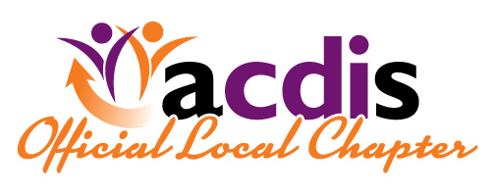

***ACDIS NW***

August 2018 Edition

What’s in the Newsletter:

1. President Resignation
2. Fall 2018 Conference Information
3. Hotel Recommendations
4. Volunteer/Nomination Form
5. Raffle Charity – Guardian Group and Conference Sponor
6. Fall Conference Registration
7. Lori announced last month she has been offered a wonderful CDI opportunity at Stanford in California providing physician education and thereby submitted her resignation as President. She expressed it has been a tremendous pleasure to serve as President and being a part of the Spring Conference.
8. FALL 2018 Conference, October 19th at St. Charles Medical Center, Bend Oregon

Conference Rooms A&B at Main Entrance

7:15 – 7:45 Registration/Continental Breakfast

7:45 – 8:00 Welcome/Facility Overview/Intro to Raffle and Charity

8:00 – 8:55 Abdominal Trauma/Injuries Management by Dr. Andrew Riggle

9:00 – 10:00 HACs/PSIs – Linda Dawson, Teri Garrett

10:00 – 10:15 Break, Raffle

10:15 – 10:45 HACs/PSIs Panel Discussion – Linda Dawson, Ellen Jantzer, Catherine Trevis

10:45 – 11:00 Vendor Presentation

11:00 – 11:30 Business meeting

11:30 – 12:30 Lunch, Raffle, Networking

12:30 – 1:55 Stroke Management by Dr. Steve Goins, Marsha Noone-Boyd, RN, Beth

2:00 – 3:00 Outpatient CDI presentation – Monique Vanderhoof

3:00 – 3:30 Panel Discussion – Monique Vanderhoof, Ellen Jantzer

Assorted pastries for continental breakfast

Boxed lunch w/assorted beverages.

C. Hotels in the Area:

We have negotiated for a rate at Comfort Inn and Suites for night of Thursday October 18 at $80.00 plus tax for a King and $90.00 plus tax for a 2-Queen room. A limited number of rooms are reserved for our event and are first come first serve for the special rate. When you call be sure and reference NW ACDIS. The Comfort Inn is the closest hotel to the St. Charles Hospital approx. 5 minutes / 1.2 miles.

Comfort Inn & Suites 62065 Se 27th Street Bend Or, 97701 (541)617-9696 <https://www.choicehotels.com/oregon/bend/comfort-inn-hotels/or135?source=gyxt>

Some other considerations no special rate negotiated:

Hampton Inn & Suites Bend 730 SW Columbia Street, Bend, Oregon 97702 (541) 388-3000 http://hamptoninn3.hilton.com/en/hotels/oregon/hampton-inn-and-suites-bend-RDMBEHX/index.html

The Oxford Hotel 10 NW Minnesota Ave. Bend, Oregon 97703 541-382-8436 https://www.oxfordhotelbend.com/

Double Tree Hilton 300 NW Franklin Avenue, Bend Oregon 97701 (541) 317-9292 http://doubletree3.hilton.com/en/hotels/oregon/doubletree-by-hilton-hotel-bend-RDMFADT/index.html

Sunriver Resort 17600 Center Dr., Sunriver, OR 97707 (855) 420-8206. (Sunriver is about 20 miles South of Bend) https://www.destinationhotels.com/sunriver-resort?&utm_source=GoogleMyBusiness&utm_medium=organic&utm_campaign=GMB&utm_term=SUNR

Riverhouse on the Deschutes 3075 N. Business Hwy. 97 Bend, Or. 97703 reservations (866) 453-4480 http://www.riverhouse.com/index

Bend Chamber of Commerce has more lodging listed and a lot of great information for visitors. https://business.bendchamber.org/list/QL/lodging-travel-15

D. During our Fall Conference Chapter meeting we will be Electing officers to begin their term in January of 2019. The Nomination Form is attached to this newsletter. I encourage you to consider a volunteer position or nominate someone you know who would interested in serving on the board. We will appreciate your entries!

E. The raffle charity chosen by St. Charles Medical Center is The Guardian Group whose mission is to prevent and disrupt the sex trafficking of women and children while enabling partners to identify victims and predators in the United States.

**Overview:** Guardian Group is a veteran run 501(c)3 headquartered here in Bend, Oregon operating nationally with the vision of eradicating sex trafficking throughout the United States. Members of the military special operations, law enforcement and intelligence work alongside resource-constrained law enforcement agencies to provide training and fill the gaps they may have in pursuing this crime; focus on hospitality industry training through the [Guardian Seal® Training Program](https://na01.safelinks.protection.outlook.com/?url=https%3A%2F%2Ftheguardiangroup.org%2Fseal%2F&data=02%7C01%7Cmsiebert%40lhs.org%7Caeca15f1b9ec42fbe07e08d603c6f869%7C3683988d7d404338bf200b5dd13f4301%7C0%7C0%7C636700550447572851&sdata=AWM0v1alKAW%2FB9dD%2FMRRJtwXga0aFyJE%2BTV3fB6eKtE%3D&reserved=0); and disrupt the exploitation cycle before rescue becomes necessary. The Guardian Group believes the rescue and recovery of children is paramount.

Our Conference sponsor: Decision Health

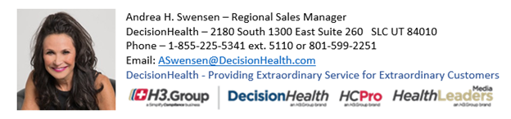

F. Registration Form

Please respond by email to [Linda.Dawson@providence.org](mailto:Linda.Dawson@providence.org) to inform us you will be registering at the door. **We need a head count for the continental breakfast and lunch preparations.**

**Five ACDIS CEU credits will be submitted for approval.**

Please mail registration form to:

Linda Dawson, 2419 SW Crestwood Place, Dallas, OR 97338

Or email your registration to [**Linda.Dawson@providence.org**](mailto:Linda.Dawson@providence.org) and pay at the registration desk

Cost: $20.00 for ACDIS NW members who have paid membership renewal at Spring Conference

$45.00 for ACDIS NW - membership renewal and conference

$45.00 for non-members (AHIMA members w/o ACDIS membership.)

Please fill out the information below. Deadline for registration is October 13th.

Name: ____________________________________________________

Hospital: ___________________________________________________

Attending: Yes_____________ No: ________________

Telephone: _________________________

Email: ______________________________________

Would you be interested in hosting a meeting at your facility?

Please comment here: _________________________________________