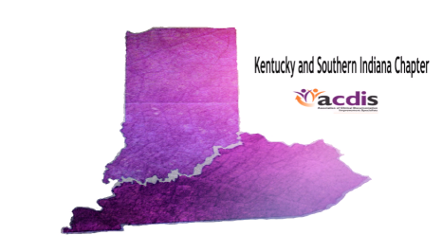

**Meeting:** **Kentucky/Southern Indiana Chapter**

**Date: November 16, 2018**

**Location: Norton Hospital-Wade Mountz Auditorium**

**AGENDA**

**1300-1315: Sign in/meet and greet**

**1315-1330: Recap of the ACDIS Regional Conference held in August**

**1330-1430: Rita Fields BSN, RN, CCDS and Susanne Warford MBA, RN, CCDS “Is Your Outpatient Query Process Compliant”**

**1430-1445: Break**

**1445-1545: Dr. Amith Roy Shamir “AKI definition and evaluation”**

**1545: Business Update/Close of Meeting**