

# FL ACDIS Quarterly Conference

Cape Coral Hospital

636 Del Prado Blvd Cape Coral, FL 33990

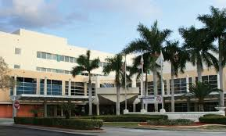

**Please RSVP to:**

Jillian Bisbe

Phone: 239-343-8110

**Cell:** 239-672-0986

E-mail: [jillian.bisbe@leehealth.org](mailto:jillian.bisbe@leehealth.org)

**Accommodations**:

The Westin Cape Coral Resort at Marina Village

5951 Silver King Blvd, Cape Coral, FL 33914

(866) 837-4278

Rate code: SET #410535

SETLEEMH

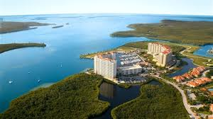

Welcome Reception Pinchers Crab Shack

** (Located at the Westin Cape Coral Resort at Marina Village)

Friday April 6th, 7-9pm ~please RSVP to Jillian Bisbe

*Light Appetizers will be provided*

|  |  |
| --- | --- |
| 0715-0800 | Registration and Breakfast  (kindly provided by EXCITE) |
| 0800-0830 | Welcome & Introductions- Jillian Bisbe |
| 0830-0900 | Scott Kashman, Chief Acute Care Officer Lee Health - Mindful Healthcare |
| 0900-1000 | Dr. Jon Elion-Outpatient CDI |
| 1000-1015 | Break |
| 1015-11-15 | Dr. Hooshang Bolooki- CDI & Cardiology |
| 1115-1130 | Announcement of New Board Members/Raffles  Deb Dallos |
| 1130-1230 | Working Lunch-(kindly provided by 3m)-Jeopardy! |
| 1230-1330 | Denise LaRue, RHIA, CCS, Inpatient Quality Coding Auditor, Sarasota Memorial Hospital  “Inpatient Quality Coding- It’s not just about what you get paid” |
| 1330-1400 | Raffles/Break (kindly provided by Harmony Healthcare) |
| 1400-1500 | Anny Yuen, RHIA, CCS, CCDS, CDIP-Outpatient CDI |
| 1500-1530 | Question & Answer/Comments/Closing Remarks |

**Agenda Saturday April 7th**