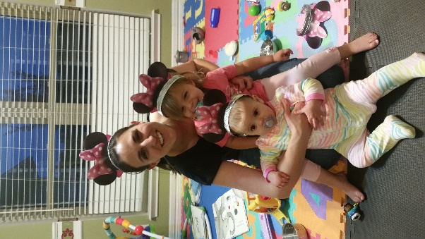Jennifer Cooper, MHIIM, RHIA, CDIP, CCS

Coding and CDI manager

Hunt Regional Healthcare

Greenville, Texas

P: 903-453-6163

E: [jcooper@huntregional.org](mailto:jcooper@huntregional.org)

Hello everyone!  I am very excited to be joining this group of people to plan for the 2018 ACDIS conference in San Antonio - yeehaw! I have been able to attend the past two conferences which were great experiences so I hope by contributing to this team I can help make it great for new comers and seasoned attendees.

First, I have a health information management (HIM) background, so a little different than many of the nurses I have come to know through ACDIS. I have been at this facility for seven years with two of those years as a coder, one year as a CDI specialist, and the last four years as the manager. In 2012, I helped develop our home-grown CDI program with our coordinated care department. We started doing the "typical" inpatient reviews for CC/MCC capture/DRG optimization. Since that time, we have started reviewing all payers with the focus shifting to quality and clinical validation. I am in the process of trying to explore our observation population by collaborating with case management to see what opportunities might be there. A lot of what I have been able to do with our CDI program is because of the resources ACDIS provides. I will also note that I am currently a leader for the Texas Chapter that is starting back up - another exciting venture!

Fun fact(s): Surprisingly, I am not from Texas, but I can talk to the talk. My husband and I, married seven years have two precious girls age 2 years and 10 months).  We are busy, but I thrive on that!  I don't like to be bored!

I look forward to working with y'all!

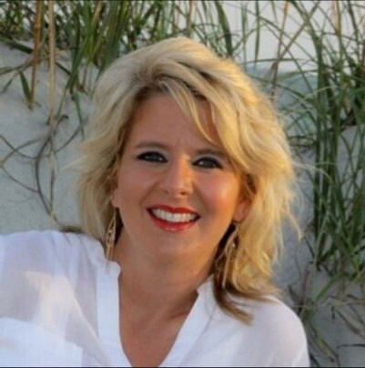

Vicki Sullivan Davis, RN

System-wide manager of CDI

Valley Health System

Las Vegas

P: 336-343-3327

E: [vicki.davis@uhsinc.com](mailto:vicki.davis@uhsinc.com)

Vicki S. Davis, RN, is the system CDI manager for The Valley Health System in Nevada. She has 20 years of nursing experience in various practice settings including telemetry, critical care, LTAC, SNF, and utilization review, and acute/complex case management. Davis has 15 years of advanced leadership expertise, including serving as a director of nursing, clinical supervisor, and acute inpatient nursing leadership. She was awarded The Nursing Excellence Award in 2016 which designated her in the top 1% of nursing for the seven-hospital system out of 9,000 nursing employees. Davis has been a part of ACDIS since 2011 in various roles including being a presenter at the NC ACDIS Chapter in 2013 and ACDIS national presenter at the ACDIS conferences in 2012, 2013, and 2014. Her expertise is in innovating CDI, mortality, and leadership. Her current projects include CDI expansion into outpatient/ED, leading the Nevada Local ACDIS Chapter, participating in the ACDIS Leadership Summit 2017, and joining the ACDIS 2018 Conference Committee.

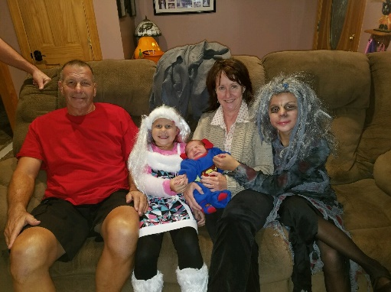Margaret Foley, PhD, CCS, RHIA

Associate Professor

Temple University

Philadelphia, Pennsylvania

P: 215-204-5815

E: [mfoley01@temple.edu](mailto:mfoley01@temple.edu)

My full-time job is an HIM instructor at Temple University in Philadelphia where I teach coding and other courses. On a part-time basis, I do pre-billing review (auditing) of inpatient coding at the Hospital of the University of Pennsylvania. In this role, I often recommend queries. I have only been an ACDIS member for a few years and am looking forward to getting more involved.

Fun Facts: My husband, Ed, and I live in Riverton, New Jersey, a suburb of Philadelphia and spend lots of time at the south Jersey Shore (very different than the Jersey Shore on TV).  The photo I’m sending along is of us with Ed’s three grandchildren from last Halloween.

LaDonna Harbour, RN, CCS, CDIP, CCDS

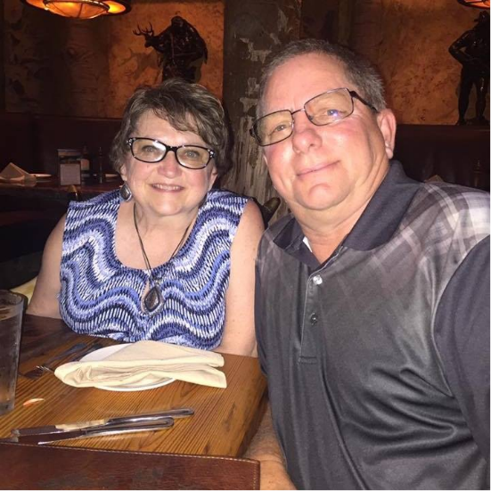Stillwater Medical Center

Stillwater, Oklahoma

P: 405-742-5352

E: [lharbour@stillwater-medical.org](mailto:lharbour@stillwater-medical.org)

What a great honor it is to be able to work with such talented and experienced people.  I am so excited to be working with all of you on the 2018 ACDIS Conference.

I am an RN, and have been in the nursing field since 1979. I was an LPN first and then in 1991 I received my RN degree. Most of my experience was in the ED, then I became the ER manager. I became the compliance director over several departments including HIM. I am currently the documentation integrity and compliance supervisor for Stillwater Medical Center which was named one of the Best Places to Work. I manage the CDI program, inpatient and outpatient, as well as denials.

I am currently starting an outpatient CDI program and am excited about the progress we’ve made. We have four beta clinics and although we’re in our infancy portion we’re having great results so far. I currently have one inpatient CDI (me) and two RHIT outpatient CDI staff. I feel that a diversified team works well. RHITs do well in the outpatient setting.

I have been in CDI for five years and look forward to continuing on this exciting career path.

Fun Fact: I am married to the most wonderful husband of 34 years, have three grown children, and 13 grandchildren with another on the way in August. I am a dachshund lover and have two, named Jaxson and Sassy. I have several certifications, CCDS, CCS, CDIP, and ACM, and am studying for the CCS-P. I hope to start an ACDIS group in Oklahoma sometime this year.

Again, I am so excited about meeting each and every one of you, and the opportunity to plan the upcoming conference. I was fortunate to have attended two conferences in the past, and last year’s was exceptional.

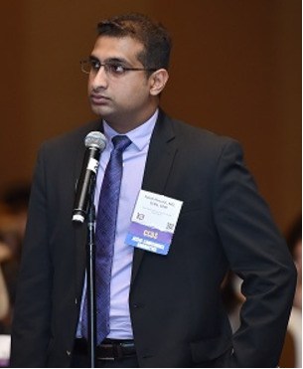Faisal Hussain, MD, CCDS, CDIP

Corporate Director, Clinical Documentation Improvement

Community Health Systems

Franklin, TN

P: (201) 884-0284

E: [smfaisalhussain@hotmail.com](mailto:faisal.hussain@rwjbh.org)

It is an absolute honor, and a privilege, to be a part of 2018 ACDIS Conference Committee. I was involved last year, too, and am happy to see some familiar names that I had the pleasure of working with at that time. I also welcome the members who are doing this for the first time. I am sure we will work together to make the 2018 conference a huge success!

As for my current role, I am a corporate director for clinical documentation improvement for large multi-facility hospital system, named Community Health Systems (CHS). We have around 140 hospitals in about 32 states.

Not so fun fact(s): I just moved from NY/NJ to Nashville, and am experiencing the south for the first time. It is obviously very different, but the niceness of people here is making it easier to adapt to the new environment. Also, am a full-time father of a 17-month old daughter, who keeps me and my wife super busy! Look forward to working with you all (or should I say y'all!).

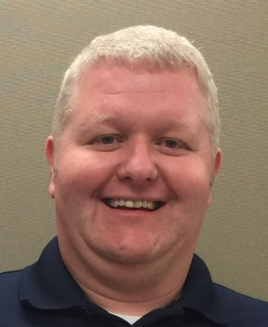Jeffrey Wayne Morris, RN, CCDS

CDI Supervisor

University of South Alabama Health System

[jwmorris@health.southalabama.edu](mailto:jwmorris@health.southalabama.edu)

I am so happy to be a part of the 2018 Conference Committee with you all (y’all for southerners) and look forward to working with everyone! I am the CDI supervisor for the University of South AL Health System comprised of Children’s and Women’s Hospital (one of only a few freestanding hospitals that combine children and women) and USA Medical Center (trauma, burns, adults).

I’ve been a nurse for 20 years and in CDI for five. I am still new to CDI management with only one year in this role. I am a huge advocate of a diversified CDI field and hope to have a blended team one day in the future. I co-presented at last year’s conference on CDI in OB-GYN and served on the Forms & Tools Committee about four years ago. I am also one of the leaders for the AL ACDIS Chapter and am very proud that we have our chapter back up and running.

Fun Facts: I am married with two boys—8 and 4 and we spend every free minute at the beach. There’s not a lot to do in south Alabama but we are only about 45-50 minutes away from Orange Beach and Gulf Shores. Our goal is to live on the water someday.

Again, I can’t wait to meet you all and plan this great conference we have every year! I have been fortunate to attend the last three conferences and gain new friends each year. I often say there’s not a problem that a group of CDI specialists can’t solve!

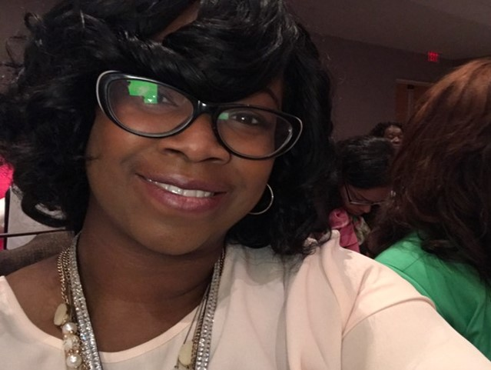

Chaka T. Prior, MPA, BSN, RN, CDIP

CDI Manager

Piedmont HealthCare

Atlanta

P: 404-861-7980

E: [Chaka.Prior@Piedmont.org](mailto:Chaka.Prior@Piedmont.org)

Personal Email: [Cprior3@gmail.com](mailto:Cprior3@gmail.com)

I attended the 2016 and 2017 conferences. I really liked the structure of the itineraries. The breaks were sufficient; and the overall structure worked extremely well in relation to navigating the venues and allowing time for networking and refueling.

I did at times find myself missing a few sessions I would have preferred to make due to how the sessions were arranged. For example, having three sessions of interest all scheduled at the same time. I'm not sure if there is a way to avoid that for such a large volume of participants, but thought I'd mention it.

The topics have been typically great. Q&A portions often included many questions from smaller programs/facilities on how to get started or how approach certain needs. A session geared towards novice programs may be useful.

I attended the session for training residents and that was excellent this year. Any opportunities with a roadmap to training physicians or assisting physician advisors in peer-to-peer training may be useful. Also, with the multitude of changes in healthcare related to pay-for-performance and quality of care, any presentations that speak to a hybrid type CDI program (with components of quality and case management) may be useful to larger systems and advanced programs.

My individual interests align with denials and compliance. I also think any opportunities to learn techniques of marketing CDI for chart completion from an organizational approach is tremendous. There was a session in 2016 that spoke of creating a task force that included all disciplines in healthcare. A session that spoke to something similar could be valuable to many.

The year of collaboration!

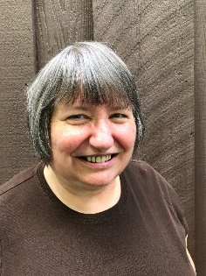Teri Ryan RN, BSN, MBA, CCDS

Clinical Documentation Quality Reviewer

Aurora Health Care

Milwaukee, WI

O: 414-379-9158

E: [teri.ryan@aurora.org](mailto:teri.ryan@aurora.org)

I am delighted to work with everyone on the 2018 ACDIS National Conference!  I was fortunately part of the 2017 team, and really enjoyed it. I’m sure to have a similar experience this year.

I am an RN with an MBA, so my background is pretty eclectic. Clinical experience includes primarily medical/respiratory ICU (but I also worked on surgical, neurosurgical, and some cardiac), transplant (I served on a liver/kidney/pancreas transplant team, which was rewarding) and ED. I also worked in the medical device industry as a product manager and clinical quality/education specialist. I have been in CDI for about 10 years, and CCDS certified around for about seven years. Currently, my title is clinical documentation quality reviewer which entails “reviewing the reviewers,” and supporting the staff with education and other related activities, development of tools for staff and provider education, and review of data for metrics. It keeps me busy!

Fun Facts: I am terminally single, no kids, but have a blast with my nieces and nephews, who keep me young at heart. I also have a great 13 ½ year old dog, named Louie after a great uncle who lived to be over 100 years old. In dog years, Louie is 94.5. Hopefully he will beat Uncle Louie’s record, and live way past 100!

_____________________________________________________________________________________

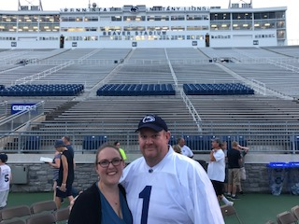Courtney Spangler, RN

CDI specialist

WellSpan

Gettysburg, Pennsylvania

P: 717-385-7572

E: [curveball68@yahoo.com](mailto:curveball68@yahoo.com)

I've CDI nurse for three years now. I still feel so green in this field but absolutely love the daily challenges, provider conversations, and learning about the opportunities I have in this role.

I was a critical care nurse for six years before entering the CDI field, but still work PRN to keep my skills and critical thinking sharp. I work at a small community hospital-WellSpan Gettysburg-which is part of a larger network including a level 1 trauma center.

I had the opportunity to attend the ACDIS 2016 Conference in Atlanta. While there, it was just enveloping and inspiring-something I hope to pass on to 2018 attendees. It really helped rejuvenate my passion in CDI and realize that my challenges are not unique, plus it offered me all sorts of ideas to implement when I returned to work.

Fun Facts: I am married to my wonderful husband, Mark, and we are celebrating 10 years in January. I'm super excited about that!! We are avid Penn State fanatics so I included our picture from Beaver Stadium -standing on the 45-yard line. We have two basset hounds-George and Fred-that I spoil relentlessly. We also have a Christmas tree farm along with fruit trees (just picked plums last night). I love to garden and my other passion is my flowers.

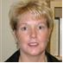Michele E. Thornton, RN, BSN, CCDS  
Clinical Documentation Specialist  
Novant Health Presbyterian Medical Center   
C: 704-534-8319

E: [methornton@novanthealth.org](mailto:methornton@novanthealth.org)

I am honored and excited to be working on the 2018 National ACDIS Conference with all of you! I am part of the CDI team for Novant Health in Charlotte, North Carolina. I have been a RN for 22 years (13 years in the Emergency Department and the last nine in CDI). I started on the CDI team at Novant Health at its inception and have had the opportunity to watch CDI evolve into an exciting career. I received my CCDS in October 2015.

My husband and I live in Belmont, a small town 17 miles west of Charlotte. I have two step children and five step-grandchildren and no pets of our own. However, the cat across the street, “BeBe,” thinks he is part of our family and helps me when I’m out working in the yard (I think he thinks he’s protecting me from potential “critters”).

Fun Facts: I enjoy CrossFit, working in the yard and watching MLB games (especially when R.A. Dickey is pitching—he is a knuckleball pitcher for the Atlanta Braves). We go to Sunset Beach, here in North Carolina as often as we can and enjoy the “laid back” lifestyle on the island (it’s still non-commercial with only one Bed & Breakfast).

I have attended three of the 10 national ACDIS conferences and I always leave with great friends and knowledge.

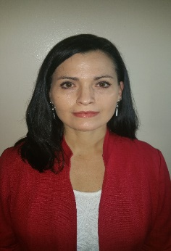Susanne Warford, MBA-HCM, RN, CCDS

Regional Manager Clinical Documentation Integrity

Eastern Region, Baptist Health

Louisville, Kentucky

O: 502-253-4845

E: [susanne.warford@bhsi.com](mailto:susanne.warford@bhsi.com)

I am so excited to be part of this committee! I have been in CDI for only four years, but I must say that I have found my true passion. CDI is the perfect marriage of all my previous experience.  I am a member of the Regional KY/Southern Indiana ACDIS Chapter. I most recently served as the secretary for the past two years and have plans to run for office this November.

I am an RN with more than 16 years of experience in high-level patient care areas including ED, neurosurgical intensive care at a Level I trauma Center, as well as supervisory experience in healthcare compliance.

Fun fact: My husband Mike and I have two children, Reese, age 9 and Maci, age 3, and have a high-maintenance shih-tzu named Chloe, who is 14. We live for weekends where we like to swim, camp-out, and watch movies in our back yard.

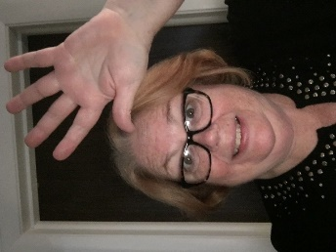Kathleen Brady Wiesler, LPN, CCDS

*Changing jobs*

ACDIS Ohio Chapter leader

[kbwcdi@yahoo.com](mailto:kbwcdi@yahoo.com)

I am looking forward to participating on this committee with you all. It is exciting to be selected. I served on the committee for nominations for the ACDIS advisory board this past year. It was great to learn about some of the processes behind this great organization. Looking forward to meeting up as a group at the next conference in 2018. Karaoke in San Antonio anyone?

CDI came into my nursing career in 2011 as I was hired as a CDI coordinator specialist at Barberton Hospital. During that time, I was the CDI department lead, and was asked to expand the Barberton hospital CDI staff and establish a branch at our sister hospital in Wadsworth. In a few weeks, with a move to join the Cleveland Clinic Health System, I will be returning to the place where I started my nurse’s training.

I have been a member of the local Ohio ACDIS group since 2011 currently serving as co-president.

Fun Fact: I am single, have had two children, Liz and Matthew. I live on the “NorthCoast” aka “Believeland” and most weekends enjoy family and overnight visits with my grandchildren. I recently decided on taking a hiatus from studying for the last 6 classes for a degree in Health Service Management.

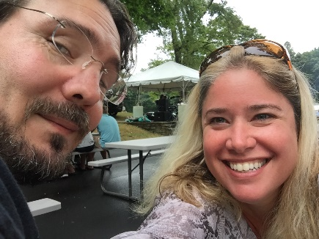

Melissa Varnavas

Associate Editorial Director

ACDIS

Middleton, Massachusetts

P: 978-624-4584

E: [mvarnavas@acdis.org](mailto:mvarnavas@acdis.org)

Melissa Varnavas, is the Associate Editorial Director for the Association of Clinical Documentation Improvement Specialists (ACDIS), where she helps manage its multiple publications, books, broadcast events, website, and social media community. She also oversees the efforts of more than 40 ACDIS local chapters across the country.

Fun fact(s): My husband and I don’t have children; we borrow my sister’s five on the weekends and spoil them rotten. We have two cats that my husband named after hurricanes—Hugo and Katrina.