CDI Professional of the Year ACDIS Achievement Award winners
Note: Please note that, to the best of our knowledge, the positions listed in bold next to the winners’ photos reflects their current positions.
2017
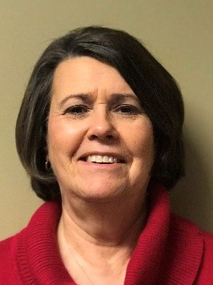
Rita Fields, BSN, RN, CCDS
Regional CDI Manager
Baptist Health
Louisville, KY
Rita is a “truly enthusiastic and active member” of the CDI community, according to her nominating peers. She has served on the ACDIS Local Chapter Advisory Board, served as president of the Kentucky/Southern Indiana ACDIS Chapter for five years, and served as the co-chair for one year. At her facility, Baptist Health, Fields is an advocate for CDI education and collaboration, starting a physician advisor program, facilitating meetings between CDI and coding departments, and moving the program toward a quality-focus as opposed to a financial one.
“Through her encouragement and leadership, many of us have joined ACDIS, are CCDS credentialed, and are active in ACDIS at the local and national levels,” one nominator wrote.

2016
Karen DiMeglio, RN, MS, CPC, CCDS
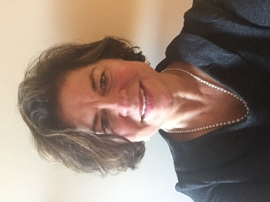
Director of CDI and Appeals
Lifespan
Providence, Rhode Island

DiMeglio has more than 30 years of progressive leadership and administrative experience in diverse acute care and ambulatory patient care settings. In 2009, DiMeglio implemented the clinical documentation integrity department for Lifespan affiliate hospitals, growing the staff from five to 15. She is a member of the Massachusetts ACDIS Chapter and has presented at several national ACDIS conferences.

2015

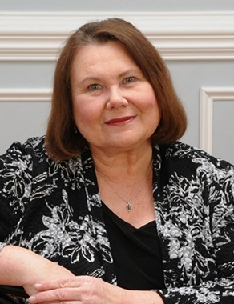
Karen Newhouser, RN, BSN, CCDS, CCS, CCM, CDIP
Director of Education
MedPartners
Tampa, Florida
An RN with 36 years’ experience, and a specialization in critical care, Newhouser transitioned to a role in case management in 2001 and CDI in 2004. In 2011, she earned a certificate in medical coding and billing as well as the CCDS credential. That same year, Newhouser co-presented a poster for the 4th Annual ACDIS Conference and joined MedPartners as the CDI supervisor at Barnes-Jewish Hospital (BJH) in St. Louis, Missouri.
Having been a mentor and preceptor throughout her career, she transitioned to the position of director of CDI education for MedPartners in 2014.
Newhouser has extensive experience in quality initiatives involving patient safety indicators, hospital acquired conditions, core measures, sepsis, and malnutrition, as well as education in ICD-9 and ICD-10, query template and tip card development, auditing, data analysis, and reporting.
Newhouser is serving on the ACDIS Advisory Board until April 2018.

2014
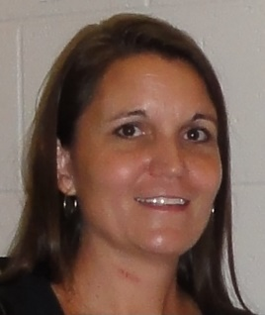
Michelle Custodio, RHIA, CCDS, CDIP
Corporate HIMS Operation Manager
Trinity Health
Lewiscenter, Ohio
Michelle has worked in the CDI field for more than 15 years and served as corporate manager over the CDI program at Banner Health, a large non-profit hospital system. She spearheaded the program’s start in 1998, and expanded Banner’s CDI efforts to 19 facilities across eight states. Custodio demonstrated her professional dedication as a speaker at AHIMA conferences in 2004, 2005, and 2011, as well as at ACDIS National Conference in 2012. In addition, she served as a CDI subject matter expert for AHIMA during its development of its CDIP credential and on its AHIMA CDI Workgroup committee. Custodio also earned recognition from this year’s ACDIS Conference Committee for her development of CDI tools, physician education materials, and her expansion of CDI efforts into areas of EMR, quality improvement, and case management concerns.
“Michelle was a subject matter expert in clinical documentation improvement. She worked with more than 30 CDI specialists providing reports, education, and leadership to the program,” wrote Sandy Severson, vice president of care improvement at Arizona Hospital and Healthcare Association, former system senior director of quality, at Banner Health. “She was a key contributor to the success of the program and our surpassing our annual goals.”
2013
Nancy Rae Ignatowicz, RN, BS, MBA, CCDS
CHI Nurse
MedPartners
Bourbonnais, Illinois
Ignatowicz has a broad clinical background in nursing prior to joining CDI, spanning all the way to quality improvement, case management, and utilization review. She has spoken at local, state, and national conferences and is the author of The CDI Toolkit. She was also a member of the 2017 CDI Week planning committee.

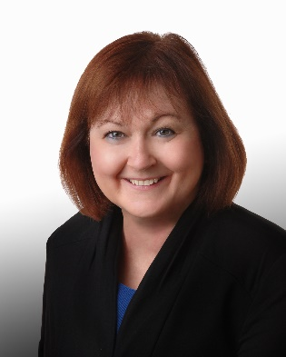
2012
Cathy Seluke, RN, BSN, ACM, CCDS
Supervisor of Clinical Documentation Compliance
MaineGeneral Health
Waterville, Maine
Seluke built and grew MaineGeneral’s CDI program in 2002 and (at the time of the award) managed two campuses over 20 miles apart. She regularly mentors clinical staff and cultivates vibrant clinical relationships with physicians. She juggles staff management while maintaining her own caseload.
She also created a marketing brochure for the CDI program with pictures of each CDI specialist to help introduce them to physicians. She served as president of the Maine ACDIS local chapter for several years.

2011
Donald Butler, RN, BSN
Manager, Clinical Documentation Advisor Program
Vidant Medical Center
Greenville, North Carolina
Butler serves as manager of the 10 member CDI team at Vidant Medical Center in Greenville, North Carolina, an 860-bed tertiary care center serving the eastern third of North Carolina. He also leads networking efforts with the four other individual CDI specialist’s at Vidant Health hospitals. Butler served 11 years as a U.S. Navy Nurse with a broad variety of clinical experiences, including labor & delivery, hematology/oncology, ED, and primary care. He has served in several leadership roles, including department head for an OB/Pediatrics clinic, performance improvement, and as a JCAHO Coordinator, as well as program development such as annual school physical program, standardizing asthma and ADD care, ED case management, and CDI.
Butler is actively involved with CDI through presentations locally and nationally, participating with CDI Week development, and is an active contributor on ACDIS Blog and the ACDIS Forum.

2010
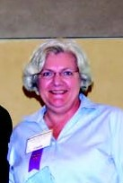
Sandra Beatty, RN, BSN, C-CDI
Director of CDI
MedPartners
Seymour, Indiana
Beatty was the very first CDI specialist hired at Columbus Regional Hospital in August 2002 (where she worked at the time of this award). Since the inception of the program through April 2009, risk of mortality improved 55.4% and severity of illness improved 17%.
She helped her hospital achieve recognition as a Thomson Reuters Top 100 Hospital in 2009 and win a 2010 HealthGrades Patient Safety Excellence Award. In 2006, she received the Scorecard Excellence Award in the Quality and Safety Pillar; in 2008, she received the Excellence in Education Award for her monthly physician newsletter.

2009
Beth Kennedy, RN, BS, CCS
Director of CDI Analytics and Training
North Shore LIJ Health System
Old Greenwich, Connecticut
Kennedy began her career as an RN working in critical care, on the medical-surgical unit, in labor and delivery, and in pediatrics. As healthcare costs continued to raise, she began to be concerned about the effects of cost containments on patient care. Because of this concern, Kennedy took a position with a healthcare consulting firm and spent two years assessing quality documentation areas and DRG assignment.
Her extensive experience made her the perfect candidate to start a CDI program, one of her nominator’s said. Though, the program existed before Kennedy started at Montefiore Medical Center in Bronx, New York, she was the one to give it real life. When she joined the team, she redesigned the CDI program, comprised on 10 CDI nurses and three managers, at Montefiore Medical Center in Bronx, New York (where she worked at the time of this award).
During her career, Kennedy has been greatly successful with physician engagement and spoken at various meetings at her facility in front of a variety of audiences.

2008
Randi Ferrare, RN, BSN
Interim Director, Case Management
Leadership Excellence Solutions, LLC
Tampa/St. Petersburg, Florida area
Based on a dismal third quarter 2006 CDI program report, Ferrare authored and championed a proposal for a separate CDI department at Morton Plant Mease Healthcare in Clearwater, Florida (where she was Director of Health Management Services at the time of this award). She then led a multidisciplinary team to develop a concurrent and retroactive process. The program (at the time of this award) consists of 12 RNs and two nurse coders.
After the program’s implementation, the set revenue goal was $500,000, but the actual was $1.22 million. Additionally, severity of illness and mortality measures also increased.
Ferrare helped to allocate funds for every CDI specialist to become a certified coder.

