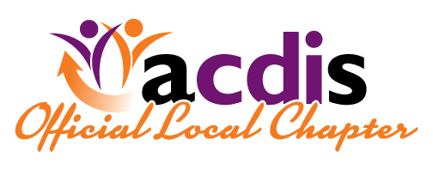  Colorado ACDIS Meeting  **POST-CDI WEEK 2018**  Wear ACDIS colors to celebrate  When  October 11th 2018  3:30-6:00pm  Where  UCHealth Anschutz Campus  Inpatient Pavilion 2  AI2CC - 1.781-B  Aurora, CO  For further information or questions please contact one of your Colorado ACDIS chapter leaders-  Rita Kohlberg Rita Kolberg@uchealth.org  Janet Robinson JRobinson@bch.org  Diane Kohler DianeKohler@Centura.org  Audio Conference Information  Call in Number: TBD  Conference ID: TBD  Special thanks to Nuance and ChartWise for prizes!! |  |  | Topic for this meeting  Maneuvering thru the quality world - a CDI mosaic -  Guest Speaker  Holly Saratella, MHA, CCS  CDI Manager  UCHealth  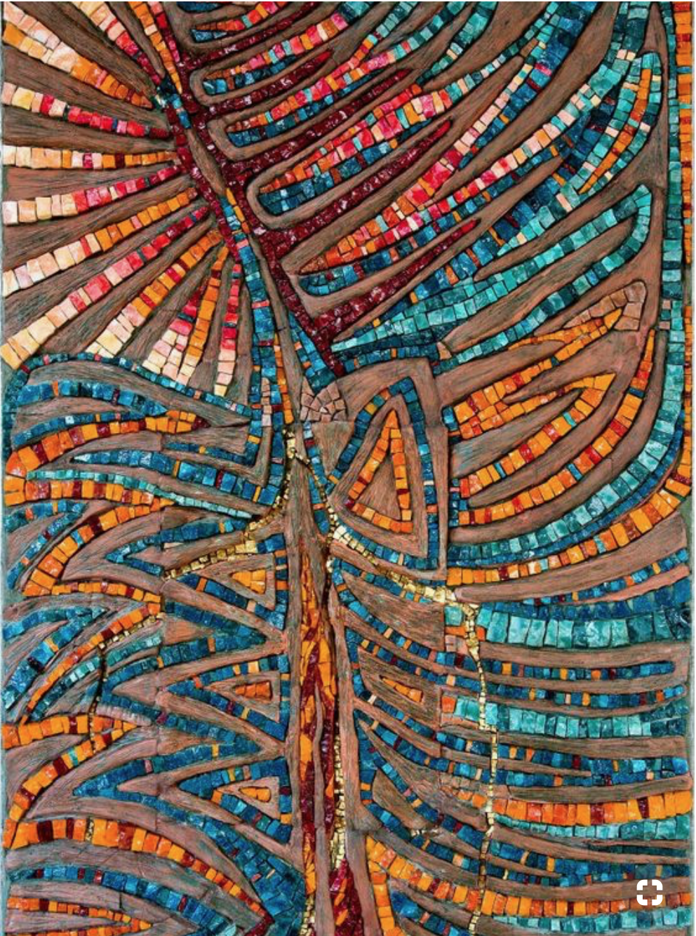  All are Welcome  Membership is not required to attend, please forward invite to your coworkers.  