TITLE: Florida ACDIS Quarterly Meeting

Date: December 1, 2018

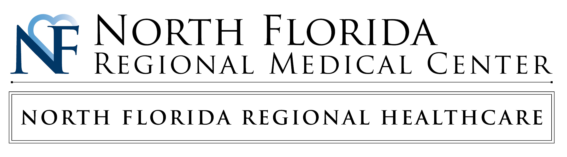

# 

# 

|  |  |  |
| --- | --- | --- |
| **7:45 a.m.- 8:15 a.m.** | **Welcome/Breakfast** | **Edna Betances-Harold – Florida ACDIS President** |
|  | | |
| **8:15 a.m.- 9:30 a.m.** | **Topics** | **Dr. Blanton MD,MS,FACEP** |
| Challenges in Clinical Documentation Integrity  Literature Definitions and Clinical Validity   * Acute Respiratory Failure * Acute Encephalopathy * Sepsis |
|  | | |
| **9:30a.m.-10:00 a.m.** | **BREAK** | |
|  |  |  |
| **10:00 a.m.- 11:00 a.m.** | **Topics** | **Karen Newhouser, RN, BSN, CCM, CCDS, CCS, CDIP** |
| Simplifying Clinical Validation   * Define clinical validation. * Explain the meaning of I.A.19. * Compare/Contrast the types of clinical validation. * Explain the clinical validation query. |
| **11:00 a.m.- 11:30 p.m.** | **Topics** | **Jaclyn O’Neil, MBA|** cid:image001.png@01CFC2B5.BB3B5290**Optum** Regional VP| Financial Integrity and Connectivity Solutions |
| **11:30 a.m.- 12:30 p.m.** | **LUNCH** | ***Lunch provided by*** cid:image001.png@01CFC2B5.BB3B5290 **Optum** |
|  |  |  |
| **12:45 p.m.- 1:35 p.m.** | **Topics** | **Dr. Howard Rodenberg** |
| Things I Hate: Clinical Validation |
|  | | |
| **1:35 p.m.- 2:00 p.m.** | **Topics** | **Raffle of gift baskets** |
|  |  |  |
| **2:15 p.m. – 3:30 p.m.** | **Topics** | **Charrington Morell RN CCDS-** **Director of Clinical Documentation Improvement- *HCA West Florida Division Office*** |
| **CDI Jeopardy** |
|  |  |  |
| **3:45 p.m. – 4:00 p.m.** | **Adjournment** | |
|  |  |  |