Angie Curry, RN, BSN, CCDS, is the CDI director at Conifer Health in Fisco, Texas, and the 2017 CDI Week advisor. Her experience covers 19 years in both nursing and CDI. Her nursing expertise includes cardiovascular, education, and now CDI. As a CDI Director she develops program metrics for reporting, monitoring, and distribution. Also, she has been responsible for DRG-based denial management, including case reviews and working with the HIM physician advisor during the appeals process. Curry has spoken at local and national CDI events, allowing her to share her passion and enthusiasm for accurate documentation. She was elected to the ACDIS Advisory Board in 2017.

Cornel Delogramtic, MD, CCS, CDIP, CCDS, is the manager of CDI and medical coding operations at Valley Presbyterian in Van Nuys, California. Delogramtic was part of the initiative committee for adopting DRG-based hospital performance programs in two European counties and has extensive knowledge of CDI, coding compliance, quality, utilization and risk management. Since coming to the United States, he has worked in both corporate health systems as well as standalone hospitals. Contact him at cdelogramtic@gmail.com.

Nancy Ignatowicz, RN, MBA, CCDS, is a remote/traveling CHI nurse with MedPartners, based in Bourbonnais, Illinois. Ignatowicz has a broad clinical background in nursing prior to joining CDI, spanning all the way to quality improvement, case management, and utilization review. She has spoken at local, state, and national conferences and is the author of The CDI Toolkit. Ignatowicz was the 2013 CDI Professional of the Year award winner. Contact her at nrmignatowicz@comcast.net.

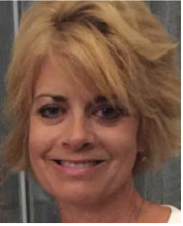
Laurie Morelle, RN, MS, CCDS, is the manager of clinical documentation at Lifespan Corporate in Providence, Rhode Island. Morelle, in addition to her clinical experience, brings her background of emergency department management and leadership and case management to the CDI table. She now has eight years of CDI experience, advancing from a CDI specialist to system-wide CDI manager at Lifespan in 2013. Contact her at lmorelle@lifespan.org.

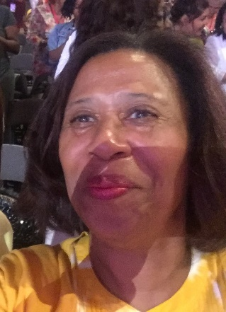
Brenda Ng, MS, RN, CCDS, CCS, is a CDI consultant at MedPartners in Greenwood Lake, New York. Prior to stepping into the CDI world, Ng gained her clinical experience in the surgical and emergency medicine arenas before moving into professorial and management roles at a variety of institutions and organizations. She has been in CDI consulting now for seven years. Contact her at ngbrnd@yahoo.com.

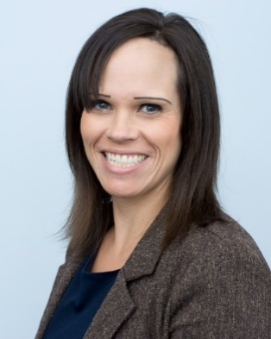
Caryn Nowak, RHIT, CDIP, is a clinical documentation integrity specialist at Rady Children’s Hospital in San Diego, California. Ms. Nowak has an extensive background in coding and compliance audits, covering diverse areas such as acute care and pediatric hospitals. She worked as a project manager in both the consulting and acute care hospital settings before joining the CDI team at Rady Children’s. Contact her at cnowak@rchsd.org.

Rhonda Peppers, RN, BS, CCDS, is a CDI specialist with MedPartners HIM in Alexandria, Tennessee. Peppers has more than 30 years of clinical nursing and healthcare management experience in addition to her six years of experience in CDI. She also spoke at the national ACDIS conference in 2014 on severity of illness and risk of mortality. Contact her at rpeppers-c@medpartners.com.

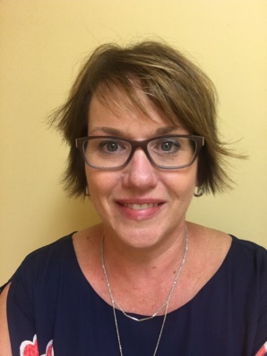
Kristie Perry, RN, MHSA, CCDS, CCS, is a CDI specialist at Erlanger Health System in Chattanooga, Tennessee. Perry has 25 years of experience in nursing. Her primary clinical experience is in the ICU setting. In addition to her long career in nursing, she has been in the CDI world for 10 years. While in CDI, her primary focuses have been trauma and critical care. Contact her at Kristie.perry@erlanger.org.

Terry Simmons, MSN, RN, CCRN-K, CCDS, is a clinical documentation specialist at Hartford Healthcare, Hospital of Central Connecticut in New Britain. She has 33 years of bedside clinical practice experience in med/surg and extended care, including 25 years as a critical care nurse. Now, she’s approaching five years in CDI. in 2004, Simmons was honored with the American Association of Critical Care Nurses Clinical Excellence Award and as a Nightingale nurse in 2011. She enjoys hiking and swimming in the ocean with family and friends. Her primary research has been in nursing documentation, so becoming CDI was a natural choice. Contact her at terry.simmons@hhchealth.org.
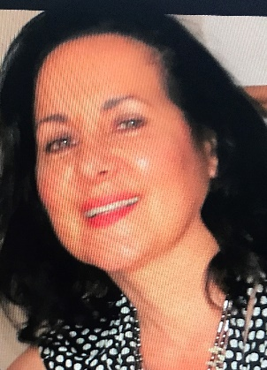
Rose Waddell, RHIA, CCS, CCS-P, CCDS, is the coding and clinical documentation improvement program manager at Exeter Hospital in Epping, New Hampshire. Waddell uses her domain knowledge to bridge the gap between coding, DRG, and clinical validation. Previously, Waddell served in the United States Army as a reservist where she was introduced to the ICD coding classification system.
Additionally, she has held various administrative positions within the hospital setting between 1989 and 1998, and multiple management and consulting positions as an HIM professional since 2000. Waddell has also served as an adjunct coding instructor since 2009. She holds a Master’s degree in business administration and a Bachelor’s degree in health information management. Having the opportunity to volunteer for the 2017 CDI week with ACDIS and other CDS professionals has been an extremely rewarding experience. Contact her at rwaddell@ehr.org.
James Wall, RN-TN, BSN, MBA, is the senior director of CDI at LifePoint Health in Brentwood, Tennessee. Wall has more than 30 years experience in healthcare, including trauma surgery, ICU, coronary and medical ICU, substance abuse treatment, pharmaceutical research, utilization review, and case management. He now directs the CDI efforts in LifePoint’s 70+ facility system. Contact him at james.wall@lpnt.net.

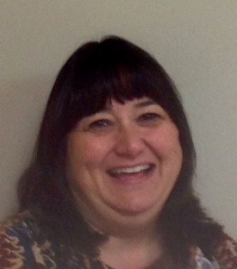
Leigh Wolff, RN, BSN, CCDS, is a clinical documentation specialist at Elkhart General Hospital in Elkhart, Indiana. Wolff has more than 20 years of clinical experience, spanning from medical-surgical to a position as a charge nurse. Additionally, she has nearly 17 years of experience in CDI, even aiding in the development of the CDI program at EGH. She conducts staff and physician education in addition to her traditional CDI duties. Wolff currently serves as the secretary for the Indiana ACDIS Chapter. Contact her at lwolff@beaconhealthsystem.org.

