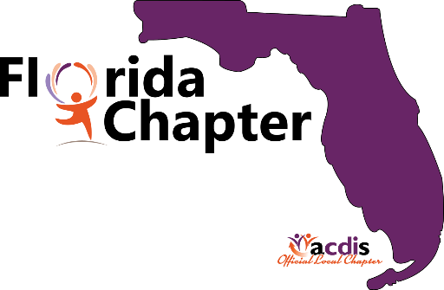
Florida ACDIS Members
We hope this letter find you well, we’ve missed you!
We are extremely pleased to announce our next
FLORIDA ACDIS quarterly meeting will take place on
Saturday October 2, 2021 from 8am to 4pm
Hosted by
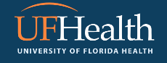
Shands Hospital in Gainesville
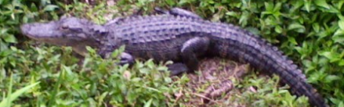
We are looking forward to seeing you in October.
More information to follow
We will begin accepting RSVP’S in August.
Florida ACDIS Board
Edna Betances-Harold (President)
Cecilia Baum (Vice-President)
Deborah Hilliard White (Secretary)
Karen Williams (Treasurer)

