How to add an image to your email signature
- Download the appropriate image from the ACDIS website and save it to your computer.
  - If you’re using Outlook, continue with steps 2-5; For Gmail, skip to steps 6-8.
- Outlook instructions: In Outlook, open a new message, click on the “Insert” tab, and click on the “Signature” dropdown. Select the “Signatures” item from the menu.
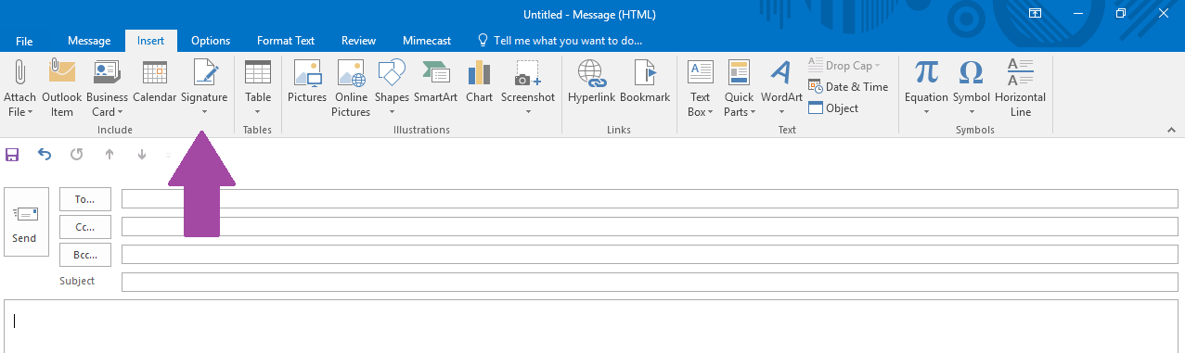
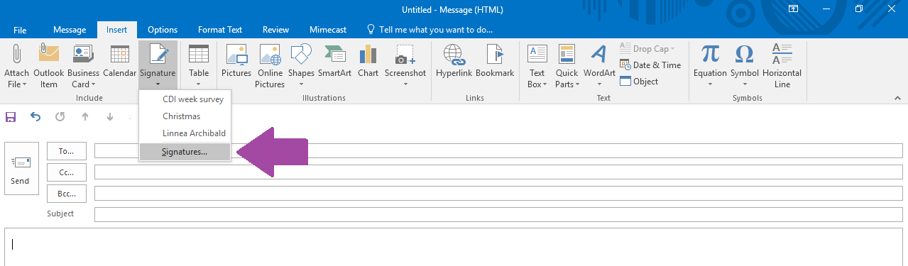

- Click the “New” button in the pop up box, type the name of your new signature, and click “OK.”
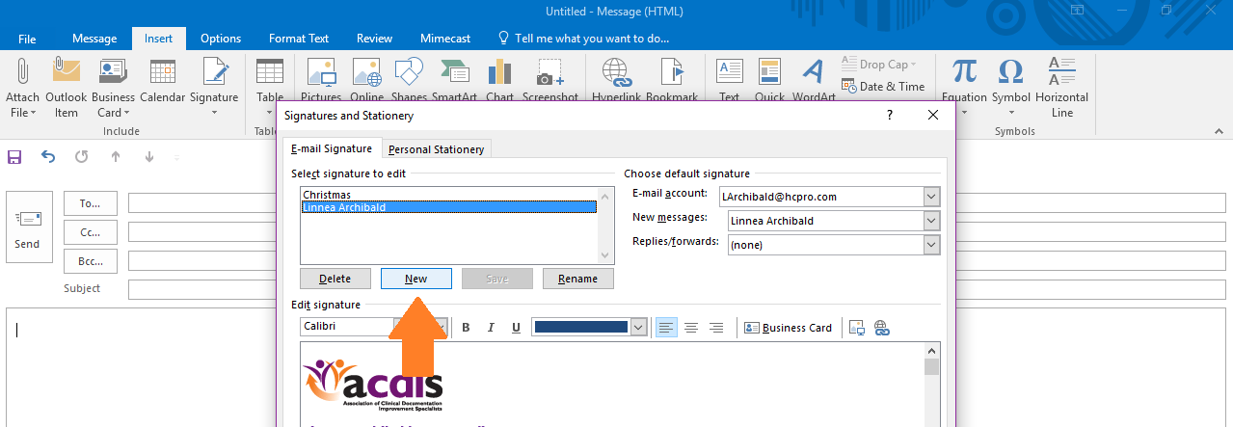
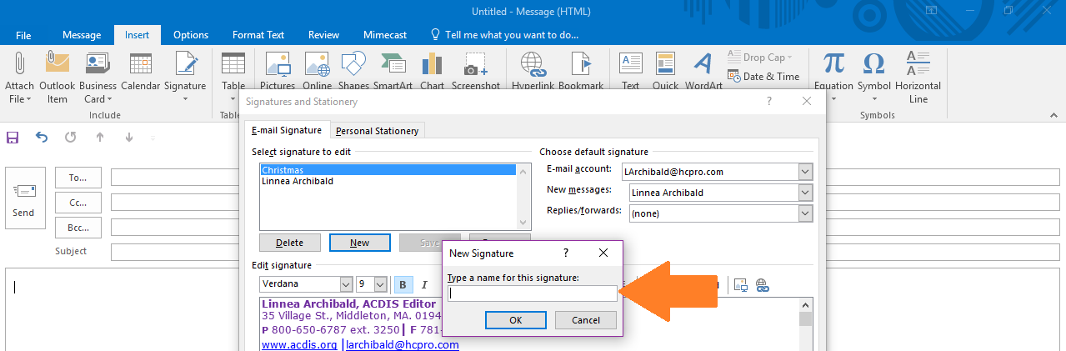

- Type your signature information into the text box under “Edit signature” and then click on the photo icon. This will bring up a file folder. Locate the signature image, click it, and click “insert.” To save the signature, just click “OK.”
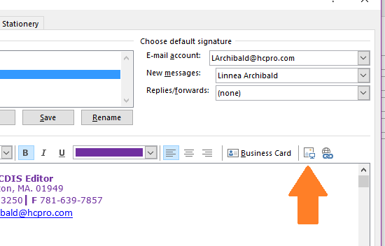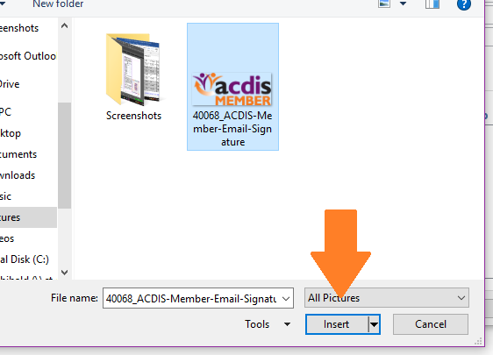

- To insert your new signature, click on the same “Signature” dropdown in your new message pop up, and select the correct signature.
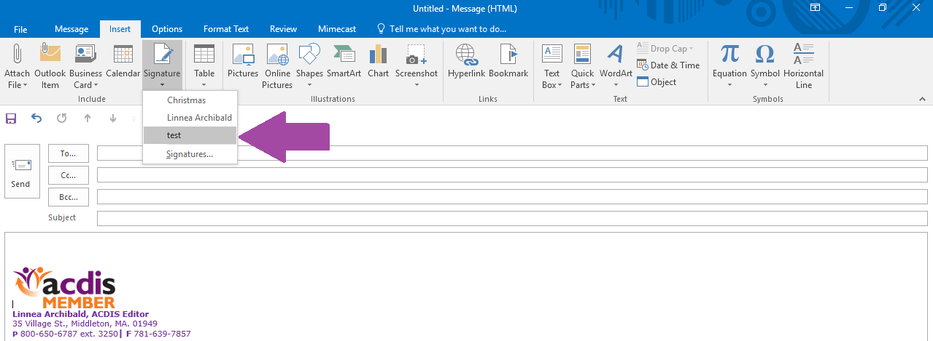

- Gmail instructions: In your Gmail inbox, click on the “Settings” icon and select “Settings” in the dropdown menu.
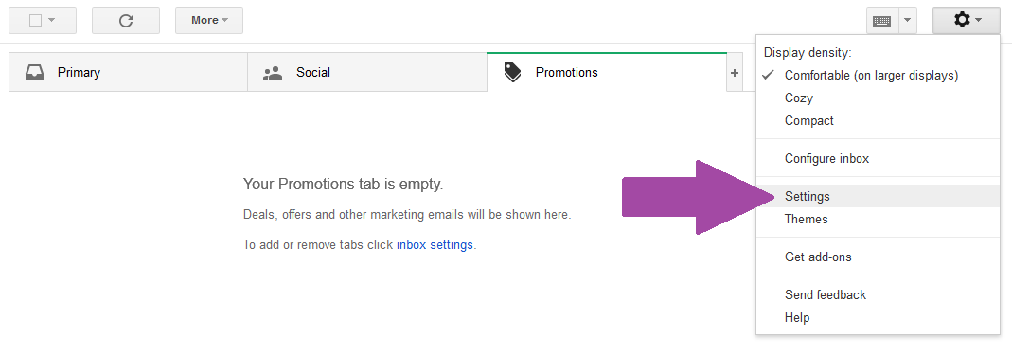

- Scroll down the settings page to the “Signatures” box. Fill in your info and then click on the “image” icon. This will bring up a box. Select “Upload” and click “Select a file from your computer.” Locate your image, select it, and click “Open.” This will insert the image into your signature.
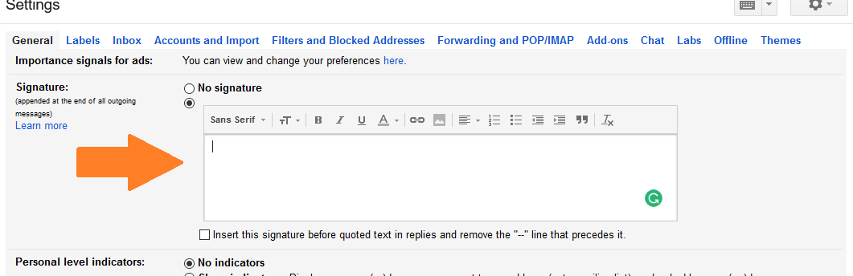
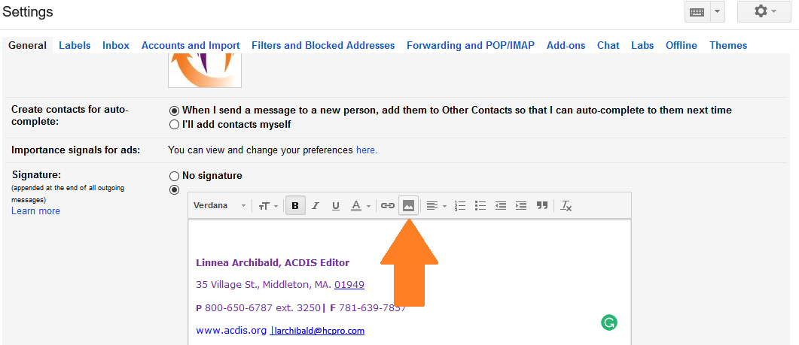
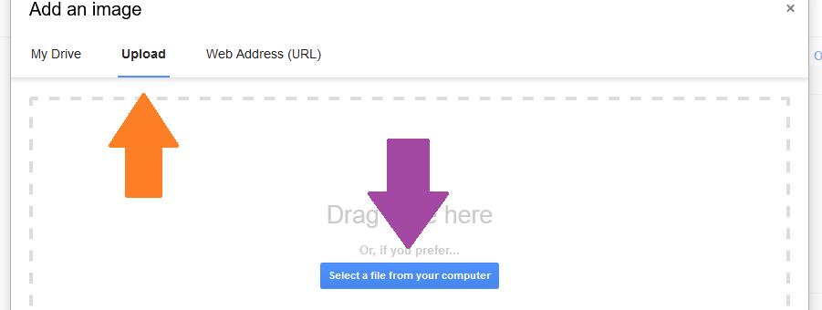
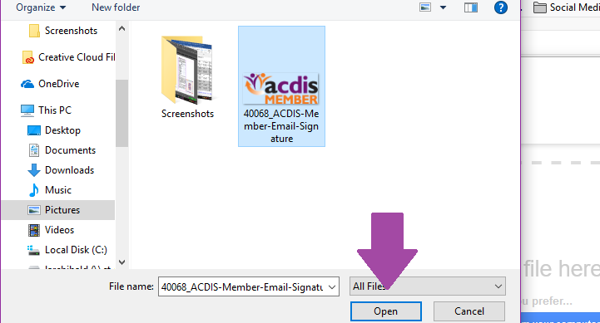

- Scroll down to the bottom of the Settings menu and click “Save changes.” Your signature will automatically add to any new messages you compose.
