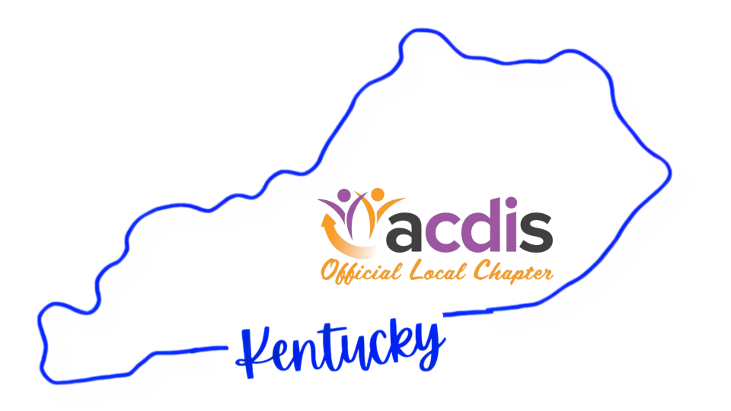

  - newsletter
ABOUT US
The Kentucky ACDIS Chapter is a thriving and steadily growing professional community dedicated to supporting clinical documentation integrity (CDI) professionals across the state of Kentucky. Our chapter brings together CDI nurses and specialists to foster collaboration, professional growth, and meaningful connections with peers in the field.
Following a leadership transition in 2024, the chapter has remained committed to delivering timely insights and resources from Association of Clinical Documentation Integrity Specialists. We provide members with valuable opportunities for engagement and development through a variety of initiatives, including an annual in-person conference, educational webinars, access to ACDIS continuing education credits, and pathways for members to take on leadership roles within the chapter.
Through these efforts, the Kentucky ACDIS Chapter continues to strengthen the CDI community across the state while supporting excellence in clinical documentation practice.

KYACDIS LEADERSHIP TEAM:
President – Cindy Ballard BSN, RN
Vice-President – Pamela Florence BSN, RN, CDIP
Secretary – Alicia Mitchell MSN, RN, CCDS
Treasurer – Danielle Skeens RN, MSN, CCDS
welcome to our chapter newsletter!  - Section 1: About Us | Membership/Dues:  - Learn about all the reasons why you should join the chapter! | education:  - Join us for our monthly educational webinars.  - Each webinar is eligible for 1 ACDIS CEU (paid members only)

Membership:

 MEMBERSHIP DUES:
- You should have received an invoice from Danielle, our treasurer. We are asking you to PLEASE pay your membership dues by January 31st. The cost is only $20 for the year. Members with paid dues have access to CEU's for webinars and the conference, discounted cost for KYACDIS' annual conference, giveaways, etc. Your membership helps build and strengthen our chapter and allows us to provide educational opportunities, a professional networking platform, the ability to grow your profession through volunteering, leadership opportunities, and so on.

Dues are $20 and payable through PayPal, Venmo and check. Simply click the link below and follow the prompts. Information on the ways to submit your dues are included. If you need any assistance with dues or payment, please reach out to Danielle Skeens at skeensx2@gmail.com.

Renew or join by clicking on this link.
https://docs.google.com/forms/d/e/1FAIpQLSeegEI727tgksMhpr0YvEN9Lwi4PJxAXEyMS8pxAM_38p3oXA/viewform?usp=header<https://urldefense.com/v3/__https://docs.google.com/forms/d/e/1FAIpQLSeegEI727tgksMhpr0YvEN9Lwi4PJxAXEyMS8pxAM_38p3oXA/viewform?usp=header__;!!DCTxO5nwB6A69OQV!zzCxm7Pq2mqHECUVwjzMRQlTFd_XLyHKzft3JMmP0KrecbTkOfT0Kvp-3vx05iH5hJUH_votFGtlioqErvv7u9g10Q$>

EDUCATION:

 EDUCATION:
- There will be monthly webinars held on the second Thursday of each month from 3:30pm - 4:30pm. Please email Alicia.mitchell@nortonhealthcare.org for meeting login info.

- Please note: our annual regional conference will be held in the month of October, so there will be no webinar for that month.

Monthly webinars (please mark your calendars):

- February 12th--- Coding Clinic Highlights (A Closer Look At Some Coding Clinic Guidance) presented by Lisa Phipps & Bridget Smith
- March 12th--- The Shocking Truth presented by Dawn Valdez
- April 9th--- A Brief Introduction Into Interventional Cardiology presented by Sarah Ray
- May 14th--- Mindset Matters: Empowering CDI Through Continuous Learning presented by Staci Josten
- June 11th--- Panel Discussion: ACDIS Conference Takeaways
- July 9th--- Achieving Physician Documentation Excellence: Working Smarter, Not Harder presented by Dr. Keith Stokes
- August 13th--- TBD
- September 10th--- Clinical Validation of High-Risk Diagnosis of MI presented by Lori Mills
- October 1st--- KYACDIS Regional Conference (see info below) SAVE THE DATE!!!
- November 12th--- TBD
- December 10th--- TBD

**These webinars, not including the conference, will be eligible for 1 ACDIS CEU. The conference will be eligible for 5 CEU’s. There will be no CEU for the June 11th panel discussion.

**Please note, you must be present on the day of the webinar and CEU's will be awarded to paid members only.

KYACDIS REGIONAL CONFERENCE:

- WHEN: Thursday, October 1st
- TIME: 7:00am-4:30pm EST
- WHERE: Norton Healthcare Learning Center - Hurstbourne Green. Address: 9500 Ormsby Station Road, Suite 200 Louisville, KY 40223 (Discounted hotel group rates will be available. Hotel info will be provided at a later date).
- INFO: A spectacular fun-filled, educational, and networking day among CDI peers and educational colleagues! This year's conference will offer several educational presentations, vendor booths, networking time, ACDIS CEU's, SWAG, prizes, giveaways, and more!!!! You will not want to miss it! Light breakfast and lunch will be served. Pricing and registration will be available soon. Note - there will be special pricing for paid KYACDIS members.

SAVE THE DATE!!!

2025 KYACDIS CONFERENCE
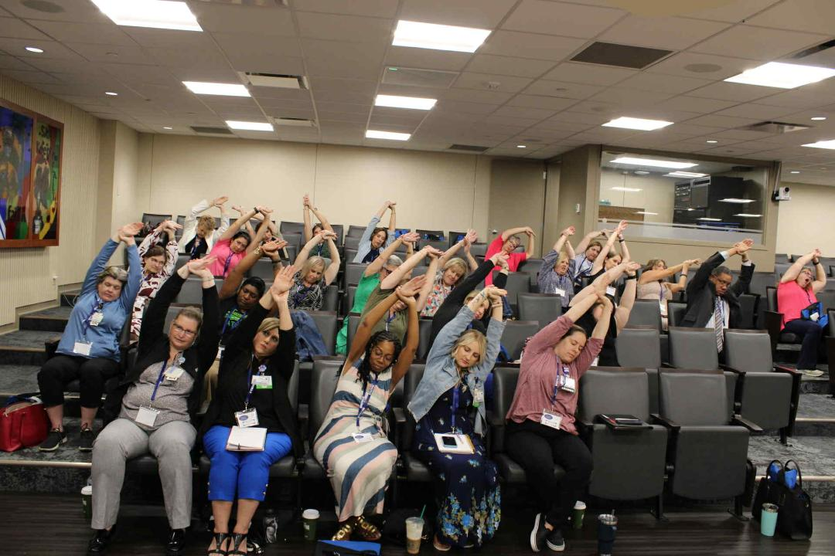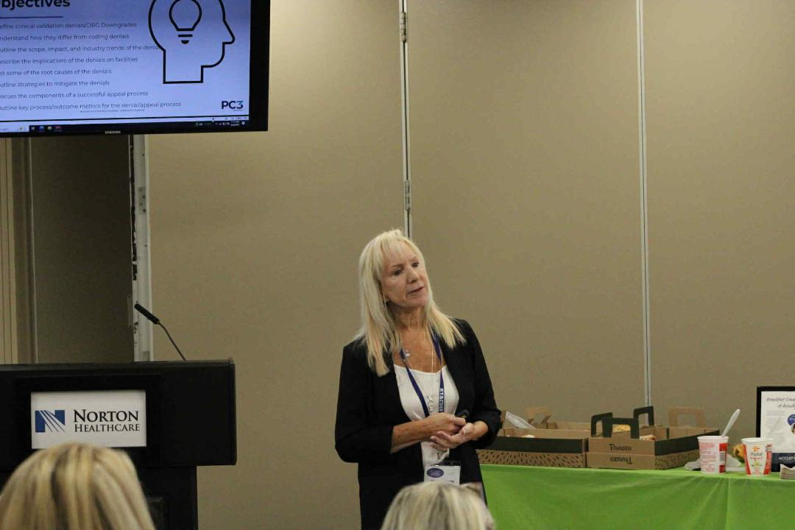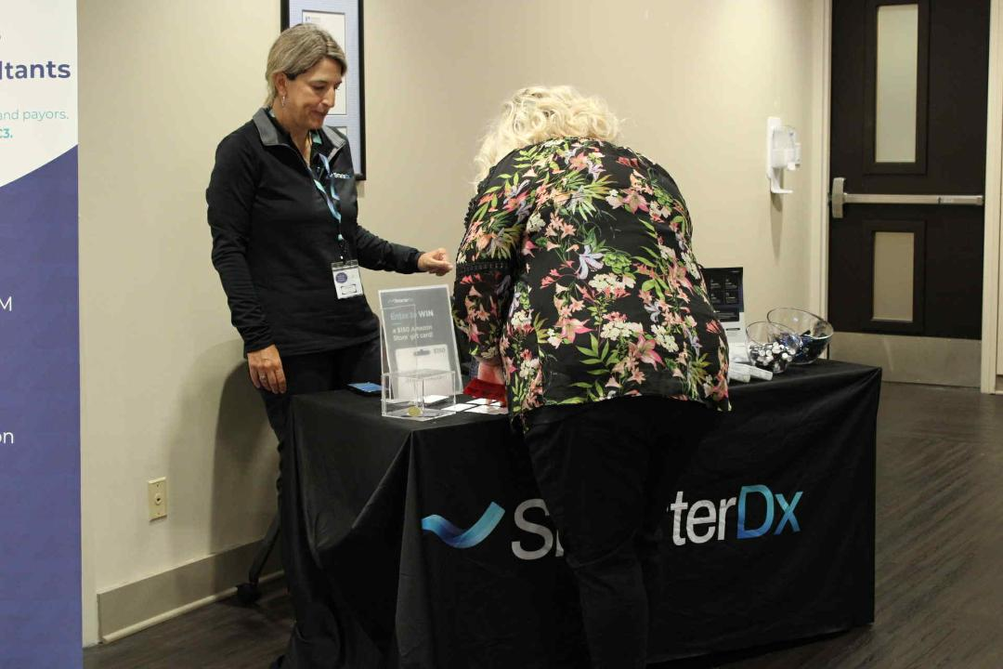
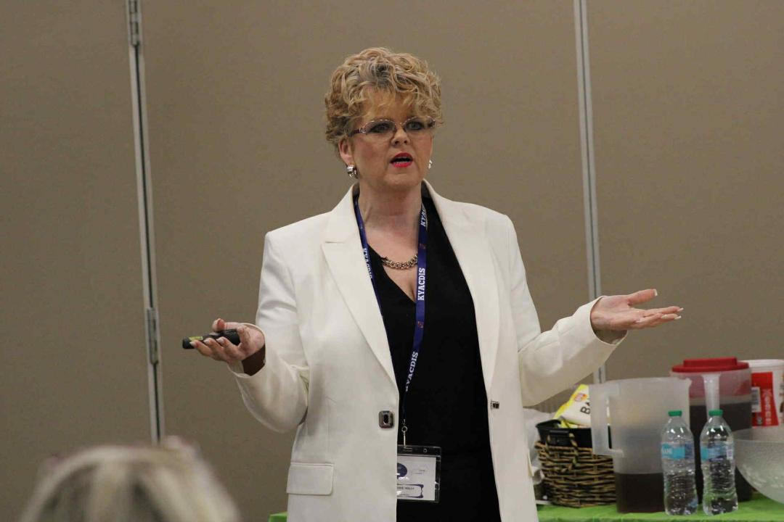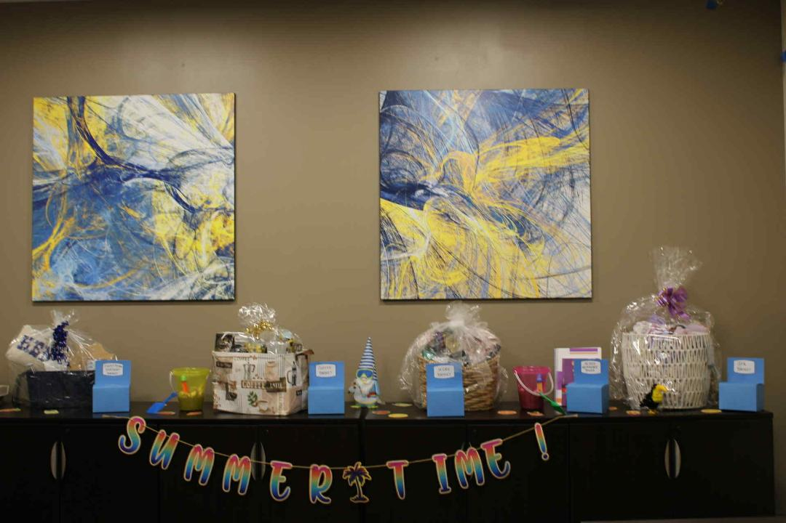
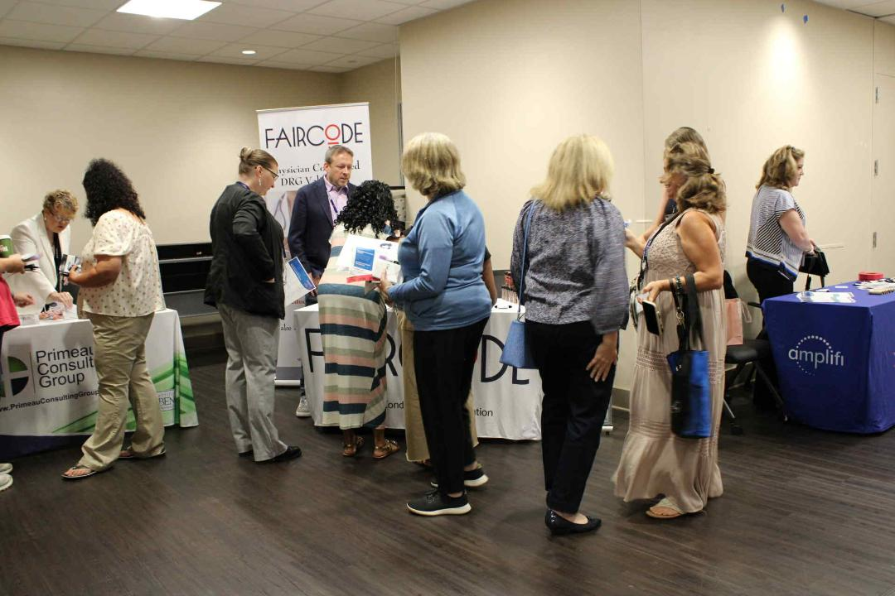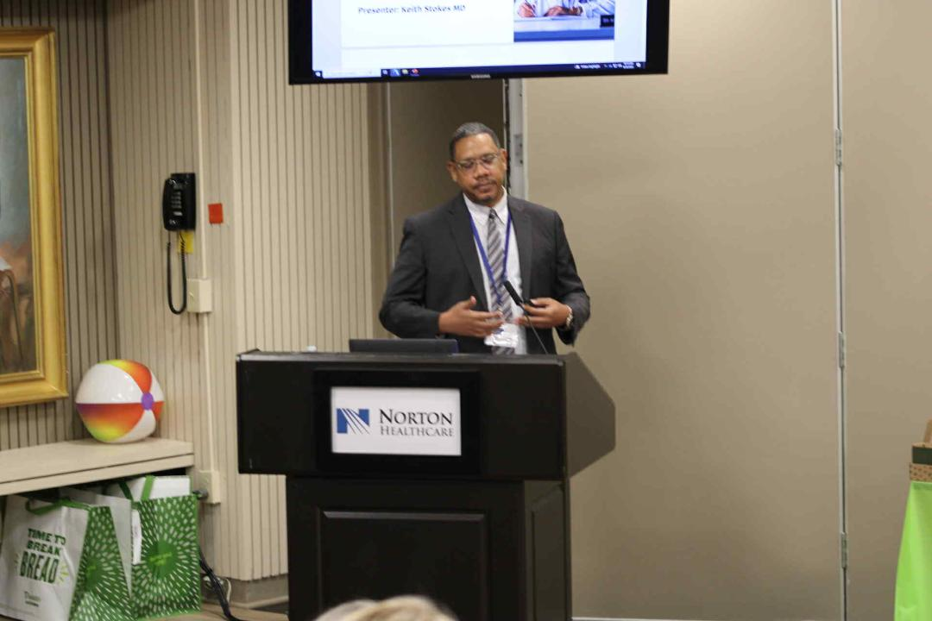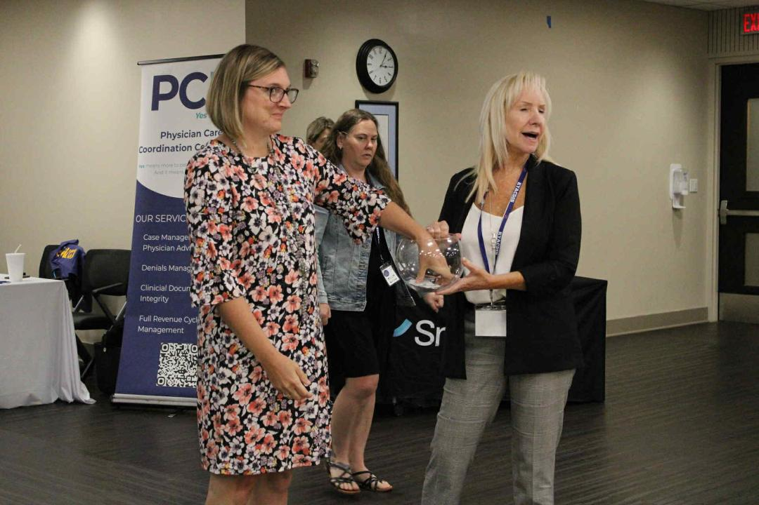

  VOLUNTEER OPPORTUNITIES:

- We are currently looking for volunteers within our chapter to join our team!
What if I want to serve on the leadership team for the chapter???.... If you have leadership skills, collaborate well with a team, can dedicate a little time each month, and would like to volunteer to join the leadership team - WE WANT TO HEAR FROM YOU!

What if I'm interested, but not sure if I can do the job???.... If you have an interest to step into a specific role but are unsure what that would look like or entail, we would be happy to have us shadow us - REACH OUT TO US TODAY!

What if I don't want to serve in a leadership role, but I wouldn't mind presenting???......Maybe leadership isn't your thing, no biggie. If you are passionate about a particular area of CDI, have great presentation skills, and/or love to educate, then we would love to talk with you about presentation opportunities - SHOOT US AN EMAIL!

Learn what the behind the scenes of the chapter looks like, get a better understanding of the responsibilities of each role, and how the team works together.

Some positions/roles of the chapter include:
- President - Secretary
- Vice President - Treasurer
- Social Media Manager - Newsletter Editor
- Conference Committee

If you have any interest in these roles, please reach out to us at:
kyacdis@yahoo.com

We are looking forward to a spectacular year with you!!!

