KYACDIS CHAPTER NEWSLETTER
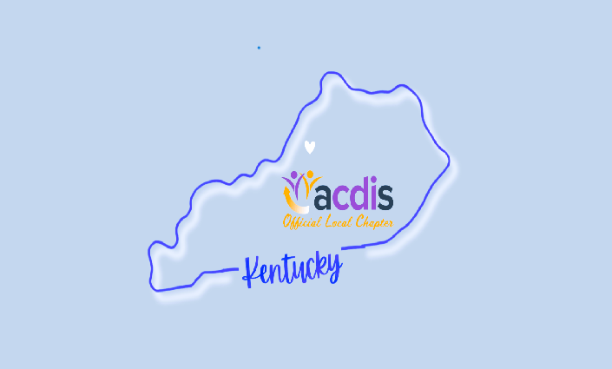
MEET THE LEADERS
CHAPTER HIGHLIGHTS

- MEET THE LEADERS

- Q1-Q2 MEETING RECAP

- SAVE THE DATE

- HELP WANTED

- MEMBER SPOTLIGHT

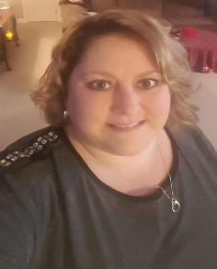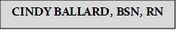
Cindy is a Kentucky native, and currently resides in Bardstown, Kentucky. She has over 26 years of healthcare experience including Medical-Surgical, Progressive Cardiac Care, and Home Health.
Her CDI journey started in 2010 at Overlake Medical Center in Bellevue, WA working in adult CDI. In 2012, she transitioned into pediatric CDI at Seattle Children’s Hospital in Seattle, WA; starting up their CDI program. She was involved in program implementation, physician education, CDI and coder peer education, creating the programs policies/procedures, and denial reviews.
In 2015, she relocated back to Kentucky from Washington state and began working remotely for Phoenix Children’s, where she is currently employed. Early on, she was involved in PCH’s physician education and assisted in the creation and implementation of electronic queries/auto queries through the EHR. She has been an active member of ACDIS and her local chapter.
Cindy has two children, a son 28yo and a daughter that is 21yo, and is newly married for almost 3 years now. Her and her husband have 3 sweet Shih-tzus: Bailey, Mia, and Zoie.

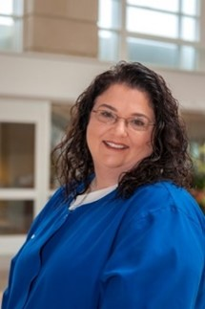Pam was born and raised in Lexington, KY although spent much of her summers at her grandparent’s home in Boyle County. She was graduated from the University of Kentucky with a BSN and a BA in Psychology. She began her nursing career at Central Baptist Hospital in Lexington working with cardiac and cardiothoracic surgical patients. In 2000, she was selected to form the initial group of nurses beginning the Clinical Documentation Improvement Program, which she worked in for the next 6 years. After nearly a year as Physician Peer Review Coordinator, she left Central Baptist to join the University of Kentucky’s Documentation Improvement Program in 2007. While at UK, Pam focused primarily on mortality reviews from 2010 until 2022. She has co-presented in webinars on mortality reviews and, in 2013, she was a co-presenter of a poster at the ACDIS conference in San Diego on risk adjustment in mortality. In 2015, she earned the Clinical Documentation Improvement Practitioner from AHIMA. She is currently a part of the Second Level Review Team at UK.
Pamela Florence BSN, RN, CDIP

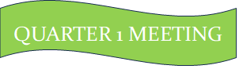
1st Quarter Meeting:
- Leaders were introduced
- Introduction of Chapter Email: KYACDIS@yahoo.com
- Reminder to update personal information on chapter roster through ACDIS.com
- Chapter dues $20 dollars with checks made payable to KSA and mailed to Pam Florence: 980 Tanbark Rd, Lexington, KY 40515
- Introduction of various educational and informational offerings through ACDIS membership
- Announcement of Local Chapter Conference scheduled for November 7th—more info to come. Reminder of upcoming ACDIS conference in Orlando, FL.
- Announcement of upcoming webinar dates for next quarterly meetings in May and August
- Review of chapter bank account standing

QUARTER 2 MEETING

2nd Quarter Meeting:
- Tonya Skeen RN, MSN, CCDS, CDIP, presented a webinar on the topic of GI and Liver Disorders
SAVE THE DATE

Save The Date:
- Upcoming August (Q3) Webinar
- When: August 22, 2024 @ 4-5PM ET
- Topic: Pediatric Respiratory Failure
- Presenter: Valerie Bica
- 1 CEU Hour
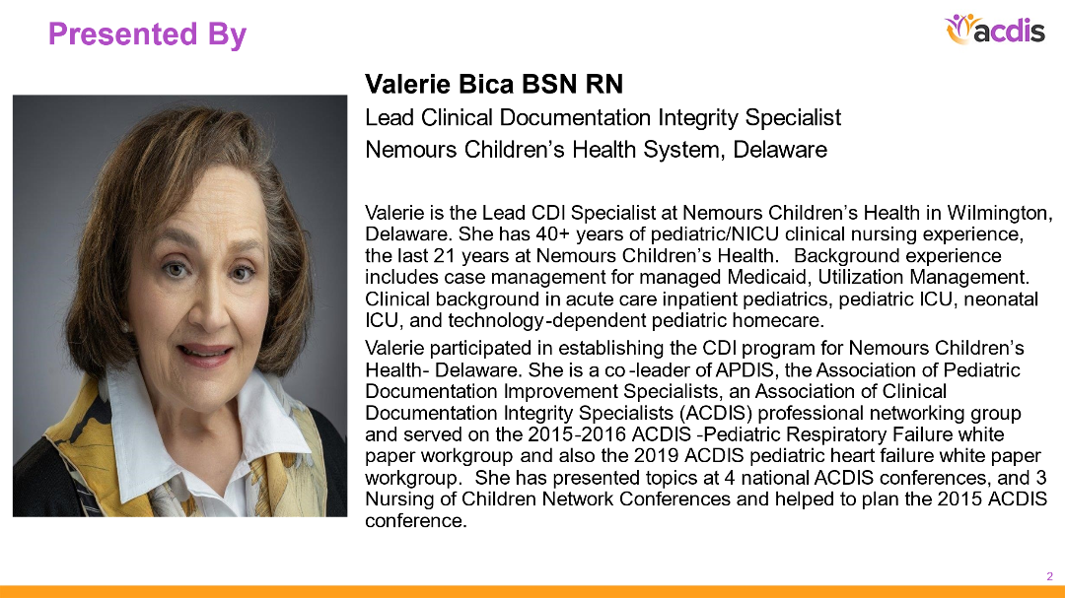
Save The Date:
- KYACDIS Local Conference: November 7, 2024
- This will be an all-day conference located in Elizabethtown, KY (More info to come)
- Registration will be sent out soon----Look out for this, as there will be deadline for registration


We really need help to run our chapter to the best of our ability, and we’re looking for more chapter members to come forward to help out.
Positions that are needed include:
- Secretary
- Treasurer
- Newsletter Manager
- Social Media Manager
Please let us know asap if you are interested in helping out in any of these positions!!!!

MEMBER SPOTLIGHT

- This is our new exciting space where we would like to highlight you, our chapter members, and your accomplishments or exciting life events (certifications, school graduation, marriage, births, trips, etc.)!!!

- If you have something exciting you would like to share with us, please send in your event and any pictures you would like included.

