|  |
| --- |
|  |
| **Journal of ACDIS, Maryland Chapter**  **February 2020** |  |

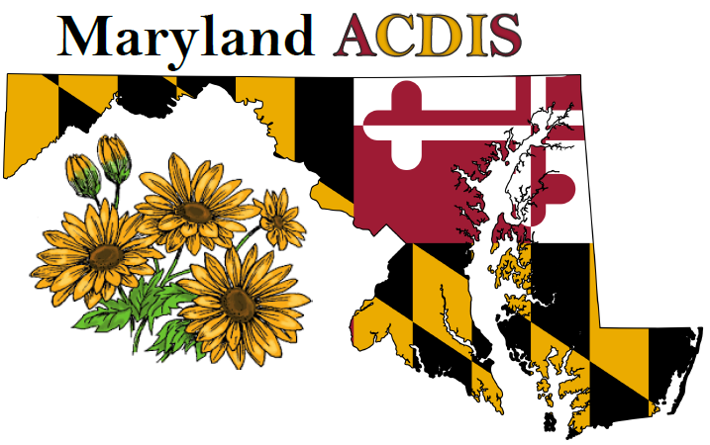

# Upcoming Events

|  |
| --- |
|  |
| **Next Maryland ACDIS**  **meeting**:    April 17  June 19  August 21  October 16  December 4  *All meetings are currently*  *scheduled from 12p - 2p*  *at the Maryland Hospital*  *Association.*  2020 Maryland ACDIS  Conference: Friday,  September 18th at  Frederick Health Village,  Frederick, MD.  **Maryland ACDIS Leadership:**    Deb McClain, President  [dmclain2@fmh.org](mailto:dmclain2@fmh.org)    Angela Roeder, Vice  President  [aroeder21@gmail.com](mailto:aroeder21@gmail.com)    Christi Sarasin, Education  Coordinator  [cdsarasin@aol.com](mailto:cdsarasin@aol.com)  Teri Gruenberg, Membership  Liaison  [Tgruenb1@jhmi.edu](mailto:Tgruenb1@jhmi.edu) |
|  |

Maryland ACDIS

|  |
| --- |
|  |
|  |
|  |

# President's message

It amazes me how fast each year seem to pass. Mindful living, staying present and making the most of each day seems cliché. Frankly, sometimes it's exhausting but it is always worth the effort.

Exciting opportunities are already coming forward for 2020. As we venture deeper into Total Cost of Care, our new Medicare waiver and a new MHAC list, more changes are certain. Many of you have voiced frustration and concern over changing workflows, continuously proving your ROI, and a larger than ever workload. This new year will remain in a state of evolution, after all healthcare is constantly evolving. We must remain flexible, slightly out of our comfort zone and willing to evolve. Yes, some days you feel like you will never hit that moving target - but you will. I believe that this is what makes our specialty Clinical Documentation Integrity exciting, refreshing and continuously educational. Staying on top of the market, keeping an eye on trends, and educating ourselves along the way will decrease frustration and assist us in remaining diligent. It will also move us a little further from our comfort zones with every new piece of knowledge and understanding.

I enjoy seeing the energy that gets generated when we meet as a group. This was palpable when we were together for the Maryland ACDIS conference in September. Your voice and attendance matter and is the essence of what makes this group shine! To that end, our leadership team is working on a short survey that will be sent out soon. Our hope is to get a high turnover in feedback. This information will be instrumental as we make decisions for how to move forward as a professional group. Please stay tuned.

I look forward to continuing to lead our chapter into the future, we are sure to have exciting times ahead of us. As always, if you have any concerns or questions, please reach out to me or one of our other leaders.

Deb

# February Membership Meeting

Due to work constraints, our Leaders cannot attend the scheduled February meeting therefore we are cancelling. We will regroup again in April, hopefully in nicer weather and sunshine.

# New Maryland ACDIS Logo

Did anyone notice our logo has been updated? Our very own Angela Roeder has some wicked secret skills that we continuously learn about. She updated our logo just prior to the conference last year. Thank you, Angela, for all your work and dedication to our group and for continuing to drive us towards raising the bar.

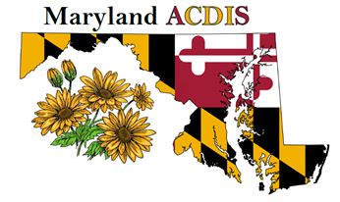

While speaking about Angela’s wonderful skills, we are so very sad to announce that she will be relocating to Florida! While we wish her good fortune and all things good, her go get’em can do attitude will be very much missed. She has been a huge contributor to the growth of this organization.

Thank you, Angela!

# Open Maryland ACDIS positions:

We have several open positions and need volunteers to help keep our group moving forward. No Leadership experience necessary, you will be mentored into your position by current leaders. Willingness to work as a team is a must!

Secretary - No experience necessary, organizational skills and willingness to work as a team is required. A keen eye or editing experience is helpful. Our Secretary will keep minutes at meetings and prepare them for distribution to membership, assist in keeping attendance, and assist in Journal production.

Vice President – Team working skills required. This position’s main role is to assist the President and cover when necessary and assist in Journal production.

Conference help needed - Looking for a few dedicated professionals for conference outreach, conference planning and hands on help on conference day. No experience necessary!

# 2019 December Membership Meeting

Our turn out was a little smaller than in past years but I am happy to report that we were still able to fill the Toys for Tots donation box! We enjoyed a quick meeting, lots of amazing food and many laughs. Another benefit we experienced was wonderful door prize gifts donated by ACDIS – we had 7 gifts for 7 winners! Thank you to everyone who donated to Toys for Tots and who participated in our meeting. We look forward to seeing you in 2020!

# 

# 2020 Maryland ACDIS meeting dates

April 17 June 19 August 21 October 16 December 4

Currently all meetings are being planned for the MHA. If your facility is interested in hosting a membership meeting, we are interested! Please reach out to Deb for more details, dmcclain2@fmh.org.

# 2020 Annual Maryland ACDIS Conference

Our conference will take place on Friday, September 18, 2020 at Frederick Health Village in Frederick, MD. We are very pleased to announce that the conference registration fee will be $10 again this year as Frederick Health is graciously offering their space for us. Seating capacity is over 200! Plan now to attend, the location is easy access to Rt 15, I70 and I270. We are exploring an agenda with a larger amount of CEUs. More information to come.

# Maryland ACDIS attendance at National Conference

Is anyone from our membership planning to attend the national conference in May? This is a unique year in that no one from our Leadership team will be able to attend the conference. If anyone is attending and would like to pull together or organize the Maryland table for State Pride Day on Thursday of the conference, please reach out to Deb McClain at [dmcclain2@fmh.org](mailto:dmcclain2@fmh.org) - She is willing to help coordinate.

# Questions from the Membership:

Is anyone in the position of potentially falling short of CEUs for CCDS renewal? How is everyone acquiring CEUs? Please send your responses to Christi at [cdsarasin@aol.com](mailto:cdsarasin@aol.com)

# Local Chapter Member Roster

Even if you are not an ACDIS member, ACDIS requests that local chapter members go to the ACDIS website and fill out the quick form stating that you are a local chapter member. This information helps support our volume of membership at the national level. The form can be found here: <https://www.surveymonkey.com/r/chapter-membership-roster>

# Getting to know you - Member Profile

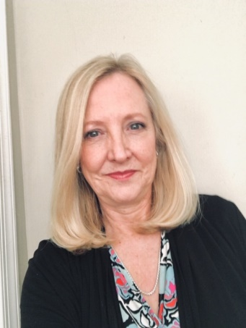

Thank you to Marian Rabeno who let us interview her for our member profile section. Marian is currently a CDS at MedStar Southern Maryland Hospital Center.

1.  *What did you do before CDI?*

I initially worked in hospital HIM and IT, having a degree in what used to be called Medical Record Administration and the RRA credential, which is now RHIA.  After a decade, I got a BSN, working in Interventional Cardiology until I became a CDI.

2.  *What attracted you to CDI?*

The opportunity to learn, build a new skill set and of course, sleep on a regular schedule!

3. *What do you like most about your role as a CDI?*

Developing education materials and communicating face-to-face with the providers.  I'm extroverted, enjoy writing, and have a passion for language precision.

4.  *What are the biggest challenges you face in CDI?*

Keeping up with the myriad of constantly changing coding rules and state quality initiatives.

5.  *How long have you worked in CDI?*

Since September of 2015.

6.  *What advice do you have to offer a new CDI?*

Seek advice with query formulation.  It can be tricky, and you'll want to present well from the start.  Treat your providers with care and respect.  They deserve it, and you do too!

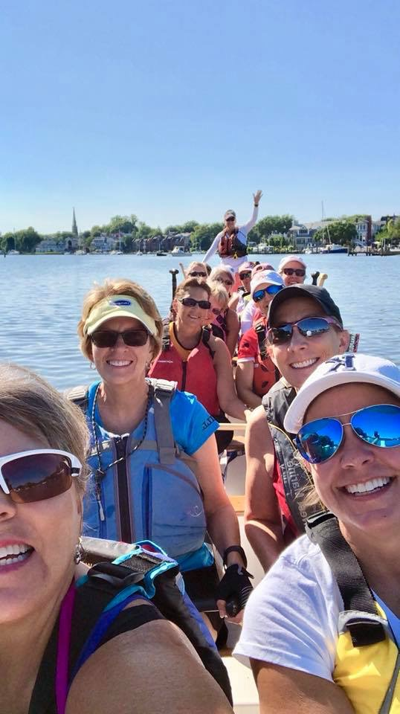7.  *How do you spend your time away from CDI?*

Most of my spare time is spent with the Annapolis Dragon Boat Club, practicing, racing, and participating in their cancer recovery outreach activities.

8.  My vacation wish list:  The Pacific Northwest, Scotland.  My favorite read:  The Week magazine.

# Job openings

CDI Manager, Meritus Health. Contact Sharon Powell [Sharon.powell@meritushealth.com](mailto:Sharon.powell@meritushealth.com)

Application can be found at meritushealth.com

Clinical Documentation Specialist, Meritus Health. Contact Sharon Powell [Sharon.powell@meritushealth.com](mailto:Sharon.powell@meritushealth.com) Application can be found at meritushealth.com

# ACDIS Conference Discount

# 

There have been many discussions recently regarding the price of the national conference and the current ability for hospital’s to provide limited reimbursement for attendance. I am happy to share that Mike Bryant is willing to offer Maryland ACDIS a group discount again this year. To obtain the discount you must contact Mike directly, let him know that you are indeed a Maryland ACDIS member and ask him about the discount to attend the national conference. With Mike’s discount, conference registration will be $760!

**Mike Bryant  800-650-6787 ext. 8127** or [mbryant@hcpro.com](mailto:mbryant@hcpro.com)

# ACDIS Membership Renewal and Chapter Information

There is a new online membership roster on the ACDIS site for local chapter members to fill out. The new roster can found [here](https://www.surveymonkey.com/r/chapter-membership-roster).

There is no special discount for renewals, but remember Maryland members receive quite a nice discount if you renew directly with Mike Bryant, our Retention Account Representative (see his contact information later in this newsletter).

# ACDIS Membership Renewals

When renewing your membership, contact Mike Bryant directly for the Maryland Local Chapter discount (see Mike’s information above). Also, please take a moment to visit the ACDIS website and fill out a local chapter membership form <https://www.surveymonkey.com/r/chapter-membership-roster>

# CEUs for CCDS Renewal

The ACDIS website is a wealth of information, including how to acquire CEUs for CCDS renewal. Did you know they offer CEUs if you are a speaker at local chapter-style events or speaking engagements that are not a part of your regular work responsibilities? Please visit <https://acdis.org/certification/ccds/recert> for all the details.

# ACDIS 2020 Membership Survey

The annual ACDIS survey is open via this link: [annual ACDIS membership survey is open](https://www.surveymonkey.com/r/2020-ACDIS-membership) , please take a few minutes to answer their questions honestly as it will guide the future of ACDIS and CEU offerings.

National ACDIS contacts:

Current HCPro Representative: Caison Morisey, Senior Account Executive/Maryland Chapter Rep

1-800-650-6787 ext. 8108, [cmorisey@hcpro.com](mailto:cmorisey@hcpro.com)

Mike Bryant, Retention Account Representative, 1- 800-650-6787 ext. 8127, [mbryant@hcpro.com](mailto:mbryant@hcpro.com)

***2019 Renewal Rate for MD ACDIS Members-$107***

# Some fun things captured from social media:

