|  |
| --- |
|  |
| **Journal of ACDIS, Maryland Chapter**  **April/May 2019** |  |

Maryland ACDIS

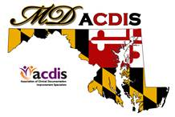

# Upcoming Events

|  |
| --- |
|  |
| **Next Maryland ACDIS**  **meeting**:    August 16  October 18  December 6  *All meetings are from 12p - 2p*  *at the Maryland Hospital*  *Association*  2019 Maryland ACDIS  Conference: Friday,  September 20th    **Maryland ACDIS Leadership:**    Deb McClain, President  [dmclain2@fmh.org](mailto:dmclain2@fmh.org)    Angela Roeder, Vice  President  [aroeder21@gmail.com](mailto:aroeder21@gmail.com)    Kyle Gafney, Secretary  [jossik@holycrosshealth.org](mailto:jossik@holycrosshealth.org)  Teri Gruenberg, Membership  Liaison  [Tgruenb1@jhmi.edu](mailto:Tgruenb1@jhmi.edu) |
|  |

|  |
| --- |
|  |
|  |
|  |

# President's message

What a conference! ACDIS conference week is always exhilarating, and exhausting. There were many excellent presentations from a wealth of experts, and by the end of the week I couldn’t absorb much more. At least 54 Maryland and DC ACDIS members got together over lunch as part of State Day. A mixer earlier in the week was another great opportunity to socialize with other members. It is always refreshing to run into and catch up with old friends as well as make new ones. There will be loads of good information to come from the conference through the year, keep your eyes open for the ACDIS announcements and postings.

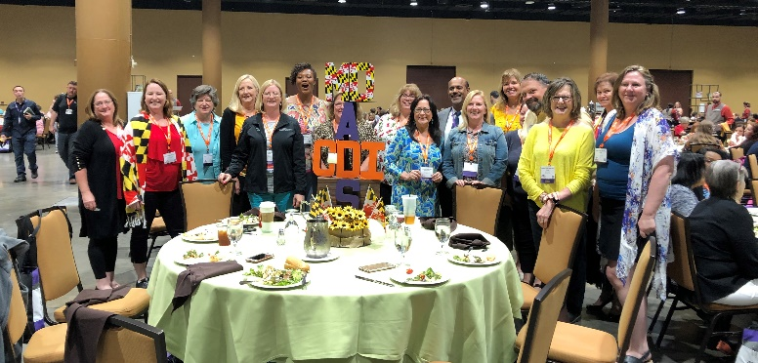

One interesting takeaway was the discussion of changing the “I” in CDI from “Improvement” to “Integrity”. This idea was shared with the audience on the first day by Brian Murphy generating many side conversations throughout the conference. Of the people I spoke with personally, the general consensus was positive towards the change. The profession has grown tremendously in the last decade, encompassing more pieces of the medical record, revenue cycle, and reimbursement processes. Sometimes change is good, and in this case it feels appropriate to the work that we are doing daily.

I look forward to seeing all of you soon,

Deb

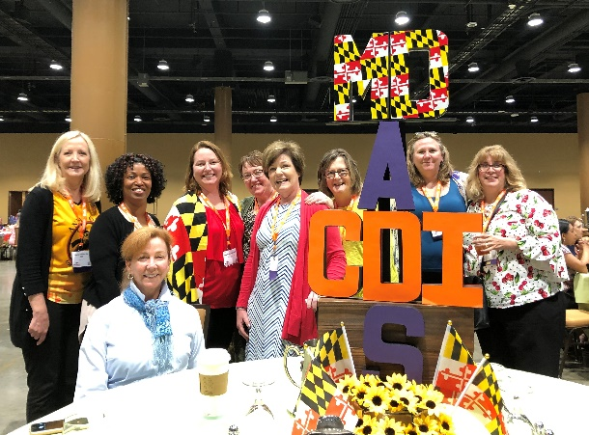

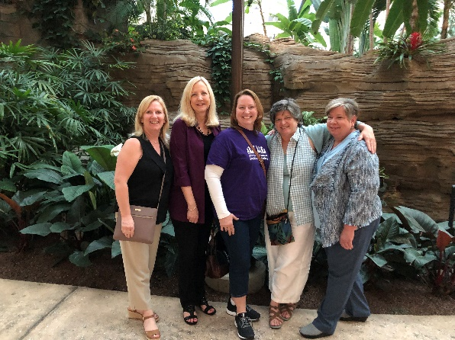

# Getting to know you - Member Profile

Many of you know Angela Roeder as the friendly face at the registration table at our Maryland ACDIS conferences. And more recently, she has joined us in the role of Vice President of Maryland ACDIS. So we asked her if she would be the first Member Profile.

1. **What did you do before CDI/Coding?** I spent most of my career

working in compliance as an auditor before starting in CDI. One of my favorite positions was working in the claims department of a health plan. That gave me a lot of valuable experience.

**2. What attracted you to CDI/Coding?** It's very rewarding to see the financial impact that CDI can make. It feels like I'm doing my part to help the organization get paid correctly.

**3. What do you like most about your role?** I love getting a detailed response on provider queries. Those are the moments when I feel like all of my hard work is paying off.

  
**4. What is/are your biggest challenge in your role?** I work remotely. While I'm very grateful for that flexibility, I miss the hands-on interactions with providers.

**5. How many years have you been in CDI/Coding?** I've been a certified coder for 9 years and have worked in CDI for 3 years.

**6. What advice would you offer to a new CDI/Coding?** Sign up to become a national ACDIS member. From there, learn how to navigate through the ACDIS website so that you can take advantage of all the helpful resources.

**7. Tell us about your family and how you spend your time away from CDI/Coding**. I have young children, ages 4 and 6. They are a blast and we enjoy family time. I like to get on their level and play. I love to hear them laugh. It's a huge stress reliever.

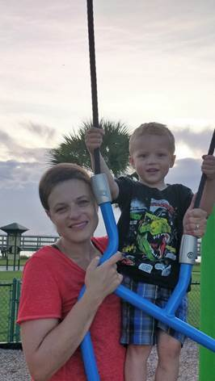 **8. Vacation wish list/best book you've recently read.** We spend 2-4 weeks in Florida a year. We used to live there for 9 years and I would love to have the opportunity to relocate there again.

# Maryland ACDIS Leadership Elections

It is with mixed emotions that I have to share that Kyle Gafney will officially be reitiring in August – for real this time. While we are very excited for her and her future opportunities, she has been invaluable to the Leadership team for many years and will be greatly missed.

The following positions are open for election: President, Secretary and Education Coordinator.

So far we have received only one nomination for the open positions. Your election committee will be meeting soon and sending information out for vote. There is still time for nominations especially with the soon to be vacant Secretarial spot. Send your nomination to any member of your Leadership team.

# 2019 Maryland ACDIS Annual Conference

CALLING ALL MEMBERS!!! We are now seeking pictures from your individual teams, thank you’s, recognitions, or other items that would be appropriate for the opening powerpoint for the conference. Please send all items to Deb McClain [dmcclain2@fmh.org](mailto:dmcclain2@fmh.org), Kyle Gafney [jossik@holycrosshealth.org](mailto:jossik@holycrosshealth.org) or Angela Roeder [aroeder21@gmail.com](mailto:aroeder21@gmail.com).

Mark your calendars: Friday, September 20, 2019 at St. Joseph’s Medical Center, 7601 Osler Drive, Towson, MD.

Conference will be a full day, dress comfortably in layers especially if you normally feel cold sitting all day. We will have 3 amazing speaker and a round robin session. We will be submitting for 4 ACDIS CEUs for the event. Three generous vendors have donated to the event and we are working out the details for catering. Registration will be coming once the fine details are finalized.

This year we will have capacity for 90 registrants, please monitor your email for further announcements.

# Maryland ACDIS and MdAHIMA Collaborative Education

We are so very excited to make this announcement. We were approached by MdAHIMA to work together on an annual CEU event starting this year. Of course, the year is quickly flying by.

Save the date: Friday, July 19, 2019

Location: GBMC

Topics: All things HSCRC! The drafted agenda, to be finalized this week included the following topics:

1. History and Overview of the HSCRC
2. HSCRC General Methodologies Update
3. HSCRC Data Update
4. Quality Program Update
5. TCOC & Benchmarking Update

Cost, Agenda, CEU information, and registration information will be coming next week. Seating capacity will be limited this day due to the venue space, if you or your team are interested please monitor your emails closely.

# Meeting topic suggestions

If you've got a burning question or want to know more about something, then chances are that someone else has the same question. Email Kyle ([jossik@holycrosshealth.org](mailto:jossik@holycrosshealth.org)) or Deb McClain [dmcclain2@fmh.org](mailto:dmcclain2@fmh.org) with your ideas. One topic we thought might be of interest to our members is the use of Linkedin. If you are a frequent user and think you could explain it's use to the rest of us, please let us know.

# CCDS Study Group Interest

We have had a request for a CCDS Study Group. Candace Blankenship and Teresa Krepps did a fantastic job this time last year with presenting a review for the exam. If anyone is interested in a group study, please contact Deb McClain [dmcclain2@fmh.org](mailto:dmcclain2@fmh.org)

# Changes at MHA

We recently learned that Justin Ziombra, Director of Policy and Data Analytics for the Maryland Hospital Association, has moved to California. He was a valuable resource for Maryland ACDIS and engaging speaker at our annual conference. We will miss him!

# NEW CALL IN NUMBER at the MHA

There is a new call in number for the MHA as of June 2019. Please make a note in your contacts or on your phone list for future meetings.

Call in number: 415-655-0001

Access Code: 314-341-495

# PPC Updates

We are now using v36 of the PPC grouper.

Below is the new and "lighter" ppc list for Maryland.

I'm sure everyone will be interested to share their experience with the new PPCs and how it has impacted their PPC rate at the next ACDIS meeting.

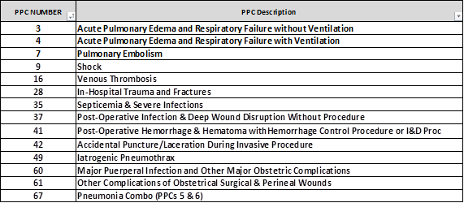

# Job Openings

Remote CDI position with Excite Health Partners

Job Title:  CDS

Client size (include Trauma level): 116 Beds No Teaching or Trauma

Remote or Onsite: Remote

Systems (EMR, Encoder, Abstracting):  3M360, Meditech

Start date: July 2nd but possibly sooner

Certs: RN or CCDS/CDIP

Top 3 skills/experience:

At least 5-7 years of experience

Must be able to review 20-21 re-reviews daily and maintain 80-81% coverage rates on Medicare and Commercial claims

Must have 3M360 Experience

# ACDIS Membership Renewal and Chapter Information

There is a new online membership roster on the ACDIS site for local chapter members to fill out. The new roster can found [here](https://www.surveymonkey.com/r/chapter-membership-roster).

There is no special discount for renewals, but remember Maryland members receive quite a nice discount if you renew directly with Mike Bryant, our Retention Account Representative (see his contact information later in this newsletter).

IPPS Proposed Rules and BMI:



|  |
| --- |
|  |

The ACDIS Regulatory Committee has been working to stay on top of the proposed IPPS changes. Please read their message below and consider submitting comments regarding the change in the status of BMI Z codes.

The ACDIS Regulatory Committee formed last fall and has been working to keep our members up to date on the regulatory changes that could potentially affect their CDI practice.  One change that they are currently monitoring is the proposed IPPS rule changes for FY 2020 that have been published by the CMS ICD 10 Coordination and Maintenance Committee ( [https://www.cms.gov/Medicare/Medicare-Fee-for-Service-Payment/AcuteInpatientPPS/FY2020-IPPS-Proposed-Rule-Home-Page.html](https://www.cms.gov/Medicare/Medicare-Fee-for-Service-Payment/AcuteInpatientPPS/FY2020-IPPS-Proposed-Rule-Home-Page.html" \t "_blank)  ).

The ACDIS Regulatory Committee has created a pilot initiative involving the proposed change to take away the CC status for the Z codes for BMI 40-49.9 and BMI 45-49.9. The committee wants to see if mobilizing the CDI specialist community to submit comment letters to oppose this change will persuade CMS to maintain the CC status for these BMI Z codes. They have asked me to distribute to you, our state chapter leaders, the comment template for this initiative as well as three other templates that they have created for our members' use. Please send these templates out to your chapter members and encourage them to submit comments to CMS. Our power is in our numbers and our dedication to safe patient care.

These are the templates that I have attached for your use:

1. General Morbid Obesity template: This is the committee's project template. Please take a moment now to download, edit, re-save, and submit this template to CMS.  We will know sometime in August if our project made an impact when CMS publishes the IPPS final rules document.
2. Appreciation template:  This can be used to submit approval of some of the proposed changes that you find helpful and you think would improve healthcare here in the USA.
3. General concerns template:  This is a template to use to express your concerns regarding the potential consequences of the proposed changes to the malignancy and sickle cell codes on the young adult and pediatric populations.
4. Specific issue template:  This template is created to help you construct a comment letter regarding a specific issue in the proposed rule changes that you feel could have a negative impact on healthcare.  The committee has included a comment letter that was used to overturn the IPPS rule change for ECMO.  This can be used to guide you in creating your own comment letter.

\*  You must first save the document before it will let you edit it.

To submit your comment letter to CMS, go to [*http://www.regulations.gov*](http://www.regulations.gov/)*.* Follow the instructions under the ‘‘submit a comment’’ tab*.*

If you have any questions regarding the templates or submitting comments to CMS, please contact Candace Blankenship at [Blankenship.Candace@mayo.edu](mailto:Blankenship.Candace@mayo.edu).

***For the original email and attachments, please reference the email sent to you by Kyle Gafney on June 6th.***

CDI Superheroes: The heroes hosptials deserve!:



|  |
| --- |
|  |

ACDIS has announced the theme for CDI Week September 16 – 20, 2019; *CDI Superheroes: The heroes hospitals deserve*! As you plan your activities to celeberate CDI week, don’t forget to take pictures and submit to your Maryland ACDIS Leadership to be included in the annual conference powerpoint!

National ACDIS is also looking for planning volunteers for CDI week and other committes. Please go to the ACDIS.org website and check them out. There is a small application process but the reward will be very satisfying and it looks good on a resume 😉!

National ACDIS contacts:



|  |
| --- |
|  |

Current HCPro Representative: Caison Morisey, Senior Account Executive/Maryland Chapter Rep

1-800-650-6787 ext. 8108, [cmorisey@hcpro.com](mailto:cmorisey@hcpro.com)

Mike Bryant, Retention Account Representative, 1- 800-650-6787 ext. 8127, [mbryant@hcpro.com](mailto:mbryant@hcpro.com)

\*\*\*2019 Renewal Rate for MD ACDIS Members-$107\*\*\*