______________________________________________________

Chapter Meeting

_________________________________________________________________________________________________________________________

When: February 8, 2023

Time: 1:00 Noon- 2:00 PM

Presentation: Components of a CDI Query Audit

Presenter: Cindy Whichard, RN, BSN, CCDS, CCRC

Senior Consultant Inpatient CDI Claro Healthcare, LLC

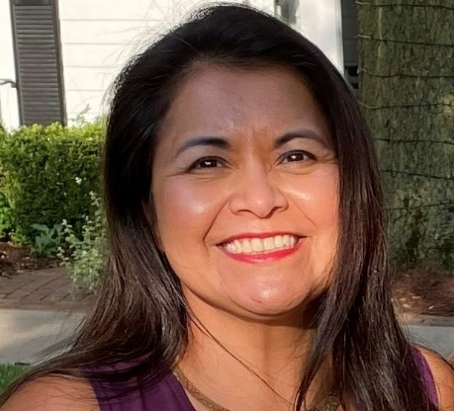
Click here to join the meeting
Meeting ID: 251 992 789 079
Passcode: 2U5K4j

For those who are not yet registered to the NI ACDIS Chapter, please click the link below and register.
https://www.surveymonkey.com/r/chapter-membership-roster

