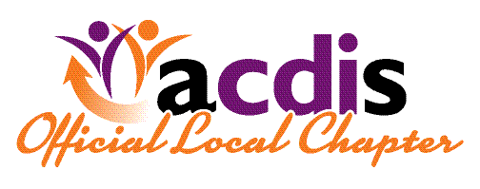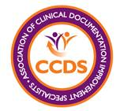
ACDIS of Oklahoma
Chapter Meeting

Guest Speaker
Dr. David Lee Gordan MD

OU Physicians Neurology

-Clinical presentation of stroke, hemorrhage,
ICD10 Coding implications, and NIHSS scale.

Focus Discussion

AHIMA Practice Brief Clinical Validation: The Next
Level of CDI (January 2019 Updated)

-with Susan Wallace Med, RHIA, CCS, CCDS, CDIP, FAHIMA
VP Inpatient Services/CDI at Administrative Consultant Services, LLC.

Friday, May 31, 2019
1pm to 3pm
Cost: Free CEU Credit: Pending

OU Medical Center Samis Conference Center
1200 Children’s Avenue 73104
Located at Children’s Hospital. Directions with map and code for event parking provided with RSVP.

RSVP: amanda.just@integrisok.com

