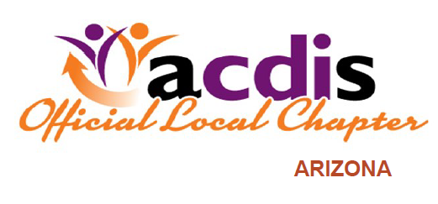
SAVE THE DATES!
AzACDIS proudly presents a WebEx presentation
for CDI, CODING and HEALTHCARE PROFESSIONALS
“How is Artificial Intelligence Impacting
Clinical Documentation?”
Presented by Tyler Coles from Nuance
Thursday, May 2, 2019 1200-1300
******************************************************
Also, Save the Date for our joint event with AzHIMA, CEUs offered
Saturday, August 3, 2019 830am-1230pm
Honor Health Shea Medical Center-- Brady Conference Center
9003 E Shea Blvd, Scottsdale, AZ 85260

Please share this flyer with your friends and colleagues and watch for more announcements and a WebEx invite

