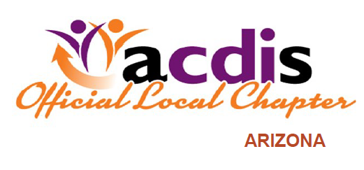
Save the Dates!
AzACDIS proudly presents a Meet and Greet for CDI, CODING and HEALTHCARE PROFESSIONALS
Roundtable Discussion on “CDI’s Involvement in Denial Management”
Mimi’s Café at Desert Ridge 21001 N. Tatum Blvd Weds, Oct 30, 2019 530-730 Approved for 1 CEU
******************************************************
AzACDIS also proudly presents a Lunch and Learn WebEx for CDI, CODING and HEALTHCARE PROFESSIONALS
“Value Based Healthcare and the Role of the CDI Educator” Presented by ME VanGelder and Elisa Sninchak
Friday, Nov, 22, 2019 @ 1200
One CEU pending (Joint event with ACDIS CDI Educator chapter)
Please share this flyer with your friends and colleagues and watch for more announcements and a WebEx invite

