Wisconsin ACDIS
Spring Conference Meeting
Saturday, April 27th, 2019

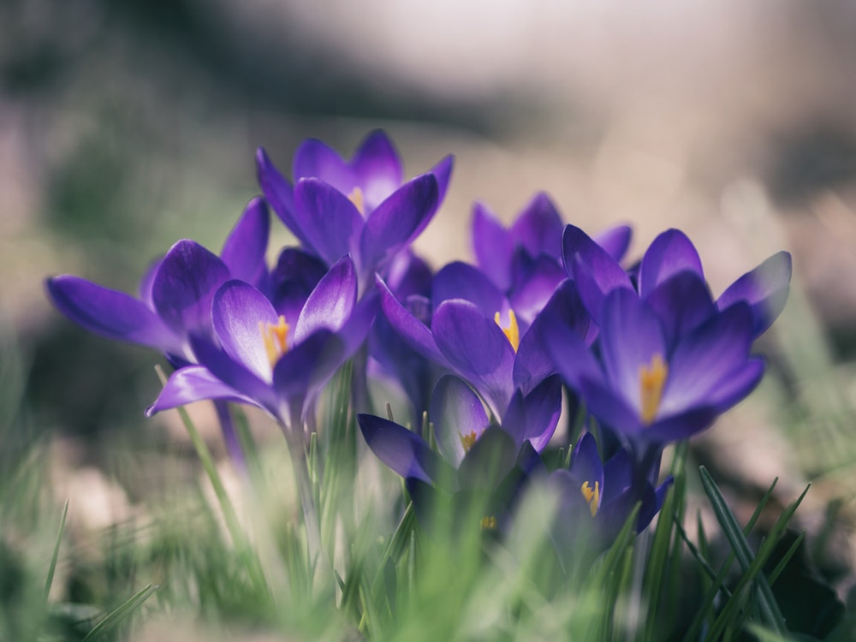

Ascension Medical Building
Conference Center 5th floor
201 N Mayfair Rd, Wauwatosa WI

Agenda
Time | Topic | Presenters
0845-0915 | Registration / Breakfast
0915-1015 | Physician Champions | David Reece  Med Partners
1030-1130 | State of the Industry | Melissa Varnavas  ACDIS
1130-1215 | Lunch / WI ACDIS Business Meeting
1215-1315 | AHIMA/ACDIS Query Practice Brief | Sheila Goethel
1330-1430 | Physician Education | Birgitta Larson Gamez  UW Health
1430-1600 | Clinical Indicators and Query Opportunities | Dr. William Haik
1600-1630 | Evaluations / Departure

Breakfast, lunch and ACDIS CEUs are provided and included in the conference fees. Application for 5.5 ACDIS CEUs pending.

Registration Information:
Registration fee is:
- $ 40 for Current 2018 WI ACDIS members (Membership renewal occurs in October)
- $ 75 for non-members - who do not want to join WI ACDIS
- $ 20 Late Fee for registration postmarked after Friday, April 12th

Payable to WI ACDIS

Please mail checks (due on Friday, April 12th) to:

Joan Korn
3847 S 93rd Street
Milwaukee, WI 53228

- Please send attached form, along with your payment for the seminar, to Joan at the above address.

- Note for the day of the conference: the main entrance will be closed, so please enter through Urgent Care. The signs will direct you to the 5th Floor Conference Center.

.

We look forward to seeing you at the Spring Conference

Wisconsin ACDIS
Spring Conference Meeting
Saturday, April 27th, 2019

Registration Information:

Registration fee is:
- $ 40 for Current WI ACDIS members
- $ 75 for non-members who do not want to join WI ACDIS
- $ 20 late fee for registrations postmarked after April 12th

Payable to WI ACDIS

Please mail checks (by Friday, April 12th) to:

Joan Korn
3847 S 93rd Street
Milwaukee, WI 53228

Attendee Name: ___________________________________

Facility: __________________________________________

Email: ___________________________________________

Address 1: _________________________________________

Address 2: ________________________________________

Phone Number: ____________________________________

