# **A virtual meeting platform guide for ACDIS local chapter leaders**

**Introduction**

The COVID-19 pandemic has caused travel restrictions, shelter-in-place and self-quarantine orders, reduced hospital censuses, and job losses. The surge of the disease hit the east coast of the United States in March and April 2020, just as many ACDIS local chapters were gearing up for their spring events. Early on, the country was told the virus behaved like the flu and as such would pass the majority of the population by with little more than flu-like symptoms. By mid-March, however, new information showed that non-symptomatic carriers were bringing the disease to the community in drastic numbers.

ACDIS began encouraging its local chapters to cancel or postpone their events. We partnered with those who had events previously scheduled web-based sessions to open their meetings to any and all chapter members across the country, and will continue to do so on a rolling basis as the pandemic continues.

Those local chapters seeking to move their meetings to a remote platform were previously encouraged to work within their communities to identify a meeting host; a facility with a corporate platform to lend to the chapter for its event. As the pandemic progressed, however, many major online meeting platforms adjusted their offerings and, as the population itself adjusted to working from home, people became much more comfortable with a wide variety of these tools.

For those local chapters who collect dues, purchasing a subscription to an online meeting platform tool may be a good way to ensure event plans seamlessly shift from in-person to online. For those chapters that do not collect dues, there are low-cost and free options, too, just not with all the bells and whistles that corporate users may need.

As furloughs, layoffs, salary cuts, and other unfortunate outcomes of COVID-19 continue, our local chapter efforts will be as vital as ever to keep our CDI community strong and connected. CDI professionals are looking for camaraderie, education, and collaboration to identify new areas of CDI expansion and preserve the value of CDI efforts. They are looking for low-cost, innovative ways to maintain their continuing education and certifications. Local chapter activities can provide all of this and more.

Below represents a high-level overview of costs and benefits of some of these tools along with some creative ideas to help our local chapter volunteers as they make decisions about their upcoming events.

**General remote meeting ideas and recommendations**

* Typically, ACDIS recommends chapters host in-person events on a quarterly basis. However, with summer vacations and winter-weather travel restrictions, local chapters may opt to conduct two remote and two in-person events.
  + Due to the COVID-19 pandemic, chapters may choose to conduct 100% virtual sessions.
* Do not attempt to include a remote option for an in-person event. Doing so doubles the work for the volunteer leadership team and disincentivizes attendees from making the commitment to attend in person.
* Consider trimming the agenda to an hour-and-a-half. People have limited attention spans and may get more from shorter sessions.
  + Generally, virtual meeting attendees try to multi-task and may not be getting the full benefit from the education. Including a video component, an actual person for the attendees to watch and pay attention to can help with this.
* Consider including two, short, half-hour sessions on tangential topics such as physician engagement and CDI metrics related to physician response. Changing speakers at the half-hour mark provides a visual cue to the attendees that some new information is coming their way.
* Include a panel discussion and identify individuals with interesting stories to share ahead of time.
  + Assign a volunteer to monitor the chat and Q&A pods to bring forward interesting thoughts to the whole team verbally.
* If the chapter has limited funds and can only use a free platform version with limited attendance, consider holding a few focused roundtable discussions.
  + For example, a chapter may wish to pull together a group of 15-20 participants to talk about tracking staff productivity. Leaders could use the online membership roster as a registration tool and pick the first 15-20 people who sign up to participate.
  + Chapter volunteers would need to curate a list of discussion topics and keep the conversation rolling.
  + Draft out a script with pre-set questions directed to specific members of the group.
  + A series of recordings could be provided to those unable to attend.
* In times past, ACDIS would dissuade local chapters from attempting to conduct full-day virtual events. Times change. The tools have changed, too. There are a wide variety of ways to leverage the tools included with some of these online platforms. Be sure to connect with your leadership team and play around with the platform’s capabilities multiple times before you go live.
* Connect with the national organization, too, for assistance. National is in touch with many of the chapter leadership teams around the country and can help provide fresh ideas and insight as you proceed with your plans.

**Tips for hosting a meeting**

* Be mindful of time zones, and ensure meetings are during typical business hours for all attendees.
  + When possible, consider contacting national ACDIS and opening up your meeting to other local chapters across the country.
* Remember to take breaks! Particularly if holding multiple education sessions, build in a break after the first meeting for your teams and start your meeting at 15 minutes after the hour.
* Provide global numbers. Most platforms provide default call in numbers for your meetings to reflect where your attendees are joining from. Check to determine if the platform also provides a generic, toll-free dial-in option but remember, most folks are using their computer speakers and microphones instead of their phones these days.
* If possible, have at least two members of the leadership team as organizers or panelists during the call. One can introduce the speaker and provide opening remarks, and the other can monitor the chat and question sections of the platform or help handle technical problems.
* At the outset of the program be sure to:
  + Welcome everyone.
  + Introduce yourself and other chapter leaders on the line.
  + Remind attendees to mute their lines when not speaking and to avoid using the hold button. Hold music will disrupt the call for everyone.
  + Remind attendees of the CEU availability and how they can expect to receive them.
  + Review the agenda.
  + Introduce the speaker and hand the program over to him/her.
* Turn off notifications for other applications. That way you will not get distracted with email and messaging pop-ups. Alternatively, choose to share a “clean” screen which allows you to have other apps and tools open for quick and easy navigation without distracting the audience.
  + Share only the content you intend to. By sharing an application, not your whole screen, you can be sure you are keeping attention on the task at hand, and not on notifications that may pop up.
* Ask your participants to mute when they’re not talking. If someone forgets, or is disrupting your meeting, you can mute noisy attendee lines from the participant panel.
  + Avoid echoing: If the participant has dialed in on the phone and has their computer speakers on, it will create a feedback loop (a similar problem might occur if participants use their speakerphones). With those listening via computer (VoIP), one of the causes of echo is a microphone, or headset with microphone, that is placed too close to computer speakers. To resolve echoing issues, mute all lines in the teleconference, remind the audience of these housekeeping tips and try unmuting again. If the problem persists, then unmute only the active speakers.
* Make it a habit to record your meetings. If someone’s not able to attend your meeting, simply share the link, keeping everyone up to date.
* Share your video. The most powerful way to encourage video sharing is to turn on your own camera. Seeing facial reactions builds trust and community particularly where local chapter members are used to (and may be missing) in-person connections.
  + Check the capabilities of the platform to determine how many video cameras can be shared at a time and consider limiting the video feed to just the panelists and presenters.
  + Double check both your own and your panelists’ backgrounds and if you notice something unusual, mention it. The visual component should be professional but personal. For those who choose virtual backgrounds, a component available on some platforms, recommend participants choose one and keep it. Playing around with the background will be distracting to attendees listening to the education being offered.
  + If the video/audio connection lags, stop sharing video and continue with the presentation. Internet connectivity in people’s homes can fluctuate markedly from day to day and depending on the time of the day. So, stay calm and be prepared with a backup plan.
* Have a backup plan. Technology is only as good as it is and there will always be challenges.
  + Leaders should have a copy of the slide presentation. If the speaker cannot take control and move the slides themselves, the leaders can do it.
  + Upload a copy of the slide deck to either your page on the ACDIS website or the online meeting platform. That way if the video/screen sharing capabilities falter the attendees can follow along on their own computers.
  + Remind users of the telephone dial-in option. If they cannot get their access to work, they can pull up the slides on their own and listen to the presentation.
  + Stay calm. Everyone is more comfortable with the flubs and missteps of online activities these days. Let the audience know what you are doing and what to expect in terms of next steps and they’ll stay with you.

**Virtual meeting platform options**

Below is a chart of some of the common platforms and some pros and cons provided by the South Carolina ACDIS chapter followed by research conducted by the ACDIS editorial team.

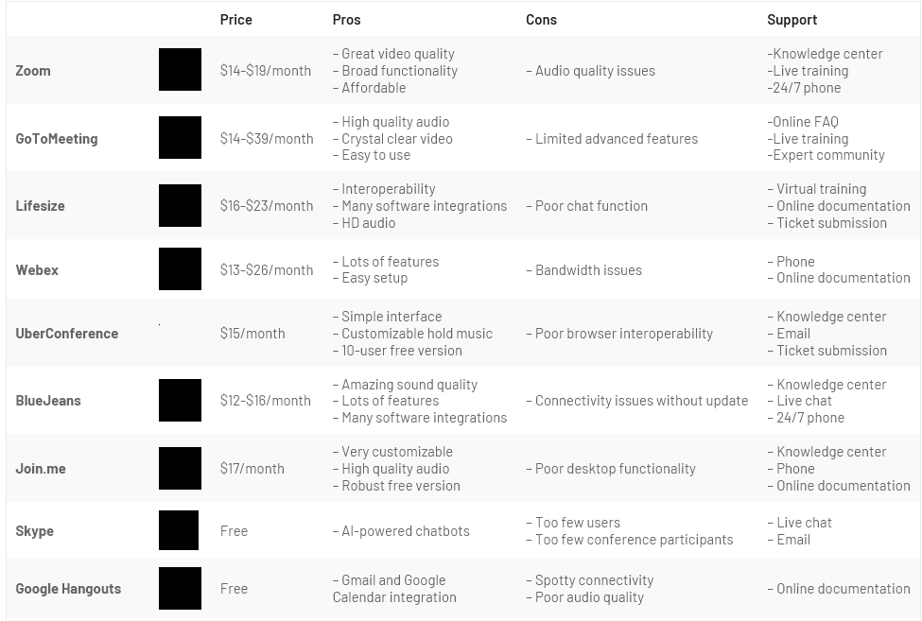 

## **GotoMeeting/Webinar (GTM/W)**

* **What is GTM/W?** GotoMeeting and GotoWebinar are web conferencing services provided by LogMeIn. They include audio and video components as well as screen sharing capabilities.
  + GTM has smaller audience capabilities anywhere from 150-200. With GTM, everyone’s lines are live, but the meeting host can mute participants manually if needed. There is a chat feature, as well, which allows participants to message the entire group or select an individual to have a private chat with. It also includes an option to record the session, so if you were to hold a roundtable-type discussion, the host could record it and then, the conversation could then be shared with the rest of the community.
  + GTW has room for up to 3,000 attendees and has far more interactivity than GTM including whiteboard features, live polls, Q&A pod, as well as typical chat functionality. It also will auto-record and notify the host/organizer when the recording is available and provide the organizer with a link to the recording library to share. It will also transcribe the call.
* **Subscription levels:** Each program has various subscription levels with the GTW options being more expensive but also of higher recording and replay value.
  + [GTM](https://www.gotomeeting.com/meeting/pricing?c_name=gget-d-c&c_mark=NAPPC&c_kwd=Plans_and_Pricing-SITELINK&cid=g2m_noam_ggs_cpc_71700000060694846_58700005493369263_p50143970146&gclid=CjwKCAjw-YT1BRAFEiwAd2WRtr17VsLuSHKsHm0wto1Nr0Sm4nxD-4T1sT9yRiq5RT4GQCRskuvUzBoCyygQAvD_BwE&gclsrc=aw.ds):
    - Professional: $12/month with 150 participants and limitations on co-organizers
    - Business: $16/month with 250 participants and allows co-organizers as well as unlimited cloud recording
  + [GTW:](https://www.gotomeeting.com/webinar/pricingb)
    - Lite: $49/month with 100 participants
    - Standard: $99/month with 250 participants, video sharing, video embedding, automated emails, and analytic reporting
* **Pros/Cons:** 
  + GTM/W is the platform generally used by ACDIS national for its committee meetings as well as many of its free webinars. The platforms are fairly easy to use and the quality of video, audio, and tools is fairly high.
  + The limitations on co-organizers with the lesser-priced GTM could be problematic as many chapters may wish to have an additional volunteer helping to track questions, assist with presenting, or other background tasks.
  + While both GTM/W are easy to use, practice makes perfect and, as with all technology, it’s good to have a friend on the line to help out should any technical troubles arise.
  + With GTW, even the lesser priced option may be too costly for local chapters.

## **Webex**

* **What is Webex?** Like other methods listed, Webex is a virtual meeting platform that includes video and audio and screen sharing capabilities. It also has chat functionality.
* **Subscription levels:** [Webex has four levels](https://www.webex.com/pricing/index.html) including:
  + Free:
    - Up to 100 participants
    - No time limit
    - No limit on number of meetings
    - Video, audio, desktop sharing
    - Q&A, polling, and chat
  + Starter ($13.50/month)
    - 100 participants
    - Cloud storage
    - Recording transcriptions
    - MP4 recordings
    - Customizable links
  + Plus ($17.95/month)
    - 100 participants
    - Assign alternate hosts
    - Allow others to schedule meeting on behalf of the host
    - Analytics and troubleshooting
    - Administrative portal
  + Business ($26.95/month)
    - 200 participants
    - 10 GB of cloud storage
    - Branding, etc.
* **Pros/Cons:**
  + Pricing is a fundamental aspect when it comes to choosing a dependable video conferencing platform for your business. Companies tend to go for cost-effective and flexible tools that allow them to scale whenever the need arises. If features are relatively similar, the cost is a great tiebreaker.
  + Some suggest that Zoom’s video quality may be superior to Webex.
  + Webex is synonymous with its ability to support co-browsing, remove attendees, and allow file transfers.
  + Webex is packed with lots of quality features and has upgraded their platform and free plan.

## **Zoom**

* **What is Zoom?** Zoom is a virtual meeting platform that allows groups to use video chat functionality as well as share their screens during presentations. The platform also has a built-in text chat feature if group attendees prefer to use that to communicate questions during a presentation or because their microphone isn’t working properly/they’re muted by the host. [*https://zoom.us/*](https://zoom.us/)
* **Subscription levels:** Zoom has two available subscription levels that would be appropriate for local chapter use. They also offer two business account levels that are more expensive (roughly $20/month/hose) and have more features than are necessary for a typical local chapter meeting. Here are the two lower level features:
  + Basic (free):
    - Up to 100 participants
    - Unlimited one-on-one meetings
    - 40-minute limit on group meetings
    - Unlimited number of meetings
    - Tech support from Zoom
  + Pro ($14.99/month/host):
    - All the basic features
    - Meeting duration limit is 24 hours
    - User management
    - Administrative feature controls
    - Reporting
    - Custom personal meeting IDs
    - Allows you to assign someone else as the “scheduler”
    - 1GB of cloud recording space
    - Integration with Skype for Business
* Pros and cons of the basic (free) subscription level:
  + Since the plan is free, it’s a very easy entry point for chapters looking for virtual meeting platform to get started.
  + The 40-minute time limit may be difficult to work around for chapter meetings since most are at least an hour long. Because of this fact, it’s likely best suited for chapter leadership meetings that can be contained to the time limit or quick “check-in” style meetings with smaller groups/chapters.
* Pros and cons of the pro subscription level:
  + The 24-hour meeting duration limit means chapters can conduct full-length virtual meetings easily and the additional reporting capabilities and meeting ID customization would be helpful for leaders to track their meeting attendance and share the meeting info with chapter members.
  + Allowing multiple “schedulers” to use the account may be helpful for leadership teams because it takes the onerous off a single leader to schedule the virtual event.
  + The price tag, however, may be a deterrent for chapters/groups that don’t have a running fund-base as it would require leaders to pay out of their own pockets.
  + Leaders looking to use Zoom for their full-length meetings may want to inquire around their chapter membership and see if any members have a paid account that could be used for chapter meetings, much like an organization offering a webex for chapter use.
* Some recommendations for chapters and networking groups using Zoom for their virtual meetings:
  + Do not share the link to the meeting on social media publicly as it isn’t password protected and anyone could join the call. Instead, share the link with your chapter email list or to a private Facebook group only accessible to your group members.
  + The host (owner of the account) has the ability to mute all participants when needed during a presentation to eliminate background noise. During the Q&A portion, remember to unmute so that participants can chime in as needed.

## **Skype**

* **What is Skype?** Skype is another virtual meeting platform, similar to Zoom allowing groups to use video chat functionality and share their screens during presentations. Skype allows for just audio, visual, or a mix of both for groups of up to 50 participants. Skype has a built-in chat box during meetings if participants prefer to interact that way to submit questions or collaborate in the background as to not interrupt the presentation.
* **Subscription levels:** Skype only has one subscription level which is free to all users. It included:
  + Up to 50 participants per meeting
  + Unlimited one-on-one and group meetings
  + Call recording and live subtitles
  + Audio, video, and file as well as screen sharing
* **Pros/Cons:**
  + Being that Skype is free, it’s a great entry point for smaller chapters to get a virtual meeting platform started.
  + Skype only allows for 50 participants, so larger chapters would not benefit as much.
  + This platform allows for participants to join with full video, audio, and screen sharing ability through the app on a computer, tablet, or smartphone. If participants do not have these options or are otherwise running around and would prefer to just listen in, a dial in number is also provided.
  + Skype does not allow for much reporting, so there will not be many analytics after the meeting.
* **Recommendations:**
  + The Skype platform is best for smaller chapters with more of a “check-in” style meeting meant for conversation and collaboration, while paid platforms are likely the best option for larger groups with presentation-focused meetings.
  + Because the platform is free, there is little risk to doing a trial run of using Skype for meeting purposes with chapter leaders.

## **Helpful resources**

* <https://www.dgicommunications.com/zoom-vs-skype/>
* [https://www.webex.com/content/dam/webex/eopi/assets/adoption-toolkits/WebexRemoteWorkingBestPractices.pdf](https://protect-us.mimecast.com/s/gl04CL9AYRIk6kn2cB7vN9?domain=webex.com)