FAQs | Date: September 18-22, 2017  The Wild West: New Frontiers in  Clinical Documentation Improvement
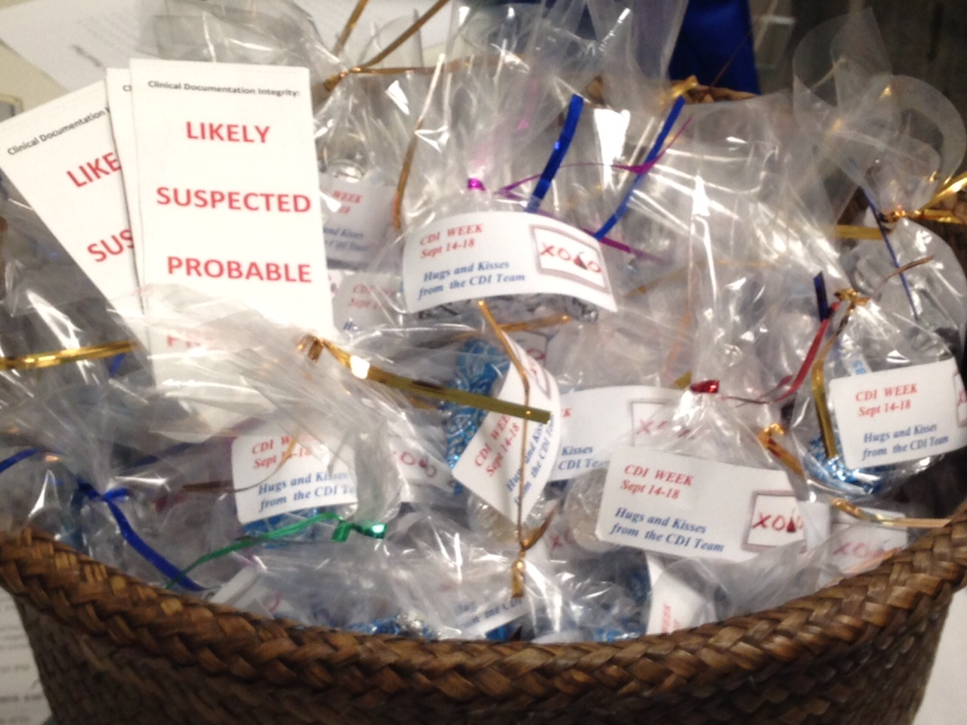  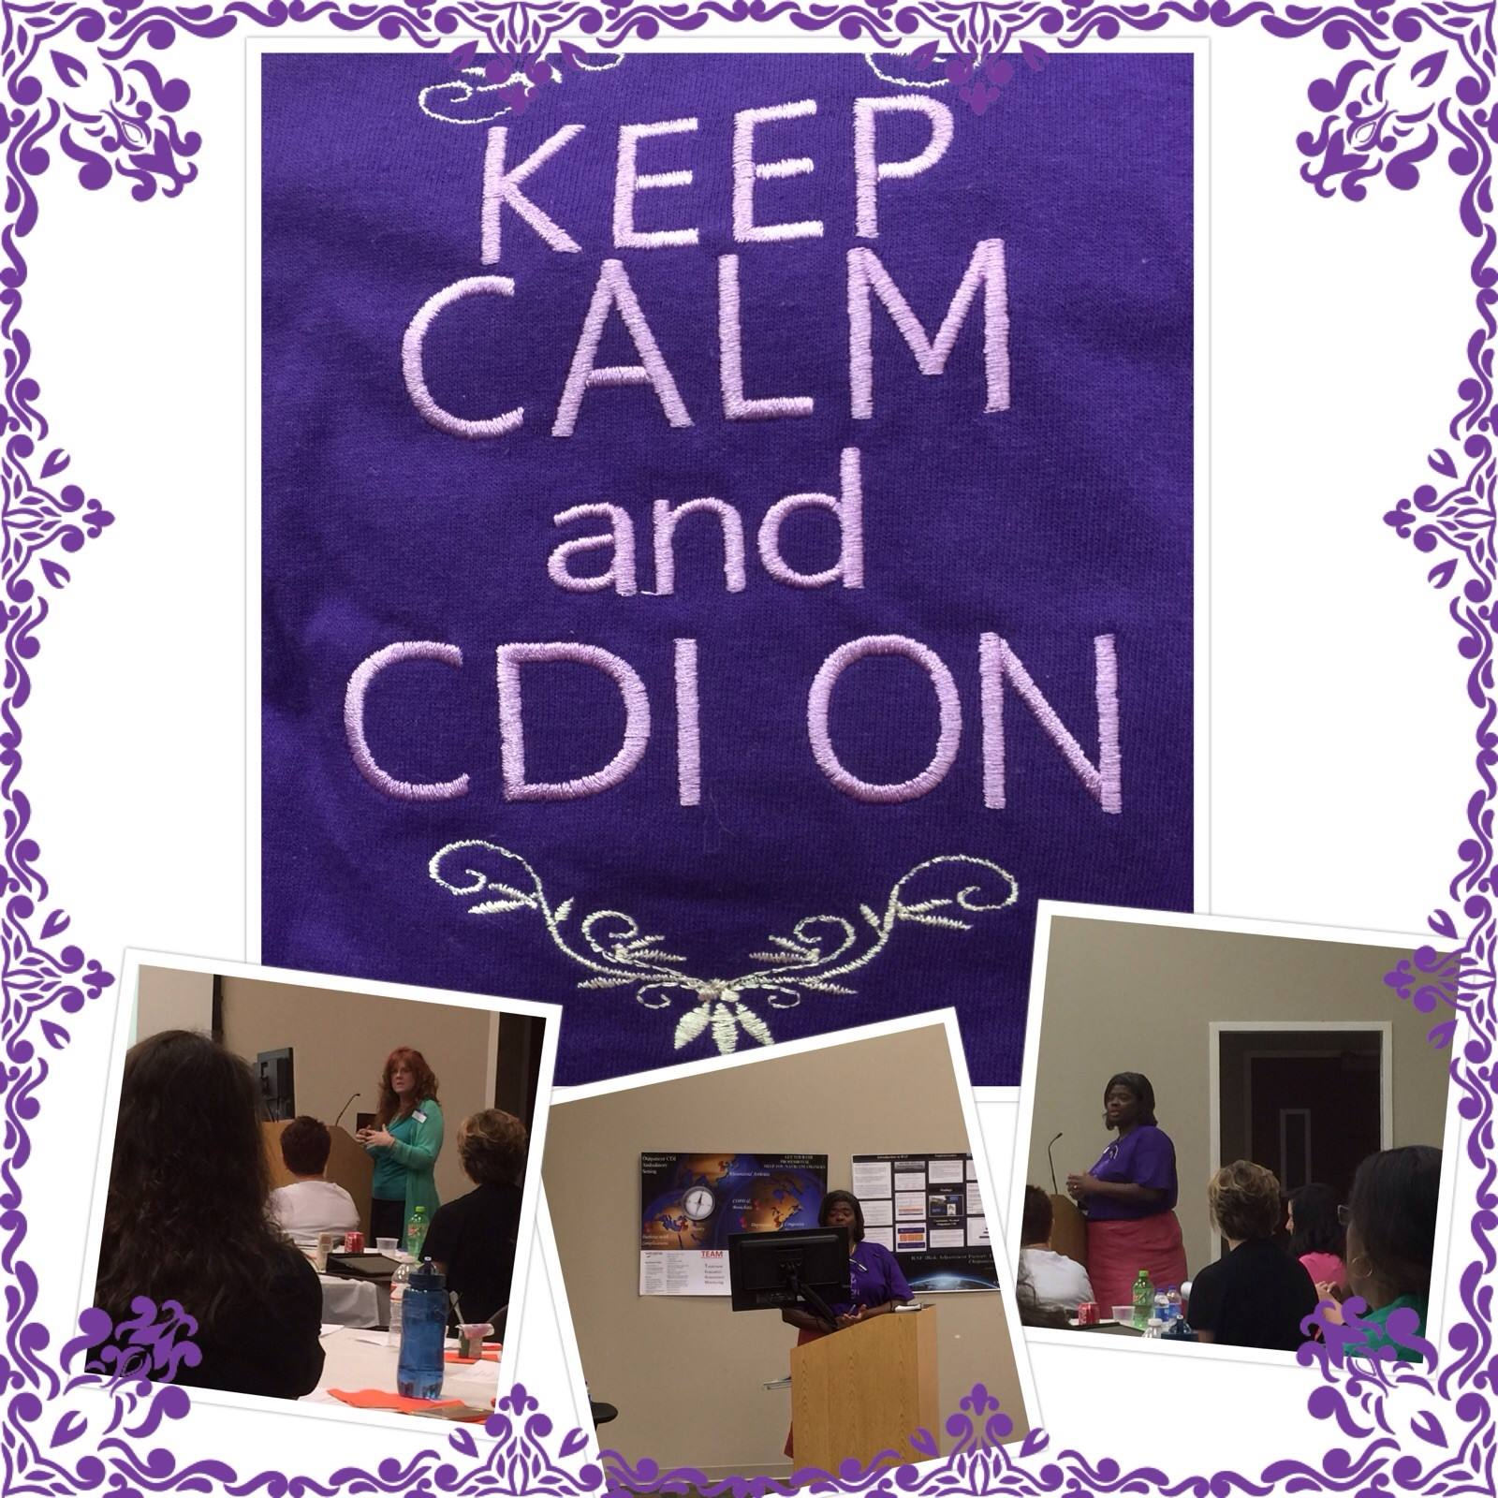  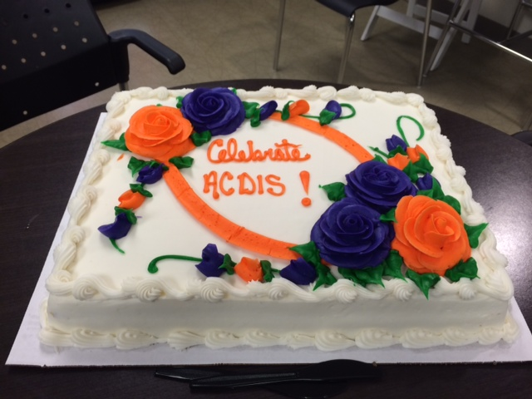 | What is CDI Week?  A week of national recognition supported by the Association of Clinical Documentation Improvement Specialists (ACDIS) to support the CDI profession.  What should we do to celebrate?  Take a look at the lists of suggested activities under the activities menu!  Who is this week for?  It’s a pat on the back for those working in CDI but it’s also an opportunity for CDI staff to give back to ancillary team members who support their documentation improvement efforts all year long!  When will I receive the CDI Week QAs?  ACDIS members will receive a QA each day Sunday through Friday via email. Non-ACDIS members can access the QAs each day via the ACDIS website.  What is the CDI Week Industry Survey?  Every year ACDIS asks its members and subscribers to offer their insight to shed light on how the profession is changing and growing. This year’s survey looked at topics such as clinical validation, career growth, physician engagement, and technology in addition to other topics. ACDIS members were emailed the survey on Sunday and non-members have access to the survey via the ACDIS website.  Is it okay for us to use the CDI Week logos and posters at our facility?  Yes! We encourage CDI team to download the poster and logo and to include it in their email signatures, communications with physicians, in their CDI Week materials, and even in murals and hallway decorations.

